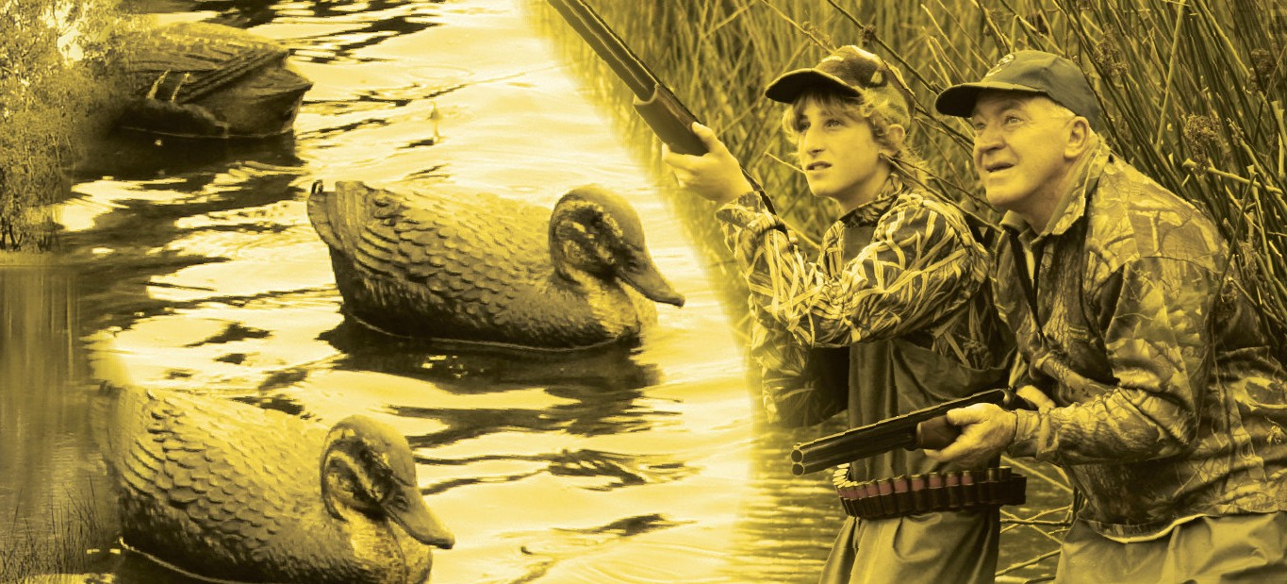

Estimates of Harvest for Deer, Duck and Quail in Victoria: Results from Surveys of Victorian Game Licence Holders in 2009

A. M. Gormley and J. D. Turnbull

2009

Arthur Rylah Institute for Environmental Research Technical Report Series No. 196

Arthur Rylah Institute for Environmental Research Technical Series No. 196

Estimates of harvest for deer, duck and quail in Victoria: Results from surveys of Victorian game licence holders in 2009

Andrew M. Gormley and John D. Turnbull

Arthur Rylah Institute for Environmental Research 123 Brown Street, Heidelberg, Victoria 3084

December 2009

In partnership with the Game Management Unit, DSE as part of the Enhancing Game Management Initiative.

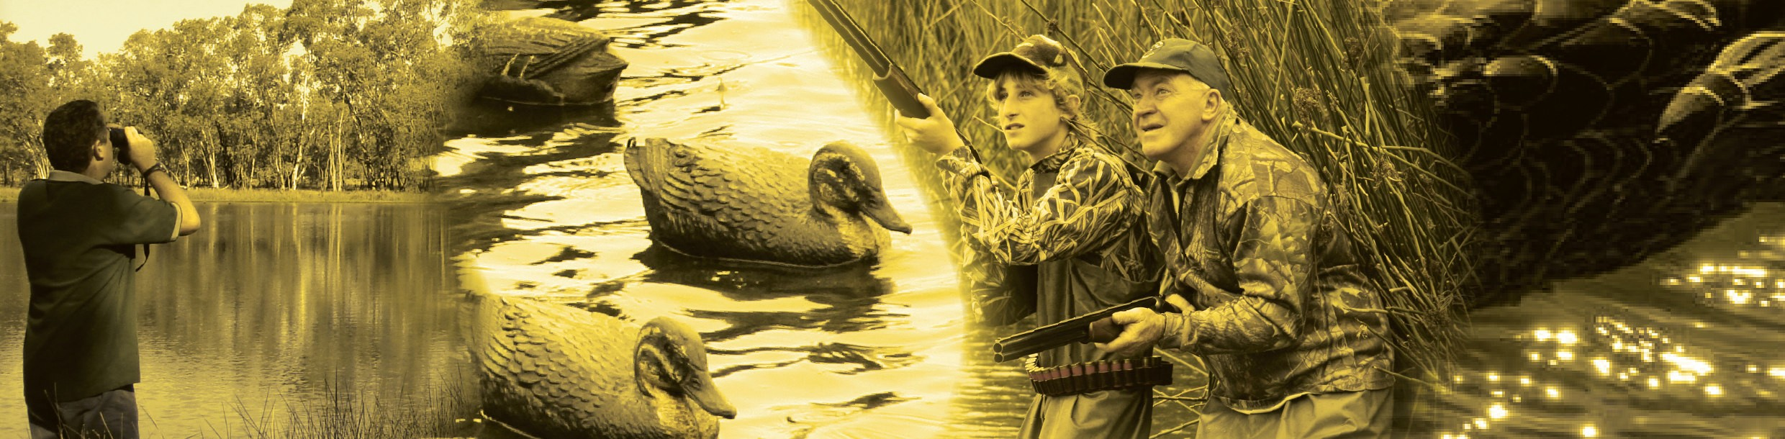

Arthur Rylah Institute for Environmental Research Department of Sustainability and Environment Heidelberg, Victoria

Report produced by: Arthur Rylah Institute for Environmental Research
Department of Sustainability and Environment PO Box 137
Heidelberg, Victoria 3084
Phone (03) 9450 8600
Website: www.dse.vic.gov.au/ari
© State of Victoria, Department of Sustainability and Environment 2009
This publication is copyright. Apart from fair dealing for the purposes of private study, research, criticism or review as permitted under the Copyright Act 1968, no part may be reproduced, copied, transmitted in any form or by any means (electronic, mechanical or graphic) without the prior written permission of the State of Victoria, Department of Sustainability and Environment. All requests and enquiries should be directed to the Customer Service Centre, 136 186 or email customer.service@dse.vic.gov.au
Citation: Gormley, A.M. and Turnbull, J.D. (2009) Estimates of harvest for deer, duck and quail in Victoria: results from surveys of Victorian game licence holders in 2009. Arthur Rylah Institute for Environmental Research Technical Report Series No. 196. Department of Sustainability and Environment, Heidelberg, Victoria

ISSN 1835-3827 (print)
ISSN 1835-3835 (online)
ISBN 978-1-74242-333-3 (print)
ISBN 978-1-74242-334-0 (online)
Disclaimer: This publication may be of assistance to you but the State of Victoria and its employees do not guarantee that the publication is without flaw of any kind or is wholly appropriate for your particular purposes and therefore disclaims all liability for any error, loss or other consequence which may arise from you relying on any information in this publication.
Front cover photo: Enhancing Game Management Initiative, Game Management Unit, DSE.
Authorised by: Victorian Government, Melbourne
Printed by: NMIT Printroom, 77-91 St Georges Road, Preston 3072

Contents
List of tables and figures iv
Acknowledgements vi
Summary 1
- Introduction 2
- Methods 3
  - General methodology 3
  - Deer 3
  - Duck 4
  - Quail 4
- Results 5
  - Deer 5
  - Duck 11
  - Quail 15
- Discussion 18
  - Deer 18
  - Duck 18
  - Quail 18
  - General 19
References 21
Appendix 1 22

List of tables and figures

List of tables
Table 1: Summary of responses for deer surveys 5
Table 2: Proportion and corresponding total number of deer licence holders that hunted, for each survey period 5
Table 3: Average harvest of deer per hunter (Game Licence holders that hunted), for each survey period. 6
Table 4: Estimates of the total deer harvest in Victoria from July 2008 until June 2009, by 16,193 holders of a Deer Game Licence 6
Table 5: Estimated harvest of deer per Game Licence holder in each survey period. 6
Table 6: The number of each deer species reported to be harvested by hunters, and estimated total 2009 harvest 7
Table 7: Reported numbers and percentages of each sex of deer species taken. Standards Errors for the percentages are shown in parentheses 8
Table 8: Days hunted per Game Licence holder 9
Table 9: Percentage of days hunted and associated deer harvest for various land types 9
Table 10: Percentage of days hunted and associated deer harvest for hunting methods 9
Table 11: Summary of responses for duck surveys in 2009. 11
Table 12: Proportion, and corresponding total number of Game Licence holders that hunted, for each survey period. 11
Table 13: Average harvest of ducks per hunter (i.e. Game Licence holders that hunted), for each survey period 12
Table 14: Estimates of the duck harvest in Victoria in 2009 by 20,030 holders of a Duck Game License 12
Table 15: Estimated harvest of ducks per Game Licence holder in each survey period. 12
Table 16: Reported numbers from hunters, proportion of the total harvest, and estimated total 2009 harvest for each species 13
Table 17: Days hunted per respondent 13
Table 18: Percentage of days hunted and associated duck harvest for various land types 13
Table 19: Summary of responses for quail surveys 15
Table 20: Proportion of respondents that hunted, and estimated total number of licence holders that hunted, for each survey period. 15
Table 21: Average harvest of quail per hunter (i.e. Game Licence holders that hunted), for each survey period 16
Table 22: Estimates of the quail harvest in Victoria in 2009 by 23,969 licensed quail hunters 16
Table 23: Estimated harvest of quail per Game Licence holder 16
Table 24: Percentage of days hunted and associated quail harvest 17
Table 25: Percentage of days hunted and associated quail harvest per grassland type 17

List of figures
Figure 1: Estimated total deer harvest for each two month survey period, by species. Vertical bars indicate 95% CIs 8
Figure 2: Estimated total deer harvest, by CMA region. Cross-hairs indicate the nearest town to harvest locations from respondents, with larger symbols representing larger reported
harvest 10
Figure 3: Estimated total duck harvest, by CMA region. Cross-hairs indicate the nearest town to harvest locations from respondents, with larger symbols representing larger reported
harvest 14
Figure 4: Estimated total quail harvest, by CMA region. Cross-hairs indicate the nearest town to harvest locations from respondents, with larger symbols representing larger reported
harvest 17

Acknowledgements
We would like to thank all of those Game Licence holders who gave up their time to take part in the survey. Rod Drew and Robert Treble of Field & Game Australia Inc, Game Managers Andrea Brumley and Heath Dunstan, and Zachary Powell and Stewart McGlashan of the Game Management Unit, DSE provided comments on the results. In addition, Rod Drew and Zachary Powell provided many useful comments that improved this report. Richard Loyn provided helpful comments on the duck survey results. Michael Lindeman assisted with the production of the maps of CMA specific harvest estimates.

Summary

A telephone survey of Victorian hunters was conducted during the 2009 hunting seasons for deer, duck and quail to determine the total harvest for each. Game Licence holders for each game type (deer, duck and quail) were randomly sampled and interviewed by telephone at intervals during the respective game seasons. Respondents were asked whether they had hunted or not during the period for which the survey applied and if applicable the number and species of animals harvested. Additional information was obtained on hunting methods and location.

Respondents hunted for approximately eight days on average during the 2008/09 deer hunting season, with an average season harvest of 2.4 deer per Game Licence holder. Based on the total number of Game Licence holders, this corresponds to an estimated 39,418 deer harvested during the 2008/09 deer hunting season in Victoria (95% confidence interval [CI] = 33,299 – 46,661). The most commonly taken species was Sambar Deer, (with an estimated total harvest of 34,368), followed by Fallow Deer, Red Deer and Hog Deer.

On average, respondents hunted for approximately four days during the 2009 duck hunting season, with an average season harvest of 11.1 ducks per Game Licence holder. Based on the total number of Game Licence holders, this corresponds to an estimated 222,302 ducks harvested during the 2009 Duck Hunting Season in Victoria (95% CI = 193,361 – 255,575). The most commonly taken species was Australian Wood Duck, (which comprised 59% of the total harvest), followed by Pacific Black Duck (25%), Grey Teal (9%), Chestnut Teal (6%) and Australian Shelduck (1%).

For quail, the average season harvest was 7.9 quail per Game Licence holder. Based on the total number of Game Licence holders, this corresponds to an estimated 189,155 quail harvested during the 2009 quail hunting season in Victoria (95% CI = 145,329 – 246,199).

The approach used here accounts for the fact that not every holder of a Game Licence will hunt during every survey period. The total number of hunters is estimated for each survey period and combined with the harvest per hunter to derive the total harvest for each survey period.

The methodology of performing phone surveys throughout the season is likely to minimise memory bias and non-response bias compared to the end of year postal survey. However sources of bias will remain due to over- and under-reporting, and the estimates of total harvest must be interpreted with care.

1 Introduction

In order to effectively manage game species, it is important to quantify harvest numbers. The Department of Sustainability and Environment (DSE) in Victoria, conduct a mail survey of 1000 randomly selected Game Licence holders during June each year. There are, however, a number of problems associated with mail surveys, including recall bias, rounding of harvest estimates, and non-response bias (Wright 1978). Due to concerns about the reliability of the harvest estimates from the mail survey, DSE commissioned a series of regular phone surveys to address the issue of recall bias. The three sets of phone surveys were carried out during the various game harvest seasons for deer, duck and quail.

Deer hunting occurs all year round in Victoria. For this report, the 2008/09 Deer Hunting Season has been defined as the 1 July 2008 until 30 June 2009. There are six species of deer able to be hunted in Victoria. Sambar Deer (Cervus unicolour) are able to be hunted all year by stalking; hunting using scent trailing hounds is restricted to 25 April until 30 November. Hunting of Red Deer (Cervus elaphus) is restricted to the months of June and July only. Fallow (Dama dama), Chital (Axis axis) and Rusa (Cervus timorensis) deer are able to be hunted all year. Hog Deer (Axis porcinus) are only permitted to be hunted during April, and are restricted to one male and one female per hunter for the season.

The 2009 Duck Hunting Season lasted seven weeks, from 21 March to 8 May. Five species were permitted to be hunted in 2009: Pacific Black Duck (Anas superciliosa), Australian Wood Duck1 (Chenonetta jubata), Australian Shelduck2 (Tadorna tadornoides), Grey Teal (Anas gracilis) and Chestnut Teal (Anas castanea). The bag limit for the 2009 season was five ducks per hunter per day, but could include only two of any combination of Australia Shelduck, Pacific Black Duck, Grey Teal and Chestnut Teal. These surveys follow from phone surveys performed during the 2005 and 2006 seasons (Barker 2006).

The 2009 Quail Hunting Season lasted 12 weeks, from 4 April to 30 June. The bag limit for the 2009 season was 20 quail per hunter per day, with Stubble Quail (Coturnix pectoralis) the only native species permitted to be hunted. This survey follows similar phone surveys performed during the 2008 season (Gormley 2009).

- Australian Wood Duck is also referred to as Wood Duck, Maned Duck, and Maned Goose.
- Australian Shelduck is often referred to as Mountain Duck.

Methods

General methodology
A consistent methodology was used to derive estimates of deer, duck and quail harvest. All surveys were conducted by telephone survey company Marketing Skill on behalf of DSE. Estimates of total harvest were based on the reported hunting activities of the survey respondents.

For each game type, a series of surveys was performed throughout the corresponding season. Each survey involved contacting a random sample of Game Licence holders and asking them to report their hunting activities only for the period covered by that survey. Therefore, although a respondent3 may have hunted during the period covered by Survey 2, if they were contacted as part of Survey 3, then information was only collected that pertained to the period covered by Survey 3.

The information from the respondents was used as an estimate of the whole population of Game Licence holders for each game type. Estimates of harvest were determined for each of the survey periods and summed to give an estimate of the total season harvest. For each survey period, the proportion of respondents that hunted was used as an estimate of the proportion of Game Licence holders that hunted. The proportion of Game Licence holders that hunted during each survey period was multiplied by the total number of Game Licence holders to give the total number of hunters for that survey period.
For each survey period, the average harvest per hunter4 was estimated from the total reported harvest divided by the number of respondents that hunted. The total harvest for each survey period was estimated by multiplying the average harvest per hunter by the total number of hunters for that survey period, as estimated previously. Finally, the total season harvest was estimated as the sum of the survey specific total harvests.

Also estimated was the total season harvest per Game Licence holder. For each survey period the average harvest per survey respondent was estimated by multiplying the average harvest per hunter by the proportion of respondents that hunted. The sum of these estimates across the season provided an estimate of the total season harvest per Game Licence holder.

Respondents that hunted were also asked to provide information on whether hunting was carried out on private land or public land (including state game reserves), the name of the town nearest to where they hunted, and the number of days they hunted. Regional harvest estimates were calculated by summing the reported harvest for each nearest town and then aggregating these by the corresponding Victorian Catchment Management Authority (CMA).

There were differences in the number and length of surveys between the duck, deer and quail surveys, as indicated below. Additional details of the methods, as well as examples of the calculations, are provided in Appendix 1.

Deer
Samples were drawn from a total of 16,193 hunters that held a Game Licence to harvest deer. Random samples of hunters were phoned every two months over the 12-month period to give a total of six surveys. Respondents were asked to report the number and sex of each species taken.

- Respondent refers to Game Licence holders that were contacted and agreed to take part in the survey.

- Hunter refers to a Game Licence holder who actually went out and hunted (successfully or unsuccessfully) at some point during the period with which the survey is concerned.

During the first two surveys, enough Game Licence holders were interviewed so as to obtain 200 people who had hunted in the corresponding survey period. For the last four surveys, 200 respondents were interviewed regardless of whether they had hunted or not. Respondents were also asked the hunting method used (stalking, scent dogs, gun dogs).

Duck
Samples were drawn from a total of 20,030 hunters who held a Game Licence to harvest ducks during the 2009 season. A random sample of 200 licence holders was interviewed by phone immediately after opening weekend (Duck Survey 1) followed by independent random samples of licence holders at two-week intervals for the remainder of the duck season (Duck Survey 2 – 4). Respondents were also asked to report the number of each species taken. Unfortunately for opening weekend, respondents were only asked for the species shot, and the total number of ducks, but not the number of each species. Nevertheless, the proportion of each species taken was estimated from the remaining surveys.

Quail
Samples were drawn from a total of 23,969 hunters who held a Game Licence to harvest quail during the 2009 season. A random sample of 200 licence holders was interviewed by phone immediately after opening weekend (Quail Survey 1) followed by independent random samples of 200 licence holders at two-week intervals for the next two surveys (Quail Surveys 2 and 3). For the last three surveys (Quail Surveys 4 – 6), the sample size was increased to 300 licence holders per survey. Respondents were asked to report the number of Stubble Quail taken, the type of grassland where hunting took place (native or stubble) and whether dogs were used to assist in the hunt.

Results

Deer
In order to achieve the required sample size, a higher number of hunters were contacted. On average, 95% of those contacted were willing to take part in the survey (Table 1). Note that Deer Surveys 1, 2 and 6 had 552, 600 and 210 respondents respectively rather than 200. The different number of respondents however makes no difference to the derived estimates as they are calculated on a per hunter basis.

Table 1: Summary of responses for deer surveys.

Deer Survey

Period
Number contacted

Respondents
Response rate
Respondents who hunted
Days hunted
Deer harvested

1 Jul–Aug 2008 572 552 97% 200 953 348
2 Sep–Oct 2008 623 600 96% 200 835 316
3 Nov–Dec 2008 205 200 98% 46 156 39
4 Jan–Feb 2009 227 200 88% 30 100 18
5 Mar–Apr 2009 205 200 98% 57 248 87
6 May–Jun 2009 212 210 99% 38 443 117
Response rate is the proportion of people who were contacted that agreed to take part. Days hunted indicates the combined number of days that were hunted and Deer harvested indicates total deer harvested respectively by respondents within each survey period.

The proportion of Game Licence holders that hunted in each survey period varied throughout the season (Table 2). An estimated 36% of Deer Game Licence holders hunted at some point during July–August 2008, dropping to a low of 15% during January–February 2009. These percentages correspond to 5867 hunters in the July–August period, down to 2,429 hunters in the January– February period (Table 2).

Table 2: Proportion and corresponding total number of deer licence holders that hunted, for each survey period.
95% CI Total 95% CI

Period | Proportion | SE | Lower | Upper | Hunters | SE | Lower | Upper
Jul–Aug 2008 | 0.36 | 0.020 | 0.32 | 0.40 | 5867 | 331 | 5253 | 6553
Sep–Oct 2008 | 0.33 | 0.019 | 0.30 | 0.37 | 5398 | 312 | 4821 | 6044
Nov–Dec 2008 | 0.23 | 0.030 | 0.18 | 0.30 | 3724 | 482 | 2893 | 4794
Jan–Feb 2009 | 0.15 | 0.025 | 0.11 | 0.21 | 2429 | 409 | 1750 | 3371
Mar–Apr 2009 | 0.29 | 0.032 | 0.23 | 0.35 | 4615 | 517 | 3708 | 5744
May–Jun 2009 | 0.32 | 0.032 | 0.27 | 0.39 | 5243 | 523 | 4315 | 6372

The average number of deer per hunter (i.e. per Game Licence holder that hunted) varied from a high of 1.74 deer per hunter during July–August 2008, down to 0.67 in January–February 2009 (Table 3).

Table 3: Average harvest of deer per hunter (Game Licence holders that hunted), for each survey period.
95% CI

Period | Average | SE | Lower | Upper
Jul–Aug 2008 | 1.74 | 0.20 | 1.38 | 2.18
Sep–Oct 2008 | 1.58 | 0.18 | 1.27 | 1.96
Nov–Dec 2008 | 0.85 | 0.25 | 0.48 | 1.50
Jan–Feb 2009 | 0.60 | 0.21 | 0.31 | 1.15
Mar–Apr 2009 | 1.53 | 0.42 | 0.89 | 2.60
May–Jun 2009 | 1.72 | 0.28 | 1.26 | 2.35
Average harvest per hunter = Deer harvested divided by Respondents who hunted, from Table 1.

There were an estimated 39,418 deer harvested by all Deer Game Licence holders from July 2008 through June 2009 inclusive (95% CI = 33,299 – 46,661; Table 4). Harvest was greatest in the winter months and lowest in the summer months.

Table 4: Estimates of the total deer harvest in Victoria from July 2008 until June 2009, by 16,193 holders of a Deer Game Licence.
95% CI

Total  Survey SE  harvest |  | Lower | Upper
Jul–Aug 2008 1 | 0,209 1,319 | 7,933 | 13,137
Sep–Oct 2008 8 | ,528 1,066 | 6,680 | 10,888
Nov–Dec 2008 3 | ,158 1,022 | 1,700 | 5,865
Jan–Feb 2009 1 | ,457 557 | 706 | 3,009
Mar–Apr 2009 7 | ,044 2,103 | 3,972 | 12,491
May–Jun 2009 9 | ,022 1,700 | 6,255 | 13,013
Total Season 39,418 3,399 |  | 33,299 | 46,661
Total harvest = Harvest per hunter (Table 3) × Total hunters (Table 2). Numbers may differ slightly due to
rounding of Harvest per hunter.

The total average season harvest was 2.43 deer per Game Licence holder (95% CI = 2.06 – 2.88; Table 5). Note that for each survey period, the average deer harvest per licence holder is much lower than the average deer harvest per hunter, as the former includes those respondents that did not hunt during the survey period.

Table 5: Estimated harvest of deer per Game Licence holder in each survey period.
95% CI

Period | Average | SE | Lower | Upper
Jul–Aug 2008 | 0.63 | 0.08 | 0.49 | 0.81
Sep–Oct 2008 | 0.53 | 0.07 | 0.41 | 0.67
Nov–Dec 2008 | 0.20 | 0.06 | 0.10 | 0.36
Jan–Feb 2009 | 0.09 | 0.03 | 0.04 | 0.19
Mar–Apr 2009 | 0.44 | 0.13 | 0.25 | 0.77
May–Jun 2009 | 0.56 | 0.11 | 0.39 | 0.80
Total Season | 2.43 | 0.21 | 2.06 | 2.88
Average harvest per Game Licence holder = Deer harvested divided by Respondents, from Table 1.

Separate harvest estimates for each species were derived, however estimates of Hog Deer and Red Deer were based on only a few records and therefore should be viewed with caution (Table 6). Note that the first two survey periods were based on 200 respondents that had hunted, whereas the remaining four were from 200 respondents, of which only a proportion had hunted.

Table 6: The number of each deer species reported to be harvested by hunters, and estimated total 2009 harvest.
    - Sambar Deer

 |  |  |  | 95% CI
Period | Reported | Total harvest | Lower |  | Upper
Jul–Aug 2008 | 322 | 9,446 | 7,251 |  | 12,305
Sep–Oct 2008 | 282 | 7,611 | 5,848 |  | 9,904
Nov–Dec 2008 | 37 | 2,996 | 1,570 |  | 5,715
Jan–Feb 2009 | 12 | 972 | 370 |  | 2,553
Mar–Apr 2009 | 81 | 6,558 | 3,681 |  | 11,685
May–Jun 2009 | 88 | 6,786 | 4,468 |  | 10,305
Annual Total |  | 34,368 | 28,701 |  | 41,154
b. Fallow Deer
 |  |  |  | 95% CI
Period | Reported | Total harvest | Lower |  | Upper
Jul–Aug 2008 | 23 | 675 | 315 |  | 1,445
Sep–Oct 2008 | 27 | 729 | 395 |  | 1,343
Nov–Dec 2008 | 2 | 162 | 35 |  | 756
Jan–Feb 2009 | 4 | 324 | 113 |  | 924
Mar–Apr 2009 | 5 | 405 | 153 |  | 1,071
May–Jun 2009 | 26 | 2,005 | 1,040 |  | 3,866
Annual Total |  | 4,299 | 2,939 |  | 6,287
c. Hog Deer
 |  |  |  | 95% CI
Period | Reported | Total harvest | Lower |  | Upper
Jul–Aug 2008 | 0 | NA | NA |  | NA
Sep–Oct 2008 | 0 | NA | NA |  | NA
Nov–Dec 2008 | 0 | NA | NA |  | NA
Jan–Feb 2009 | 0 | NA | NA |  | NA
Mar–Apr 2009 | 1 | 81 | 16 |  | 417
May–Jun 2009 | 0 | NA | NA |  | NA
Annual Total |  | 81 | 16 |  | 417
*NB: Hog Deer are only permitted to be hunted during April.

d. Red Deer
95% CI

Period | Reported | Total harvest | Lower | Upper
Jul–Aug 2008 | 3 | 88 | 31 | 252
Sep–Oct 2008 | 7* | 189 | 73 | 490
Nov–Dec 2008 | 0 | 0 | NA | NA
Jan–Feb 2009 | 2* | 162 | 31 | 841
Mar–Apr 2009 | 0 | 0 | NA | NA
May–Jun 2009 | 3 | 231 | 46 | 1,175
Annual Total |  | 670 | 288 | 1,562
*NB: Red Deer are only permitted to be hunted in June and July

14000

12000

Sambar Fallow Hog Red

10000

8000
Deer Harvest

6000

4000

2000

0

July/Aug 08 Sep/Oct 08 Nov/Dec 08 Jan/Feb 09 Mar/Apr 09 May/Jun 09

Period

Figure 1: Estimated total deer harvest for each two month survey period, by species. Vertical bars indicate 95% CIs.

For Sambar Deer, a higher proportion of stags (52%) were taken compared to hinds (43%; Table 7). For Fallow Deer, a higher proportion of hinds (57%) were taken compared to stags (34%). For Red Deer and Hog Deer, the reported numbers were too small to make any conclusions in terms of sex specific harvest.

Table 7: Reported numbers and percentages of each sex of deer species taken. Standards Errors for the percentages are shown in parentheses.

Species | n | Stags  % (SE) | n | Hinds  % (SE) | Can’t n | Recall/Unsure  % (SE)
Sambar Deer | 423 | 51.5% (1.7) | 351 | 42.7% (1.7) | 48 | 5.8% (0.8)
Fallow Deer | 30 | 34.5% (5.1) | 50 | 57.5% (5.3) | 7 | 8.0% (2.9)
Hog Deer | 1 | NA | 0 | NA | 0 | NA
Red Deer | 7 | 46.7% (12.9) | 6 | 40.0% (12.6) | 2 | 13.3% (8.8)

The number of days hunted in each survey period varied throughout the season. On average each deer licence holder hunted on approximately 7.75 days in total during the 2008/09 deer hunting season, corresponding to a total of 125,458 hunter days (95% CI = 112,916 – 139,392; Table 8).

Table 8: Days hunted per Game Licence holder

95% CI

Period | Av | SE | Lower | Upper
Jul–Aug 2008 | 1.73 | 0.13
Sep–Oct 2008 | 1.39 | 0.11
Nov–Dec 2008 | 0.78 | 0.14
Jan–Feb 2009 | 0.50 | 0.10
Mar–Apr 2009 | 1.24 | 0.19
May–Jun 2009 | 2.11 | 0.28
Total days per respondent | 7.75 | 0.42 | 6.97 | 8.61
Total hunting days | 125,458 | 6,746 | 112,916 | 139,392
NB: 95% CIs were only calculated for total days

More deer hunting was carried out on public land (64.7%) than on private land (25.3%), with similar proportions of harvested deer (Table 9).

Table 9: Percentage of days hunted and associated deer harvest for various land types.

Land Type | Days | Deer
Private Land | 25.3% | 22.1%
Public Land | 64.7% | 67.9%
Both | 10.0% | 10.0%

Stalking was the preferred hunting method, used in 53% of the hunting days compared to 36% for scent hounds. Hunting by stalking was the most productive method, accounting for 76% of the reported harvest (Table 10).

Table 10: Percentage of days hunted and associated deer harvest for hunting methods.

Hunting Method | Days | Deer
Gundogs | 2.6% | 2.1%
Scent hounds | 36.3% | 17.3%
Stalking | 53.4% | 76.0%
Misc dogs (not specified) | 4.3% | 2.1%
Other 3.4% 2.6%

Total harvest was estimated to be greatest in the Goulburn Broken CMA region, followed by the Northeast, West Gippsland and East Gippsland CMA regions (Figure 3).

MALLEE

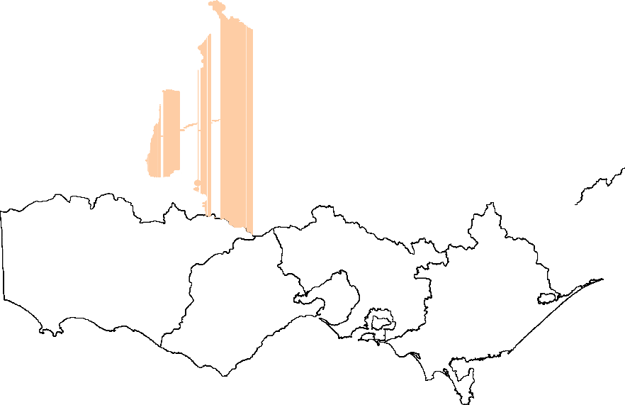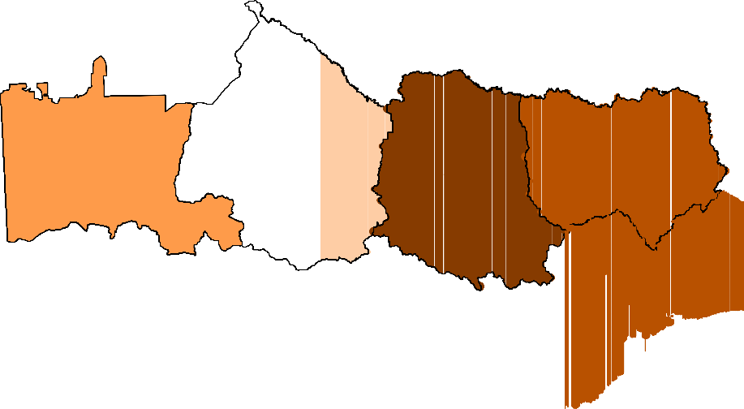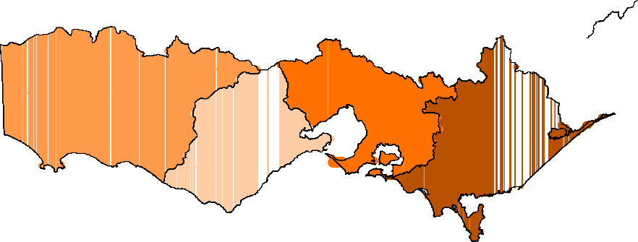Estimated Deer Harvest 0
1 - 500
501 - 1500
1501 - 5000
5001 - 10000
10001 - 15000

WIMMERA

NORTH CENTRAL

GOULBURN BROKEN ð
ð
ð ð
ð ð ð

ð
ð ð ð

NORTH EAST ð
ð

ð ð ð
ð ðð ð ð

ð ð ð
ð
ð
ð ð ð ð ð
ð
ð
ð
ð
ð
ð ð ð
ð ð ð ð ð
ð
ð

ð
ð ð
ð ð
ð
EAST GIPPSLAND
ð ð

ð ð
ð
ð PORT PHILLIP AND ð ð
ð WESTERNPORT
ð ð
ð ð
ð
ð
ð ð
ð ð
ð
ð ð ð

GLENELG HOPKINS
CORANGAMIT E

ð
ð ð ð ð ð
ð ð ð
ð
ð
ð
ð

WEST GIPPSLAND
ð ð
ð

Figure 2: Estimated total deer harvest, by CMA region. Cross-hairs indicate the nearest town to harvest locations from respondents, with larger symbols representing larger reported harvest.

Duck
In order to achieve a sample size of 200 respondents per survey, a slightly higher number of hunters were contacted, with on average 98% of those contacted being willing to take part in the survey (Table 11). Note that Duck Survey 1 had 237 respondents rather than 200; however, this difference does not affect the derived harvest estimates as they are calculated on a per hunter basis.

Table 11: Summary of responses for duck surveys in 2009.

Duck Survey
Response rate
Respondents who hunted
Days hunted
Ducks harvested

1 99% 114 196 508
Nu Period  con | mber  Respondents tacted
21 Mar–22 Mar 239 237
23 Mar–5 Apr 205 200
6 Apr–19 Apr 206 200
20 Apr–8 May 202 200

2 98% 100 246 713
3 97% 77 218 624
4 99% 54 166 456
Response rate is the proportion of people who were contacted that agreed to take part. Days hunted indicates the combined number of days that were hunted and Ducks harvested indicates total ducks harvested respectively by the respondents, within each survey period.

The proportion of Game Licence holders that hunted in each survey period varied throughout the season: 48% of licence holders hunted during opening weekend, corresponding to approximately 9,600 hunters (Table 12). The proportion that hunted during other survey periods varied from 27% to 50%, corresponding to between 5,400 and 10,000 duck hunters respectively (Table 12).

Table 12: Proportion, and corresponding total number of Game Licence holders that hunted, for each survey period.
95% CI Total 95% CI

Period | Proportion | SE | Lower | Upper | Hunters | SE | Lower | Upper
1. 21 Mar–22 Mar | 0.48 | 0.033 | 0.42 | 0.48 | 9,653 | 650 | 8,442 | 10,995
2. 23 Mar–5 Apr | 0.50 | 0.035 | 0.43 | 0.50 | 10,015 | 708 | 8,720 | 11,502
3. 6 Apr–19 Apr | 0.39 | 0.034 | 0.32 | 0.39 | 7,712 | 689 | 6,475 | 9,185
4. 20 Apr–8 May | 0.27 | 0.031 | 0.21 | 0.27 | 5,408 | 629 | 4,309 | 6,787

The average number of ducks per hunter (i.e. per Game Licence holder that hunted) varied throughout the season (Table 13). The average harvest per hunter was 4.46 ducks on opening weekend, and ranged from 7.13 to 8.44 for the other survey periods. It is important to note that these figures are not directly comparable, as each duck survey covers a different number of days, ranging from two days for Survey 1 (Opening Weekend) to 19 days for Survey 4 (20 April to 8 May).

Table 13: Average harvest of ducks per hunter (i.e. Game Licence holders that hunted), for each survey period.
95% CI

Period | Average | SE | Lower | Upper
1. 21 Mar–22 Mar | 4.46 | 0.300 | 3.90 | 5.08
2. 23 Mar–5 Apr | 7.13 | 0.831 | 5.66 | 8.93
3. 6 Apr–19 Apr | 8.10 | 0.940 | 6.46 | 10.17
4. 20 Apr–8 May | 8.44 | 0.972 | 6.74 | 10.57
Average harvest per hunter = Ducks harvested divided by Respondents who hunted, from Table 11.

There were an estimated total of 42,934 ducks harvested during opening weekend (95% CI 35,629
– 51,736). The total season harvest estimate was 222,302 (95% CI = 193,361 to 255,575; Table
14).

Table 14: Estimates of the duck harvest in Victoria in 2009 by 20,030 holders of a Duck Game License.

Period
Total
SE
Harvest |  |  | Lower | Upper
1. 21 Mar–22 Mar | 42,934 | 4095 | 35,629 | 51,736
2. 23 Mar–5 Apr | 71,207 | 9724 | 54,552 | 92,946
3. 6 Apr–19 Apr | 62,494 | 9152 | 46,972 | 83,144
4. 20 Apr–8 May | 45,668 | 7470 | 33,212 | 62,797
Total Season | 222,302 | 15,840 | 193,361 | 255,575

95% CI

Total harvest = Harvest per hunter (Table 13) × Total hunters (Table 12).

The total average season harvest per licence holder was estimated to be 11.10 (95% CI = 9.65 – 12.76; Table 15). Note that for each survey period, the average duck harvest per Game Licence holder is lower than the average duck harvest per hunter, as the former includes those respondents that did not hunt during the survey period, whereas the latter is conditional on those that hunted.

Table 15: Estimated harvest of ducks per Game Licence holder in each survey period.
95% CI

Period | Average | SE | Lower | Upper
1. 21 Mar–22 Mar | 2.14 | 0.204 | 1.78 | 2.58
2. 23 Mar–5 Apr | 3.56 | 0.485 | 2.72 | 4.64
3. 6 Apr–19 Apr | 3.12 | 0.457 | 2.35 | 4.15
4. 20 Apr–8 May | 2.28 | 0.373 | 1.66 | 3.14
Total Season | 11.10 | 0.79 | 9.65 | 12.76
Average harvest per Game Licence holder = Ducks harvested divided by Respondents, from Table 11.

The percentage of total harvest for each species was estimated from information collected in surveys 2, 3 and 4. Australian Wood Duck comprised 59% of the total reported harvest, followed by Pacific Black Duck (25%), Grey Teal (9%), Chestnut Teal (6%) and Australian Shelduck (1%). Total harvest estimates for each species were obtained by multiplying the total estimated duck harvest by the percentages of total harvest for that species (Table 16).

Table 16: Reported numbers from hunters, proportion of the total harvest, and estimated total 2009 harvest for each species.
95% CI

Reported Proportion Species  of harvest | SE Estimated  SE  Harvest | Lower | Upper
Pacific Black Duck 406 0.25 | 0.011 55,150 4589 | 46,864 | 64,901
Australian Wood Duck 905 0.59 | 0.012 131,084 9718 | 113,377 | 151,555
Australian Shelduck 16 0.01 | 0.002 2173 562 | 1,320 | 3,580
Grey Teal 154 0.09 | 0.007 20,919 2189 | 17,049 | 25,668
Chestnut Teal 97 0.06 | 0.006 13,176 1601 | 10,393 | 16,706

On average each Game Licence holder hunted on approximately four days in total during the 2009 duck hunting season (Table 17). When multiplied by the total number of Game Licence holders, this corresponds to a total of 76,659 hunter days (95% CI = 70,888 – 89,516).

Table 17: Days hunted per respondent

95% CI

Period | Average | SE | Lower | Upper
1. 21 Mar–22 Mar | 0.83 | 0.07
2. 23 Mar–5 Apr | 1.23 | 0.13
3. 6 Apr–19 Apr | 1.09 | 0.14
4. 20 Apr–8 May | 0.83 | 0.13
Total per respondent | 3.98 | 0.24 | 3.54 | 4.47
Total hunting days | 76,659 | 4,745 | 70,888 | 89,516
NB: 95% CIs were only calculated for total days

More duck hunting was carried out on private land (57.4%) than on public land (42.1%), with a minor amount in State Game Reserves (0.5%). Total harvest was estimated to be greatest in the North Central and Goulburn Broken CMA regions (Figure 3).

Table 18: Percentage of days hunted and associated duck harvest for various land types.

Land Type | Days | Duck harvest
Private Land | 57.4% | 59.8%
Public Land | 42.1% | 40.0%
State Game Reserves | 0.5% | 0.2%

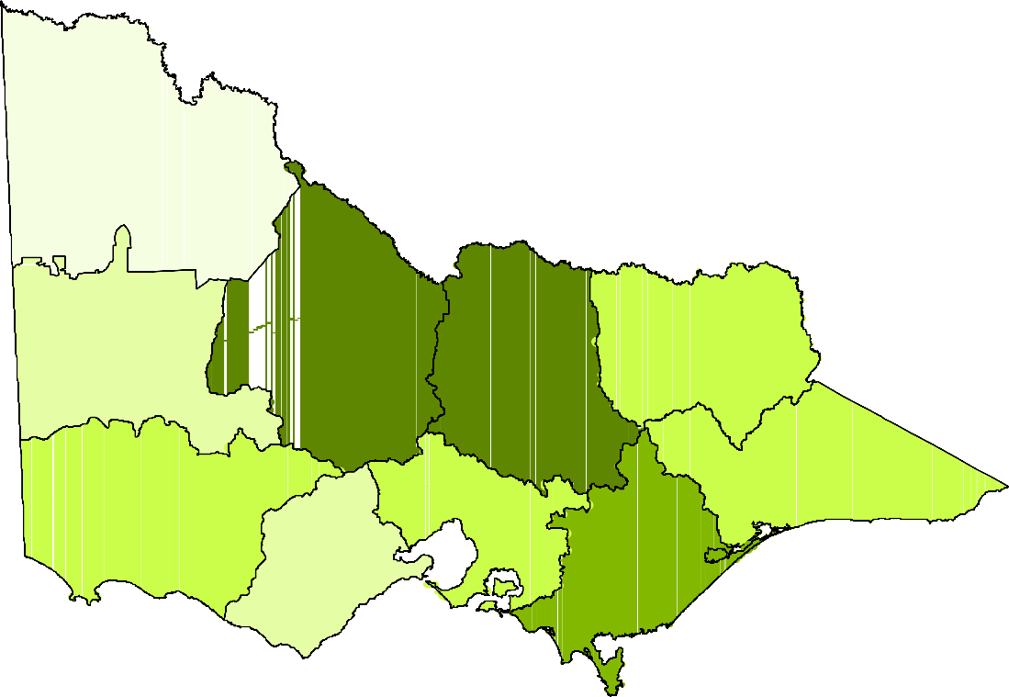Estimated Duck Harvest

ð ð 0 - 5000

5001 - 10000
10001 - 20000
20001 - 30000
30001 - 40000
40001 - 60000
MALLEE

ð

ð
ð
ðð

ð ðð

ð ð
ð ð ð
ð
ð ð ð ð ð
ð
ð ðð ð
ð
ð ð
ð
ð ðð ð ð

WIMMER A
NORTH CENTRAL ð ð ð
ð ð ð
ð
ð

ð NORTH EAST

ð ð ð
ð ð ð ð ð

GOULBURN BR OKEN
ð ð
ð ð
ð

ð ð
ð
ð

ð ð

ð ð
ð
ð
ð ð
ð ðð ð ð
ð
ð ð ð ð

ð
ð

ð

EAST GIPPSLAND
ð ð
ð

ð ð ð
GLEN ELG HOPKINS

ð
PORT PHILLIP AND
WESTEðRNPORT ð
ð ð
ð

ð ð
ð
ð WEST GIPPSLAND
ð
ð ð ð
ð ð
ð

ð
ð
ð
ð ð ð
CORANGAMITE
ð
ðð ð
ð ð ð ð
ð
ð
ð ð ð
ð
ð ð ð
ð
ðð ð ð

ð

Figure 3: Estimated total duck harvest, by CMA region. Cross-hairs indicate the nearest town to harvest locations from respondents, with larger symbols representing larger reported harvest.

Quail
In order to achieve the required sample size of respondents, a slightly higher number of hunters were contacted, with on average 98% of those contacted being willing to take part in the survey (Table 19). Note that the first three Quail surveys had 200 respondents each, which was increased to 300 for the last three surveys. However, this makes no difference to the derived harvest estimates as they are calculated on a per hunter basis.

Table 19: Summary of responses for quail surveys.
Quail Survey
Nu Period  con | mber  Respondents tacted
4 Apr–19 Apr | 204 200
20 Apr–3 May | 201 200
4 May–17 May | 208 200
18 May–31 May | 305 300
1 Jun–14 Jun | 300 300
15 Jun–30 Jun | 308 300

Response rate

Respondents who hunted

Days hunted

Quail harvested

1 98% 26 55 397
2 99% 22 42 234
3 96% 19 26 166
4 98% 27 49 547
5 100% 18 37 355
6 97% 20 38 270
Response rate is the proportion of people who were contacted that agreed to take part. Days hunted indicates the combined number of days that were hunted and Quail harvested indicates the total quail harvested respectively by respondents within each survey period.

The proportion of Game Licence holders that hunted in each survey period was generally low, varying throughout the season ranging from between 6% to 13%. These percentages correspond to between 1,438 to 3,116 hunters in any two-week period (Table 20).

Table 20: Proportion of respondents that hunted, and estimated total number of licence holders that hunted, for each survey period.
95% CI Total 95% CI

Period | Proportion | SE | Lower | Upper | Hunters | SE | Lower | Upper
4 Apr–19 Apr | 0.13 | 0.025 | 0.09 | 0.19 | 3,116 | 570 | 2,184 | 4,447
20 Apr–3 May | 0.11 | 0.022 | 0.07 | 0.16 | 2,637 | 530 | 1,785 | 3,895
4 May–17 May | 0.10 | 0.021 | 0.06 | 0.14 | 2,277 | 497 | 1,492 | 3,475
18 May–31 May | 0.09 | 0.017 | 0.06 | 0.13 | 2,157 | 396 | 1,510 | 3,082
1 Jun–14 Jun | 0.06 | 0.014 | 0.04 | 0.09 | 1,438 | 329 | 9,24 | 2,238
15 Jun–30 Jun | 0.07 | 0.014 | 0.04 | 0.10 | 1,598 | 345 | 1,051 | 2,429

The average number of quail per hunter (i.e. per Game Licence holder that hunted) varied throughout the season (Table 21). The average harvest per hunter was as low as 8.74 quail during survey 3, up to 20.26 quail in survey 4. It is important to note that these figures are not directly comparable, as the first and sixth quail survey both cover 16 days while the other surveys cover 14 days.

Table 21: Average harvest of quail per hunter (i.e. Game Licence holders that hunted), for each survey period.
95% CI

Period | Average | SE | Lower | Upper
4 Apr–19 Apr | 15.27 | 4.60 | 8.57 | 27.22
20 Apr–3 May | 10.64 | 2.20 | 7.12 | 15.88
4 May–17 May | 8.74 | 1.95 | 5.67 | 13.45
18 May–31 May | 20.26 | 3.63 | 14.30 | 28.70
1 Jun–14 Jun | 19.72 | 5.00 | 12.09 | 32.17
15 Jun–30 Jun | 13.50 | 3.21 | 8.53 | 21.37
Average harvest per hunter = Quail harvested divided by Respondents who hunted, from Table 19.

There were an estimated 189,155 quail harvested by all holders of a Game Licence for quail during the 2009 quail season (95% CI = 145,329 to 246,199; Table 22).

Table 22: Estimates of the quail harvest in Victoria in 2009 by 23,969 licensed quail hunters.
95% CI

Tot Period  Harv | al  SE  est | Lower | Upper
4 Apr–19 Apr 47,5 | 78 16,779 | 24,320 | 93,078
20 Apr–3 May 28,0 | 44 8,088 | 16,115 | 48,803
4 May–17 May 19,8 | 94 6,207 | 10,947 | 36,153
18 May–31 May 43,7 | 03 11,211 | 26,646 | 71,680
1 Jun–14 Jun 28,3 | 63 9,683 | 14,796 | 54,371
15 Jun–30 Jun 21,5 | 72 6,929 | 11,673 | 39,867
Total Season 189,1 | 55 25,552 | 145,329 | 246,199
Total harvest = Harvest per hunter (Table 21) × Total hunters (Table 20).

The total average season harvest was 7.89 quail per Game Licence holder (95% CI = 5.96 – 10.45; Table 23). Note that for each survey period, the ‘average quail harvest per Game Licence holder’ is lower than the ‘average quail harvest per hunter’, as the former includes those respondents that did not hunt during the survey period, whereas the latter is conditional on those that hunted.

Table 23: Estimated harvest of quail per Game Licence holder.
95% C.I.

Period | Average | SE | Lower | Upper
4 Apr–19 Apr | 1.99 | 0.70 | 1.01 | 3.88
20 Apr–3 May | 1.17 | 0.34 | 0.67 | 2.04
4 May–17 May | 0.83 | 0.26 | 0.46 | 1.51
18 May–31 May | 1.82 | 0.47 | 1.11 | 2.99
1 Jun–14 Jun | 1.18 | 0.40 | 0.62 | 2.27
15 Jun–30 Jun | 0.90 | 0.29 | 0.49 | 1.66
Total Season | 7.89 | 1.14 | 5.96 | 10.45
Average harvest per licence holder = Quail Harvested divided by Respondents.

Most quail hunting was carried out on private land (94% of the hunting days), resulting in 97.3% of the harvested quail (Table 24). Only a small proportion of hunting was carried out in State Game Reserves (4.9%). Dogs were used to assist in quail hunting approximately 71% of the time. Most quail hunting took place on stubble grasslands, followed by native grasslands, and other

introduced grasslands, with similar proportions of quail (Table 25). The total quail harvest was greatest in the Corangamite CMA region, followed by North Central and Glenelg Hopkins (Figure 4).

Table 24: Percentage of days hunted and associated quail harvest.

 | Days | Quail harvest
a). Private land | 94.2% | 97.3%
b). State game reserves | 4.9% | 3.7%
c). Dogs used | 70.9% | 69.9%

Table 25: Percentage of days hunted and associated quail harvest per grassland type

Grassland | Days | Quail harvest
Introduced grass | 8.6% | 11.3%
Native grass | 20.2% | 21.5%
Stubble | 61.0% | 57.9%
Stubble & native | 7.2% | 5.7%
Stubble, native & introduced | 3.1% | 3.6%

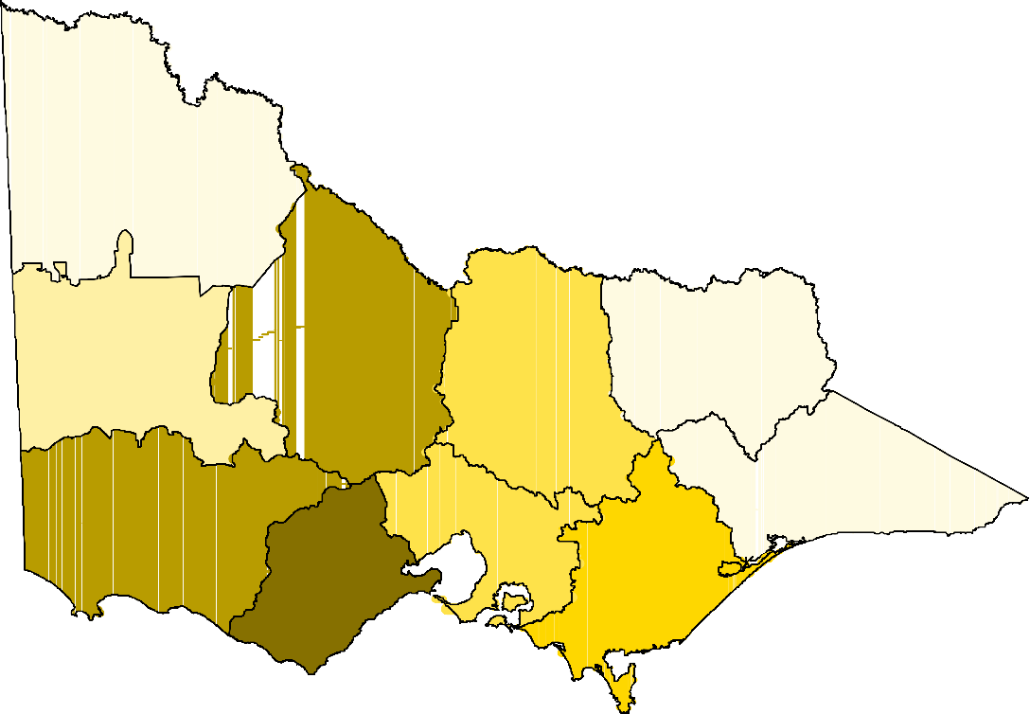Estimated Quail Harvest
 |  | 1 - 5000
 |  | 5001 - 10000
 |  | 10001 - 20000
 |  | 20001 - 30000
 |  | 30001 - 40000
MALLEE |  | 40001 - 50000

ð ð
ð ð
ð
ð ð ð ð ð
WIMMERA NORTH CENTRAL ð

ð ð ð ð
ð ð NORTH EAST

ð ð GOULBURN BROKEN

ð
ð
ð
ð ð
ð
ð
GLENE LG HOPKINS ð ð

EAST GIPPSLAND

ð ð ð
ð
ð
ð ð ð
ð PORT PHILLIPð AND
ð
ð
W ESTE RNPORT
ð

ð
WEST GIPPSLAND

ð ð ð ð
ð ð ð
ð ð ð
ð ð ð

CORANGAMITE ð
ð
ð ð

Figure 4: Estimated total quail harvest, by CMA region. Cross-hairs indicate the nearest town to harvest locations from respondents, with larger symbols representing larger reported harvest.

Discussion

Deer
A total of 39,418 deer were estimated to be harvested in Victoria during the 2008/09 financial year (95% CI = 33,299 – 46,661). The most common deer species harvested was Sambar Deer (34,368), followed by Fallow Deer (4,299). It is difficult to make any inference about the harvest estimates of Red Deer and Hog Deer due to the small numbers of reported harvest from surveyed Game Licence holders. Nevertheless, the actual harvests of Red Deer and Hog Deer are likely to be very small. Hog Deer are heavily regulated and as such the actual numbers of animals taken are recorded through checking stations. For 2009, there was a total harvest of 85 Hog Deer, comprised of 28 hinds and 57 stags. This number excludes animals taken on Sunday Island – a private cooperative. The known harvest of Hog Deer (85) is very similar to the estimated figure (81) providing some validation to the current survey method.

Due to a miscommunication error, the first two deer survey periods had 552 and 600 respondents respectively. Because the harvest estimates are based on the average reported harvest per respondent, these greater numbers do not affect the harvest estimates themselves. However, the consequence of having a greater sample size is that the coefficient of variation (CV = SE/Average) is smaller, resulting in more certainty about the harvest. The CV for the first two periods is 13%, whereas for the last four surveys, it ranges from 19 – 38%. The survey with the highest CV (i.e. greatest amount of uncertainty) was for the January–February 2009 period, due to it being the period with the lowest proportion of licence holders that hunted (15%), and the lowest average deer harvest per hunter (0.67). The uncertainty around the total deer harvest was relatively low with a CV of approximately 9%.

Duck
The results suggest a total harvest of 222,302 ducks in Victoria during the 2009 season (95% CI = 193,361 – 255,575). Estimates of the duck harvest were determined using the same methodology for the 2005 and 2006 season (Barker 2006). As a result the harvest estimate from the 2009 season is directly comparable with those from previous surveys. The total duck harvests from the 2005 and 2006 seasons were 336,629 and 333,172 respectively, compared to an estimate for the 2009 season of 222,302. The lower harvest in 2009 is not surprising given the differences between the seasons. The 2005 and 2006 seasons lasted 12 weeks whereas the 2009 season was for seven weeks. In addition, the bag limit in 2009 was five per hunter per day, compared to seven in 2006. There was however a significant increase in the total days hunted in 2009. Again this is unsurprising in light of the season closure in 2007 and 2008. However, days do not necessarily represent hunting effort, as it is possible that hunters may have hunted for a longer fraction of the day in earlier seasons compared to 2009, giving the same overall hunting time.

Quail
The estimate of the total quail harvest for 2009 is 189,155 (95% CI = 145,329 – 246,199), much greater than the estimate for 2008 of 118,295. This increase is due to a number of reasons. Firstly, the proportion of Game Licence holders that hunted in a two-week period was slightly greater, averaging 8.8% in 2009 compared with 7.6% in 2008. In addition, the average harvest in a two- week period was 14.9 quail per hunter in 2009, up from 11.6 in 2008. These factors combined to give an increase in the total number of quail per licence holder for the season (7.89 in 2009

compared with 5.64 in 2008). Finally, there were a greater number of quail Game Licence holders in 2009 (23,969) compared with 2008 (20,977).

It should be noted that not every holder of a quail Game Licence hunts during the quail season. There are very few Game Licences issued only for quail. Rather, Game Licence holders often add quail in addition to other game species for their licence. A Game Licence to hunt game birds includes quail, and can also include ducks at no additional cost. Similarly, the cost of a Game Licence to hunt deer is the same as the cost of a licence to hunt deer and quail (DSE 2009). For many hunters, duck and deer hunting will be their primary target species. Therefore, a high proportion of Game Licence holders will be permitted to hunt quail, even though they may not have any intention of ever doing so. This situation does not affect the estimates of quail harvest, as the calculations explicitly account for the proportion of quail Game Licence holders that did not actually hunt for quail.

The sample size for quail was increased from 200 to 300 halfway through the season. The primary reason for this was the relatively low numbers of quail Game Licence holders that had hunted, resulting in relative high CVs (32%). Despite the larger sample sizes, the CVs for the second half of the season remained at similar levels to the first, due to an even smaller proportion of Game Licence holders hunting.

General
The estimates of harvest for each game type are derived under the assumption that the samples of respondents are representative of the entire population of Victorian Game Licence holders. This assumption may be violated for a number of reasons. One main reason relates to the grounds for non-response. For example, if some Game Licence holders do not want to take part in the survey due to having exceeded their bag limit, then the estimate of total harvest will be an underestimate of the true harvest. Conversely, if Game Licence holders do not want to take part as they had hunted unsuccessfully, then the estimate of harvest will be an overestimate of the true harvest. Other potential sources of bias are due to memory recall (respondents cannot remember their harvest), as well as over- or under-reporting (reported numbers are knowingly reported incorrectly). Memory bias and non-response bias tend to inflate estimates of total harvest by as much as 40% (Wright 1978, Barker 1991). It is likely, however, that the sampling strategy of telephone interviews after each two-week period in the case of ducks and quail, and every two months for deer, will ensure that both memory bias and non-response bias will be kept low when compared with postal surveys and complete end of season surveys (Barker 1991, Barker et al. 1992). It is worth noting that the response rate for all surveys was generally above 95%. Nevertheless, it is likely that some bias remains, and the estimates of total harvest must be interpreted with care.

It is important to note that the methodology explicitly accounts for the fact that not every Game Licence holder hunts in every survey period, let alone hunts successfully (indeed some Game Licence holders may not hunt at all during the season). This is achieved by estimating the total number of Game Licence holders that hunted in each survey period e.g. there are only between 1500 – 3000 people hunting for quail in any two-week period, out of a potential number of 24,000 quail hunters. Similarly, the estimate of total season bag per Game Licence holder is the sum of the harvest per Game Licence holder, not the sum of the harvest per hunter. For example, the average season bag for deer was estimated as 2.43 deer per Game Licence holder. By comparison, summing the harvest per hunter (from Table 3), there is a total of 8.1 deer: this would be the

average season bag if every holder of a Game Licence for deer hunted in each period, which, of course, is not the case.

The reported uncertainty in the estimates of total harvest for deer, duck and quail is due to two factors. Firstly, there is always going to be variation in the reported numbers of animals shot between respondents that had hunted. For example, within a given survey period for duck hunting, some respondents indicated that they hunted unsuccessfully, whereas others took multiple trips and indicated a total harvest of up to 50 ducks during that period. The second source of uncertainty is due to taking samples of hunters rather than a complete census. However, the degree of sampling uncertainty is reduced by having a sample size of at least 200 respondents per survey. These sources of uncertainty are reflected by the confidence intervals around estimates of total harvest.

A potentially important unreported source of uncertainty is in the number of Game Licence holders for each game type. The number of Game Licence holders for deer, duck and quail was reported as constant for the entire season for each game type. In reality, the number of licence holders will fluctuate throughout the season. These changes were not accounted for in approach used here. It is expected that the analyses of future game seasons will include the number of Game Licence holders in each survey period, and will therefore more accurately reflect the actual harvest numbers.

The spatial distributions of the deer, duck and quail harvest should be interpreted with some degree of care. Grouping the harvest by a relatively large region (CMA) provides a broad scale view of the distribution of harvest. Grouping by smaller regions would provide a finer scale representation, however this would come at a cost of increased bias in many regions. Because the data is from a sample of Game Licence holders rather than a complete census, it is likely that some areas that were actually hunted would be shown as having a zero harvest if no respondents that hunted those areas were contacted. This would be increasingly likely at finer spatial scales. Furthermore, respondents were only asked to report the nearest town to where they hunted, not the actual location. It is therefore possible that the nearest town was in a different CMA than the hunting location.

The methodology used to produce these harvest estimates address some of the issues present in the hunter mail surveys. Repeating these surveys in subsequent years with the same methodology will enable better informed management decisions to be made.

References

Barker, R.J. (1991) Nonresponse to New Zealand waterfowl harvest surveys. Journal of Wildlife Management 55: 126-131.

Barker, R.J. (2006) Survey of waterfowl hunting in Victoria by Victorian licence holders 2006. Report for the Game Management Unit, DSE, Victoria.

Barker, R.J., Geissler, P.H., Hoover, B.A. (1992) Sources of nonresponse to the Federal waterfowl hunter questionnaire. Journal of Wildlife Management 56: 337-343.

Department of Sustainability and Environment (2009). Victorian Hunting Guide 2009. 46pp.

Gormley, A.M. (2009) Survey of Quail Hunting in Victoria by Victorian licence holders 2008. Report for the Game Management Unit, DSE, Victoria. 10pp.

Wright, V.L. (1978) Causes and effects of biases on waterfowl harvest estimates. Journal of Wildlife Management 42: 251-262.

Appendix 1

Common definitions used

SD = standard deviation of the data. Represents the variation in the numbers reported.

SE = standard error of the mean. Represents the variation in the estimate of average harvest per person.

CV =
SE
Average

Coefficient of variation. This provides an indication as to how much uncertainty is in the estimate relative to the mean.

Calculations

For each survey j, we surveyed nj respondents of which hj had hunted. The proportion of respondents that hunted in each period j is given as:

p = h j
j
n j

. e.g. for duck survey 3 we obtain:
77 = 0.385
200

The total number of hunters for each survey period (Hj) was estimated by multiplying the total number of licence holders (L) by the proportion of respondents that reported having hunted during that survey period (pj), as found previously:
H j = p j L . e.g. for duck survey 3 we obtain: 0.385× 20,030 = 7712

The estimated average harvest per hunter (wj) is the total reported harvest for survey j (yj) divided by the total number of respondents that hunted (hj):

y j
w j =
h j

. e.g. for duck survey 3 we obtain:
624
77

= 8.10

The total harvest for each survey period (Wj) was estimated by multiplying the average harvest per hunter (wj) by the total number of hunted (Hj):

W j = w j H j
e.g. for duck survey 3 we obtain: 8.10 × 7712 = 62,494

The estimate of total harvest is calculated as the sum of the estimated harvest for each survey period:

WTOT
= W1 + W2 + W3 + W4

Standard errors for the proportion of respondents that hunted are given as:
p (1 − p )
j j

0.39(0.61)

SE( p j ) =
n j
e.g. for duck survey 3 we obtain:

200
= 0.034

Standard errors for the average harvest per hunter are given as:

SD(w )
j

8.25

SE(w j ) = e.g. for duck survey 3 we obtain:
h j
= 0.94
77

The standard errors for the total estimated harvest per survey period (Wj) is found by determining the CV of pj and wj and then adding their sum of squares to find the combined CV.

CV(w j ) =
SE(w j )
w j
j
j

, and CV( p j ) =
SE( p j )
p j

CV(W j ) =
j
j
(CV(w
))2 + (CV( p
))2

SE(W j
) = CV(W
)×W

The standard error of the total harvest is calculated as:
1
3
2
4

SE(WTOT ) =
(SE(W ))2 + (SE(W
))2 + (SE(W ))2 + (SE(W
))2

Confidence intervals were computed on the natural logarithm scale and back-transformed so as to ensure that lower limits cannot be less than zero. A consequence is that confidence intervals are
asymmetric, and cannot be reported as the estimate plus or minus a fixed value. In general, for

some estimate denoted as

upper limit = Xˆ × r
Xˆ , 95% confidence interval limits were calculated using:

lower limit = Xˆ ÷ r , where:

r = exp (1.96 ln (1+ CV 2 ))

e.g. For the total duck harvest we have

CV =
15,840
222, 302

= 0.071

r = exp (1.96 ln (1+ 0.0712 )) = 1.15

Therefore, Upper and Lower Confidence Intervals are given by:

UL = 222, 302 ×1.15 = 255, 575
LL = 222, 302 ÷1.15 = 193, 361

ISSN 1835-3827 (print)
ISSN 1835-3835 (online)
ISBN 978-1-74242-333-3 (print)
ISBN 978-1-74242-334-0 (online)

