

Estimates of Harvest for Deer, Duck and Quail in Victoria: Results from Surveys of Victorian Game Licence Holders in 2013

P.D. Moloney and J.D. Turnbull

**October 2013**

Arthur Rylah Institute for Environmental Research

Technical Report Series No. 251

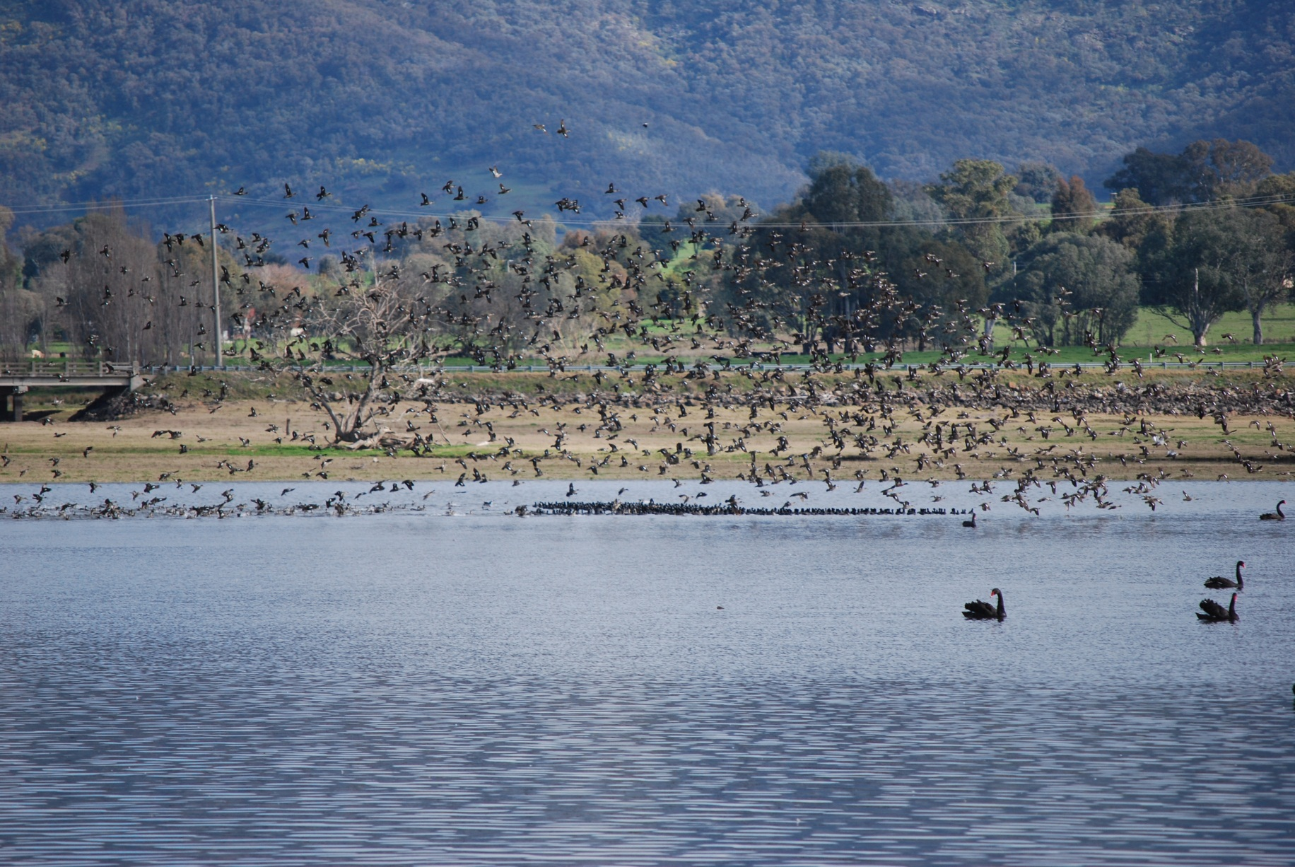



Estimates of Harvest for Deer, Duck and Quail in Victoria: Results from Surveys of Victorian Game Licence Holders in 2013

Paul D. Moloney and John D. Turnbull

Arthur Rylah Institute for Environmental Research   
123 Brown Street, Heidelberg, Victoria 3084

Game Victoria, Department of Environment and Primary Industries   
1 McKoy Street, Wodonga, Victoria 3690

October 2013



Arthur Rylah Institute for Environmental Research   
Department of Environment and Primary Industries  
Heidelberg, Victoria

**Report produced by:** Arthur Rylah Institute for Environmental Research  
Department of Environment and Primary Industries  
PO Box 137  
Heidelberg, Victoria 3084  
Phone (03) 9450 8600  
Website: www.depi.vic.gov.au/ari

© State of Victoria, Department of Environment and Primary Industries 2013

This publication is copyright. Apart from fair dealing for the purposes of private study, research, criticism or review as permitted under the *Copyright Act 1968*, no part may be reproduced, copied, transmitted in any form or by any means (electronic, mechanical or graphic) without the prior written permission of the State of Victoria, Department of Environment and Primary Industries. All requests and enquiries should be directed to the Customer Service Centre,   
136 186 or email customer.service@depi.vic.gov.au

**Citation:**  Moloney, Paul D. and Turnbull, John D. (2013) Estimates of Harvest for Deer, Duck and Quail in Victoria: Results from Surveys of Victorian Game Licence Holders in 2013. Arthur Rylah Institute for Environmental Research Technical Report Series No. 251. Department of Environment and Primary Industries, Heidelberg, Victoria

ISSN 1835-3827 (print)

ISSN 1835-3835 (online)

ISBN 978-1-74287-950-5 (print)

ISBN 978-1-74287-950-2 (online)

**Disclaimer:** This publication may be of assistance to you but the State of Victoria and its employees do not guarantee that the publication is without flaw of any kind or is wholly appropriate for your particular purposes and therefore disclaims all liability for any error, loss or other consequence which may arise from you relying on any information in this publication.

**Accessibility:**  
If you would like to receive this publication in an accessible format, such as large print or audio, please telephone   
136 186, or through the National Relay Service (NRS) using a modem or textphone/teletypewriter (TTY) by dialling 1800 555 677, or email customer.service@depi.vic.gov.au

This document is also available in PDF format on the internet at www.depi.vic.gov.au

**Front cover photo:** Grey Teal at Sandy Creek arm of Hume Weir (John Turnbull).

**Authorised by:** Victorian Government, Melbourne

**Printed by:** NMIT Printroom, 77-91 St Georges Road, Preston, 3072

##### Contents

Acknowledgements iv

Summary 1

1 Introduction 2

2 Methods 3

2.1 General methodology 3

2.2 Deer 4

2.3 Duck 4

2.4 Quail 4

3 Results 5

3.1 Deer 5

3.2 Duck 13

3.3 Quail 18

4 Discussion 23

4.1 Deer 23

4.2 Duck 23

4.3 Quail 24

4.4 Assumptions 25

References 27

Appendix 1 28

# Acknowledgements

This project was funded by the Department of Environment and Primary Industries through Game Victoria. We thank all the Game Licence holders who gave their time to participate in the surveys, which were conducted by Marketing Skill Pty Ltd (Mt Eliza, Victoria). We would also like to thank Dave Forsyth and David Ramsey for making valuable comments on drafts of this report.

# Summary

A telephone survey of Victorian hunters was conducted during the 2013 hunting seasons for deer, duck and quail to determine the total harvest for each game type. Game licence holders for each game type (deer, duck and quail) were randomly sampled and interviewed by telephone at intervals during the respective game seasons. For all surveys, respondents were asked whether they had hunted or not during the period for which the survey applied and, if applicable, the number and species of animals harvested. Additional information was obtained on hunting methods and locations.

Each holder of a Game Licence for deer hunted on approximately 6.4 days from July 2012 to June 2013, with an average season harvest of 2.1 deer per Game Licence holder. Based on the total number of holders of a deer Game Licence, this corresponds to an estimated 50,112 deer harvested during the 2013 deer-hunting season in Victoria (95% confidence interval (CI) = 40,279–62,346). The most commonly harvested species was Sambar Deer (with an estimated total harvest of 42,847), followed by Fallow Deer (6,138).

Each holder of a Game Licence for ducks hunted on approximately 3.7 days during the 2013 duck-hunting season, with an average season harvest of 17.2 ducks per Game Licence holder. Based on the total number of Game Licence holders, this equates to an estimated 422,294 ducks harvested during the 2013 duck-hunting season in Victoria (95% CI = 369,822–482,212). The most commonly harvested species was Grey Teal (which comprised 32% of the total harvest), followed by Australian Wood Duck (25%), Pacific Black Duck (22%), Chestnut Teal (9%), Pink-eared Duck (7%), Hardhead (2%), Australasian Shoveler (2%) and Australian Shelduck (<1%).

Each holder of a Game Licence for quail hunted on approximately 0.8 days during the 2013 quail-hunting season, with an average season harvest of 6.7 quail per Game Licence holder. Based on the total number of Game Licence holders, this equates to an estimated 184,123 quail harvested during the 2013 quail-hunting season in Victoria (95% CI = 139,007–243,882).

It is estimated that the total number of hunter days during the survey was 264,616 (95% CI = 236,480 – 296,099)

The approach used here explicitly accounts for the possibility that not every holder of a Game Licence will hunt during every survey period. The total number of Game Licence holders who hunted is estimated for each survey period and combined with the harvest per hunter to derive the total harvest for each survey period.

The methodology of performing telephone surveys throughout the season is likely to minimise memory bias and non-response bias compared to the end of year postal survey. However, sources of bias will remain due to over- and under-reporting, and the estimates of total harvest must be interpreted with care.

1. Introduction

In order to effectively manage game species it is important to quantify the numbers harvested. Game Victoria (Department of Environment and Primary Industries) conducts a mail survey of 1,000 randomly selected Game Licence holders during June each year. There are, however, a number of problems associated with mail surveys, including recall bias, rounding of harvest estimates, and non-response bias (Wright 1978). Due to concerns about the reliability of the harvest estimates from the mail survey, Game Victoria commissioned a series of regular telephone surveys to address the issue of recall bias. The three sets of telephone surveys were conducted during the various game harvest seasons for deer, duck and quail.

Deer hunting occurs all year round in Victoria for some species. For this report, the 2013 deer-hunting reporting period was defined as 1 July 2012 until 30 June 2013. Sambar Deer (*Cervus unicolor*) could be hunted all year by stalking. Hunting using scent-trailing hounds was restricted to the 1st April until 30 November. Hunting of Red Deer (*Cervus elaphus*) was not permitted in August during the survey period[1]. Hog Deer (*Axis porcinus*) could be hunted only during April, and were subject to additional restrictions such as one male and one female per hunter. All other species could be hunted all year: Fallow Deer (*Dama dama*), Chital Deer (*Axis axis*) and Rusa Deer (*Cervus timorensis*). This survey follows similar telephone surveys performed during the 2009 to 2012 deer-hunting seasons (Gormley and Turnbull 2009, 2010, 2011; Moloney and Turnbull 2012).

The 2013 duck-hunting season lasted 13 weeks, from 16 March to 10 June. Eight species could legally be hunted in 2013: Pacific Black Duck (*Anas superciliosa*), Australian Wood Duck[2] (*Chenonetta jubata*), Australian Shelduck[3] (*Tadorna tadornoides*), Grey Teal (*Anas gracilis*), Chestnut Teal (*Anas castanea*), Pink-eared Duck (*Malacorhynchus membranaceus*), Hardhead[4] (*Aythya australis*), and Australasian Shoveler[5] (*Anas rhynchotis*). The daily bag limit for the 2013 season was ten game ducks per hunter (with a limit of two Australasian Shoveler). These surveys follow from telephone surveys performed during the 2005, 2006, and 2009 to 2012 duck-hunting seasons (Barker 2006; Gormley and Turnbull 2009, 2010, 2011; Moloney and Turnbull 2012).

The 2013 quail-hunting season lasted 12 weeks, from 6 April to 30 June. The daily bag limit for the 2013 season was 20 quail per hunter, with Stubble Quail (*Coturnix pectoralis*) the only native species that could legally be hunted. This survey follows similar telephone surveys performed during the 2008 to 2012 quail-hunting seasons (Gormley 2009; Gormley and Turnbull 2009, 2010, 2011, Moloney and Turnbull 2012).

1. Methods
   1. General methodology

A similar methodology was used to estimate deer, duck and quail harvests. All surveys were conducted by the telephone survey company Marketing Skill on behalf of Department of Environment and Primary Industries. Estimates of total harvest by Game Licence holders were based on the reported hunting activities of the survey respondents.

For each game type, a series of surveys was performed throughout the corresponding season. Each survey involved telephoning a random sample of Game Licence holders and asking them to report their hunting activities only for the periods covered by that survey. Therefore, although a respondent[6] may have hunted during the period covered by Survey 2 and Survey 3, if they were contacted as part of Survey 3, then information was only collected that pertained to the period covered by Survey 3.

The information from the respondents was used as an estimate of the whole population of Game Licence holders for each game type. Estimates of harvest were determined for each of the survey periods and were summed to give an estimate of the total season harvest. For each survey period, the proportion of respondents who hunted was used as an estimate of the proportion of Game Licence holders who hunted. The proportion of Game Licence holders who hunted during each survey period was multiplied by the total number of Game Licence holders to give the total number of hunters for that survey period.

For each survey period, the average harvest per hunter[7] was estimated from the total reported harvest divided by the number of respondents that hunted. The total harvest for each survey period was estimated by multiplying the average harvest per hunter by the total number of hunters for that survey period, as estimated previously. Finally, the total season harvest was estimated as the sum of the survey-specific total harvests.

We also estimated the season harvest per Game Licence holder. For each survey period, the average harvest per survey respondent was estimated by multiplying the average harvest per hunter by the proportion of respondents who hunted. The sum of these estimates across the season provided an estimate of the total season harvest per Game Licence holder.

Respondents who hunted were also asked to provide information on whether hunting was conducted on private land or public land (such as State Game Reserves), the name of the town nearest to where they hunted, and the number of days they hunted during the survey period. Regional harvest estimates were calculated by summing the reported harvest for each nearest town and then aggregating these by the corresponding Victorian Catchment Management Authority (CMA) region.

There were differences in the number and length of surveys between the duck, deer and quail surveys, as indicated in the following sections. Additional details of the methods, as well as examples of the calculations, are provided in Appendix 1.

* 1. Deer

Samples were drawn from hunters who held a Game Licence to harvest deer. Random samples of hunters were telephoned every two months over the 12-month period to give a total of six surveys. Respondents were asked to report the number and sex of each species harvested. During each survey, 200 respondents were interviewed regardless of whether they had hunted or not. Respondents were also asked what hunting methods they used (i.e. stalking, scent-trailing hounds or gun dogs).

* 1. Duck

Samples were drawn from hunters who held a Game Licence to harvest ducks during the 2013 season. A random sample of 200 licence holders was interviewed by telephone immediately after opening weekend (Duck Survey 1) followed by independent random samples of licence holders at two-week intervals for the remainder of the duck season (Duck Surveys 2–7). Respondents were also asked to report the number of each species harvested.

* 1. Quail

Samples were drawn from hunters who held a Game Licence to harvest quail during the 2013 season. A random sample of 300 licence holders was interviewed by telephone each month for April (Survey 1), May (Survey 2) and June (Survey 3). Respondents were asked to report the number of Stubble Quail harvested, the type of grassland where hunting occurred (native, stubble or introduced), and whether or not dogs were used.

1. Results
   1. Deer

The number of Game Licence holders endorsed to hunt deer ranged from a high of 24,777 in November–December 2012, to a low of 20,741 in January–February 2013 (Table 1). In order to achieve the required sample size of respondents, slightly more than 200 licence holders were contacted each survey, with an average of 98.8% of those contacted willing to take part.

Table 1. Summary of responses for deer surveys July 2012 to June 2013.

|  |  |  |  |  |  |  |
| --- | --- | --- | --- | --- | --- | --- |
| Deer Survey | Period | Licence holders | Respondents | Respondents who hunted | Days hunted[8] | Deer harvested[9] |
| 1 | Jul–Aug 2012 | 23,154 | 200 | 69 | 361 | 122 |
| 2 | Sep–Oct 2012 | 24,349 | 200 | 67 | 391 | 145 |
| 3 | Nov–Dec 2012 | 24,777 | 200 | 31 | 79 | 28 |
| 4 | Jan–Feb 2013 | 20,741 | 200 | 19 | 90 | 17 |
| 5 | Mar–Apr 2013 | 22,321 | 200 | 31 | 170 | 57 |
| 6 | May–Jun 2013 | 24,080 | 200 | 50 | 195 | 56 |

The proportion of deer Game Licence holders who hunted in each survey period varied throughout the season (Table 2). An estimated 35% of deer Game Licence holders hunted at least once during July–August 2012, declining to a low of 10% during January–February 2013. These percentages correspond to 7,988 hunters in the July–August period and 1,970 hunters in the January–February period.

Table 2. Proportion and corresponding total number of deer licence holders that hunted, for each survey period.

|  |  |  |  |  |  |  |  |  |
| --- | --- | --- | --- | --- | --- | --- | --- | --- |
| Period | Proportion | SE | 95% CI | | Total | SE | 95% CI | |
|  |  |  | Lower | Upper | hunters |  | Lower | Upper |
| Jul–Aug 2012 | 0.35 | 0.034 | 0.29 | 0.42 | 7,988 | 778 | 6,602 | 9,664 |
| Sep–Oct 2012 | 0.34 | 0.033 | 0.28 | 0.41 | 8,157 | 813 | 6,713 | 9,911 |
| Nov–Dec 2012 | 0.16 | 0.026 | 0.11 | 0.21 | 3,840 | 634 | 2,785 | 5,296 |
| Jan–Feb 2013 | 0.10 | 0.021 | 0.06 | 0.14 | 1,970 | 430 | 1,291 | 3,007 |
| Mar–Apr 2013 | 0.16 | 0.026 | 0.11 | 0.21 | 3,460 | 571 | 2,509 | 4,771 |
| May–Jun 2013 | 0.25 | 0.031 | 0.20 | 0.32 | 6,020 | 737 | 4,739 | 7,646 |

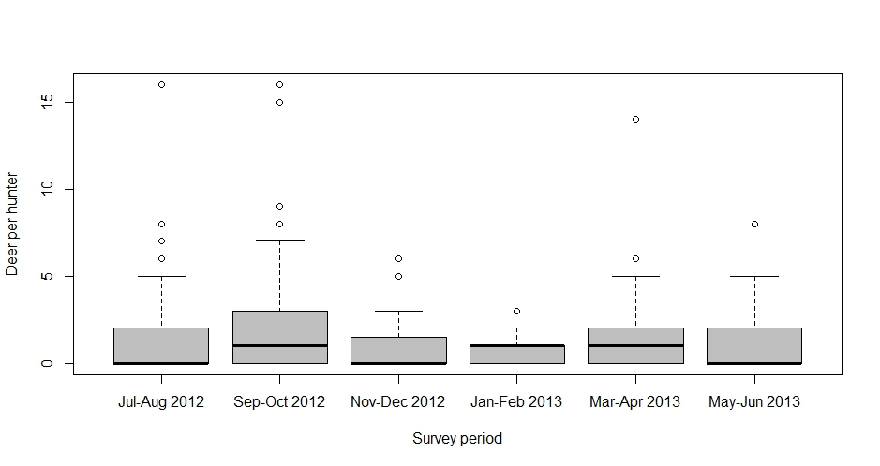Within each survey period there was large variation in the reported harvest of deer per hunter   
(i.e. per Game Licence holder who hunted), with some hunters harvesting more than 10 deer in a survey period (Figure 1). The average number of deer harvested per hunter ranged from a high of 2.16 deer per hunter during September–October 2012 to a low of 0.89 in January–February 2013 (Table 3).

Figure 1. Boxplot of the number of deer reported harvested by individual hunters for each survey period. The bottom and top of each “box” indicates the 25th and 75th percentile, respectively, with the black horizontal line indicating the median reported value.

Table 3. Average harvest of deer per hunter (Game Licence holders who hunted) for each survey period.

|  |  |  |  |  |
| --- | --- | --- | --- | --- |
| Period | Average harvest per hunter[10] | SE | 95% CI | |
|  |  |  | Lower | Upper |
| Jul–Aug 2012 | 1.77 | 0.34 | 1.22 | 2.57 |
| Sep–Oct 2012 | 2.16 | 0.39 | 1.52 | 3.08 |
| Nov–Dec 2012 | 0.90 | 0.28 | 0.50 | 1.63 |
| Jan–Feb 2013 | 0.89 | 0.25 | 0.52 | 1.54 |
| Mar–Apr 2013 | 1.84 | 0.50 | 1.09 | 3.10 |
| May–Jun 2013 | 1.12 | 0.24 | 0.74 | 1.70 |

There was an estimated total of 50,112 deer harvested by all deer Game Licence holders from July 2012 through June 2013 inclusive (95% CI = 40,279–62,346; Table 4). Harvest was greatest in the mid-winter to mid-spring months and lowest in the summer months.

Table 4. Estimates of the total deer harvest in Victoria from July 2012 until June 2013, by holders of a deer Game Licence.

|  |  |  |  |  |
| --- | --- | --- | --- | --- |
| Period | Total harvest[11] | SE | 95% CI | |
|  |  |  | Lower | Upper |
| Jul–Aug 2012 | 14,124 | 3,035 | 9,312 | 21,420 |
| Sep–Oct 2012 | 17,653 | 3,665 | 11,802 | 26,405 |
| Nov–Dec 2012 | 3,469 | 1,217 | 1,779 | 6,764 |
| Jan–Feb 2013 | 1,763 | 629 | 895 | 3,474 |
| Mar–Apr 2013 | 6,361 | 2,023 | 3,462 | 11,688 |
| May–Jun 2013 | 6,742 | 1,665 | 4,185 | 10,862 |
| **Total Season** | **50,112** | **5,602** | **40,279** | **62,346** |

The total average season harvest was 2.13 deer per Game Licence holder (95% CI = 1.71–2.64; Table 5). Note that for each survey period the average deer harvest per Game Licence holder (Table 5) is much lower than the average deer harvest per hunter (Table 3), as the former includes those respondents who did not hunt during the survey period.

Table 5. Estimated average harvest of deer per Game Licence holder in each survey period.

|  |  |  |  |  |
| --- | --- | --- | --- | --- |
| Period | Average harvest[12] | SE | 95% CI | |
|  |  |  | Lower | Upper |
| Jul–Aug 2012 | 0.61 | 0.13 | 0.40 | 0.93 |
| Sep–Oct 2012 | 0.73 | 0.15 | 0.48 | 1.08 |
| Nov–Dec 2012 | 0.14 | 0.05 | 0.07 | 0.27 |
| Jan–Feb 2013 | 0.09 | 0.03 | 0.04 | 0.17 |
| Mar–Apr 2013 | 0.29 | 0.09 | 0.16 | 0.52 |
| May–Jun 2013 | 0.28 | 0.07 | 0.17 | 0.45 |
| **Total Season** | **2.13** | **0.24** | **1.71** | **2.64** |

Separate harvest estimates for each deer species are presented in Figure 2 and Table 6. No Hog, Red, Chital, or Rusa Deer were reported harvested. This is the first time since the telephone survey began in 2009 that no Hog or Red Deer were reported harvested (Moloney and Turnbull 2012).

Additionally, ten deer were reported without a species being recorded. It is estimated that these deer of unknown species account for 1127 (95% CI = 622–2043) of the estimated total deer harvest.

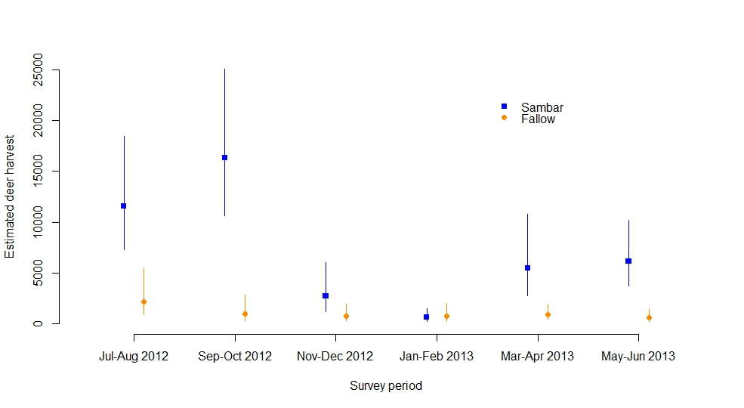

Figure 2. Estimated total deer harvest for each two-month survey period, by species. Vertical bars indicate 95% confidence intervals.

Table 6. Estimated average harvest of deer per Game Licence holder in each survey period.

**a.** Sambar Deer

|  |  |  |  |  |  |
| --- | --- | --- | --- | --- | --- |
| Period | Reported | Total Harvest | SE | 95% CI | |
|  |  |  |  | Lower | Upper |
| Jul–Aug 2012 | 100 | 11,577 | 2,776 | 7,283 | 18,401 |
| Sep–Oct 2012 | 134 | 16,314 | 3,621 | 10,614 | 25,075 |
| Nov–Dec 2012 | 22 | 2,725 | 1,148 | 1,234 | 6,019 |
| Jan–Feb 2013 | 6 | 622 | 296 | 257 | 1,509 |
| Mar–Apr 2013 | 49 | 5,469 | 1,961 | 2,766 | 10,814 |
| May–Jun 2013 | 51 | 6,140 | 1,610 | 3,704 | 10,178 |
| **Total Season** | **362** | **42,847** | **5,354** | **33,572** | **54,686** |

**b.** Fallow Deer

|  |  |  |  |  |  |
| --- | --- | --- | --- | --- | --- |
| Period | Reported | Total Harvest | SE | 95% CI | |
|  |  |  |  | Lower | Upper |
| Jul–Aug 2012 | 19 | 2,200 | 1,076 | 887 | 5,453 |
| Sep–Oct 2012 | 8 | 974 | 571 | 336 | 2,826 |
| Nov–Dec 2012 | 6 | 743 | 394 | 280 | 1,971 |
| Jan–Feb 2013 | 7 | 726 | 408 | 260 | 2,025 |
| Mar–Apr 2013 | 8 | 893 | 352 | 424 | 1,880 |
| May–Jun 2013 | 5 | 602 | 268 | 261 | 1,387 |
| **Total Season** | **53** | **6,138** | **1,415** | **3,930** | **9,586** |

For Sambar Deer, similar proportions of stags and hinds were harvested (Table 7). For Fallow Deer, a slightly greater proportion of females were harvested (57%).

Table 7. Estimated average harvest of deer per Game Licence holder in each survey period.

|  |  |  |  |  |  |  |  |  |
| --- | --- | --- | --- | --- | --- | --- | --- | --- |
| Species | Stags | | | |  | Hinds | | |
|  | n | % (SE) |  | n | | | % (SE) |
| Sambar Deer | 178 | 49.9% (2.6) |  | 179 | | | 50.1% (2.6) |
| Fallow Deer | 23 | 43.4% (6.8) |  | 30 | | | 56.6% (6.8) |

The number of days hunted in each survey period varied throughout the season, with most hunting occurring in from mid-winter to mid-spring. Each deer licence holder hunted an average of   
6.4 days during the 2013 deer-hunting season, corresponding to a total of 150,910 hunter days (95% CI = 126,843–179,543; Table 8).

Table 8. Days hunted per Game Licence holder.

|  |  |  |  |  |
| --- | --- | --- | --- | --- |
| Period | Days hunted | SE | 95% CI | |
|  |  |  | Lower | Upper |
| Jul–Aug 2012 | 1.81 | 0.23 | 1.41 | 2.31 |
| Sep–Oct 2012 | 1.96 | 0.28 | 1.48 | 2.58 |
| Nov–Dec 2012 | 0.40 | 0.08 | 0.26 | 0.59 |
| Jan–Feb 2013 | 0.45 | 0.13 | 0.26 | 0.77 |
| Mar–Apr 2013 | 0.85 | 0.19 | 0.55 | 1.30 |
| May–Jun 2013 | 0.98 | 0.15 | 0.72 | 1.33 |
| **Total days per licence holder** | **6.43** | **0.46** | **5.59** | **7.39** |
| **Total hunting days** | **150,910** | **13,403** | **126,843** | **179,543** |

More deer hunting occurred exclusively on public land (65.6%) than on private land (15.6%), with correspondingly similar proportions of deer harvested (Table 9).

Table 9. Percentage of days hunted and associated deer harvest by land tenure.

|  |  |  |
| --- | --- | --- |
| Land Tenure | Days | Deer |
| Private land only | 15.6% | 18.6% |
| Public land only | 65.6% | 66.1% |
| Both | 17.8% | 15.1% |
| **Total** | **99.0%** | **99.8%** |

Stalking was the preferred hunting method, being used in 58.5% of the hunting days and accounting for 55.4% of the reported harvest. Hunting with scent-trailing hounds or stalking with a gundog were more productive hunting methods, with their proportion of the harvest being roughly double their respective proportion of days (Table 10). It should be noted that the hunting method was not specified in 16.9% of the hunting days and associated with none of the harvest.

Table 10. Percentage of days hunted and associated deer harvest for hunting methods.

|  |  |  |
| --- | --- | --- |
| Hunting Method | Days | Deer |
| Stalking | 58.5% | 54.4% |
| Stalking with gundog | 6.6% | 12.5% |
| Scent-trailing hounds | 18.0% | 33.2% |
| **Total** | **83.1%** | **100.0%** |

While stalking is the preferred hunting method, it would seem to be more productive on private land, accounting for 13% of the surveyed hunting days but 19% of the surveyed harvest (Table 11). The vast majority (86%) of all hunting days using scent-trailing hounds was on public land only. While this accounted for 15% of the total hunting days, it contributed over 30% of the surveyed harvest.

Table 11. Percentage of days hunted and associated deer harvest by hunting method and land tenure.

|  |  |  |  |  |  |  |  |  |
| --- | --- | --- | --- | --- | --- | --- | --- | --- |
| Land Tenure | Private Only | | Public Only | | Both | | Total | |
| Hunting Method | Days | Deer | Days | Deer | Days | Deer | Days | Deer |
| Stalking | 12.7% | 18.6% | 35.4% | 26.6% | 10.2% | 8.9% | **58.5%** | **54.4%** |
| Stalking with gundog | 0.5% | 0.0% | 4.5% | 8.7% | 1.6% | 3.8% | **6.6%** | **12.5%** |
| Scent-trailing hounds | 0.0% | 0.0% | 15.5% | 30.8% | 2.5% | 2.4% | **18.0%** | **33.2%** |
| **Total** | **15.6%** | **18.6%** | **65.6%** | **66.1%** | **17.8%** | **15.1%** | **100.0%** | **100.0%** |

Total harvest was estimated to be greatest in the West Gippsland CMA, followed by the Goulburn Broken CMA, the North East CMA and the East Gippsland CMA (Figure 3). There was no reported harvest in the Mallee CMA or North Central CMA.

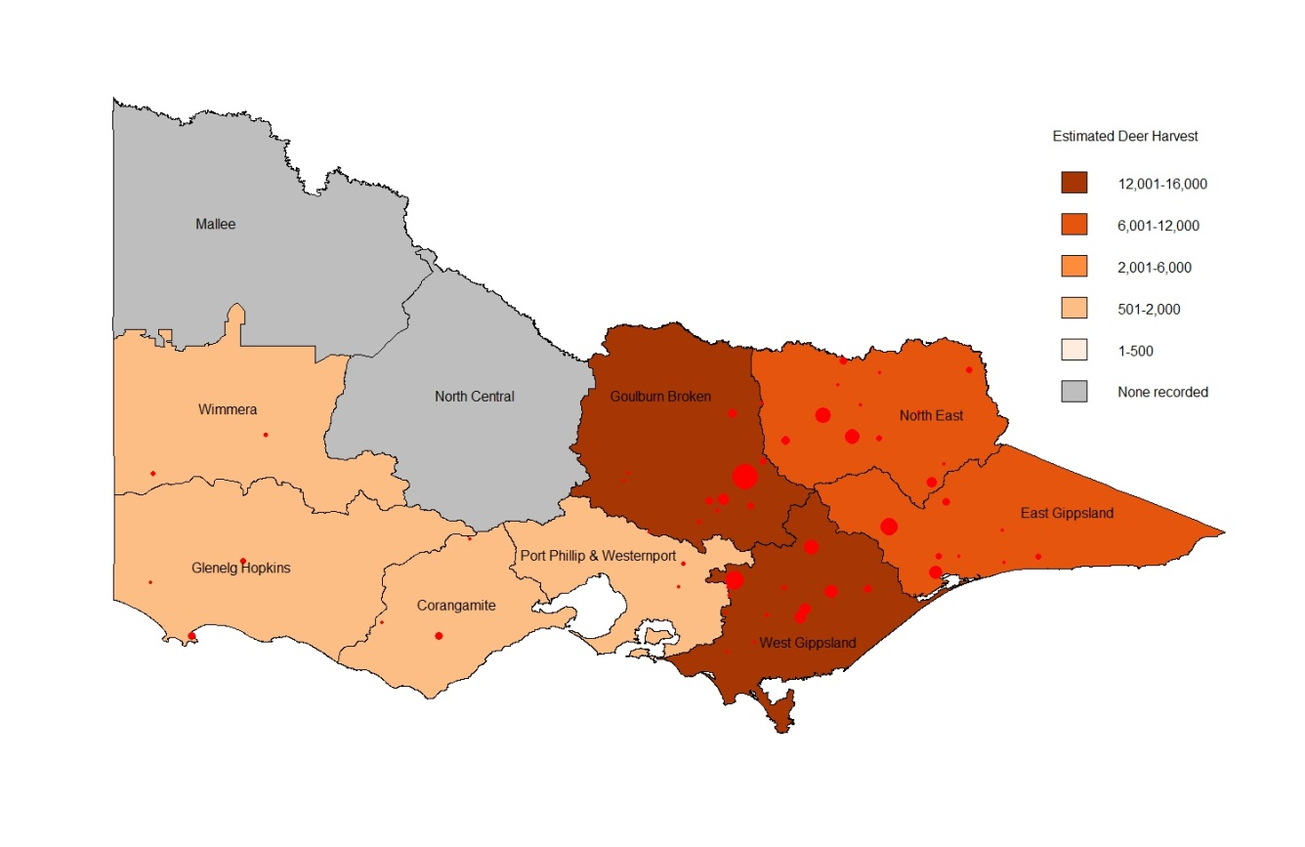

Figure 3. Estimated total deer harvest by CMA region. Red circles indicate the nearest town to harvest locations, with symbol size proportional to reported harvest.

* 1. Duck

The number of Game Licence holders endorsed to hunt ducks remained relatively constant throughout the season, increasing from 24,036 at opening weekend to 25,099 at the end of the season (Table 12). In order to achieve the required sample size of respondents, slightly more than 200 licence holders were contacted each survey, with an average of 98.7% of those contacted willing to take part.

Table 12. Summary of responses for duck surveys in 2013.

|  |  |  |  |  |  |  |
| --- | --- | --- | --- | --- | --- | --- |
| Deer Survey | Period | Licence holders | Respondents | Respondents who hunted | Days hunted[13] | Ducks harvested[14] |
| 1 | 16 Mar–18 Mar | 24,036 | 200 | 123 | 212 | 1,162 |
| 2 | 19 Mar–30 Mar | 24,036 | 200 | 46 | 112 | 435 |
| 3 | 31 Mar–13 Apr | 24,627 | 200 | 34 | 90 | 244 |
| 4 | 14 Apr–27 Apr | 24,627 | 200 | 37 | 92 | 349 |
| 5 | 28 Apr–13 May | 24,979 | 200 | 47 | 97 | 518 |
| 6 | 14 May–27 May | 24,979 | 200 | 35 | 64 | 357 |
| 7 | 28 May–10 Jun | 25,099 | 200 | 41 | 82 | 383 |

The proportion of duck Game Licence holders who hunted in each survey period varied throughout the season: 62% of licence holders hunted during opening weekend, corresponding to approximately 14,782 hunters (Table 13). The proportion that hunted during other survey periods varied from 17% to 24%, corresponding to between 4,187 and 5,870 duck hunters, respectively (Table 13).

Table 13. Proportion and corresponding total number of duck licence holders who hunted in each survey period.

|  |  |  |  |  |  |  |  |  |
| --- | --- | --- | --- | --- | --- | --- | --- | --- |
| Period | Proportion | SE | 95% CI | | Total | SE | 95% CI | |
|  |  |  | Lower | Upper | hunters |  | Lower | Upper |
| 16 Mar–18 Mar | 0.62 | 0.034 | 0.55 | 0.69 | 14,782 | 827 | 13,248 | 16,494 |
| 19 Mar–30 Mar | 0.23 | 0.030 | 0.18 | 0.30 | 5,528 | 715 | 4,295 | 7,116 |
| 31 Mar–13 Apr | 0.17 | 0.027 | 0.13 | 0.23 | 4,187 | 654 | 3,088 | 5,676 |
| 14 Apr–27 Apr | 0.19 | 0.027 | 0.14 | 0.25 | 4,556 | 676 | 3,411 | 6,085 |
| 28 Apr–13 May | 0.24 | 0.030 | 0.18 | 0.30 | 5,870 | 749 | 4,576 | 7,530 |
| 14 May–27 May | 0.18 | 0.027 | 0.13 | 0.24 | 4,371 | 671 | 3,241 | 5,896 |
| 28 May–10 Jun | 0.21 | 0.029 | 0.16 | 0.27 | 5,145 | 716 | 3,921 | 6,751 |

Within each survey period, there was large variation in the reported harvest of ducks per hunter (i.e. per Game Licence holder who hunted), with some hunters harvesting more than 20 ducks in a survey period (Figure 4). The average number of ducks per hunter varied throughout the season (Table 14). The average harvest per hunter was 9.45 ducks on opening weekend. The lowest average harvest per hunter was 7.18 ducks, while the largest was 11.02 ducks.

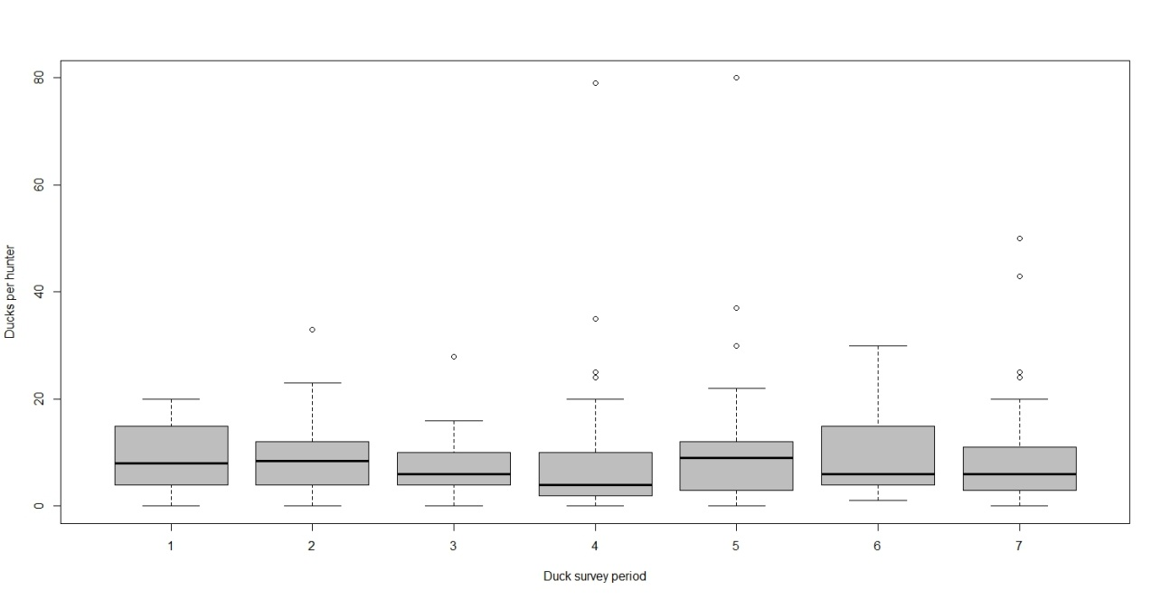

**Figure 4.** Boxplot of the number of duck reported harvested by individual hunters for each survey period. The bottom and top of each “box” indicates the 25th and 75th percentile, respectively, with the black horizontal line indicating the median reported value.

Table 14. Average harvest of ducks per hunter (Game Licence holders who hunted) for each survey period.

|  |  |  |  |  |
| --- | --- | --- | --- | --- |
| Period | Average harvest per hunter[15] | SE | 95% CI | |
|  |  |  | Lower | Upper |
| 16 Mar–18 Mar | 9.45 | 0.59 | 8.35 | 10.69 |
| 19 Mar–30 Mar | 9.46 | 1.06 | 7.60 | 11.76 |
| 31 Mar–13 Apr | 7.18 | 0.98 | 5.50 | 9.37 |
| 14 Apr–27 Apr | 9.43 | 2.36 | 5.82 | 15.30 |
| 28 Apr–13 May | 11.02 | 1.92 | 7.85 | 15.47 |
| 14 May–27 May | 10.20 | 1.53 | 7.62 | 13.66 |
| 28 May–10 Jun | 9.34 | 1.67 | 6.60 | 13.23 |

There were an estimated 139,649 ducks harvested during opening weekend (95% CI = 118,435–164,664), more than twice the estimate of any fortnight. The harvest throughout the season varied considerably between surveys, with fortnightly estimates ranging from 30,045 to 64,696 ducks harvested. The total season harvest estimate was 422,294 (95% CI = 396,822–482,212;Table 15).

Table 15. Estimates of the duck harvest in Victoria in 2013 by holders of a duck Game Licence.

|  |  |  |  |  |
| --- | --- | --- | --- | --- |
| Period | Total harvest[16] | SE | 95% CI | |
|  |  |  | Lower | Upper |
| 16 Mar–18 Mar | 139,649 | 11,761 | 118,435 | 164,664 |
| 19 Mar–30 Mar | 52,278 | 8,936 | 37,486 | 72,907 |
| 31 Mar–13 Apr | 30,045 | 6,236 | 20,089 | 44,936 |
| 14 Apr–27 Apr | 42,974 | 12,514 | 24,567 | 75,172 |
| 28 Apr–13 May | 64,696 | 13,971 | 42,574 | 98,312 |
| 14 May–27 May | 44,588 | 9,562 | 29,425 | 67,563 |
| 28 May–10 Jun | 48,065 | 10,900 | 30,988 | 74,550 |
| **Season Total** | **422,294** | **28,620** | **369,822** | **482,212** |

The total average season harvest per licence holder was estimated to be 17.2 (95% CI = 15.11–19.67; Table 16). Note that for each survey period the average duck harvest per Game Licence holder is lower than the average duck harvest per hunter, as the former includes those respondents who did not hunt during the survey period, whereas the latter is conditional on those who hunted.

Table 16. Estimated average harvest of ducks per Game Licence holder in each survey period.

|  |  |  |  |  |
| --- | --- | --- | --- | --- |
| Period | Average harvest [17] | SE | 95% CI | |
|  |  |  | Lower | Upper |
| 16 Mar–18 Mar | 5.81 | 0.49 | 4.93 | 6.85 |
| 19 Mar–30 Mar | 2.18 | 0.37 | 1.56 | 3.03 |
| 31 Mar–13 Apr | 1.22 | 0.25 | 0.82 | 1.82 |
| 14 Apr–27 Apr | 1.75 | 0.51 | 1.00 | 3.05 |
| 28 Apr–13 May | 2.59 | 0.56 | 1.70 | 3.94 |
| 14 May–27 May | 1.79 | 0.38 | 1.18 | 2.70 |
| 28 May–10 Jun | 1.92 | 0.43 | 1.23 | 2.97 |
| **Season Total** | **17.24** | **1.16** | **15.11** | **19.67** |

Total harvest estimates for each species were obtained by multiplying the total estimated duck harvest by the percentages of total harvest for that species (Table 17). The most frequently harvested species was the Grey Teal, comprising 32% of the total reported harvest, followed by Australian Wood Duck (25%) and Pacific Black Duck (22%). Other species comprised 21% of the total harvest.

Table 17. Reported numbers of ducks harvested by hunters, proportion of the total harvest, and estimated total 2013 harvest for each duck species.

|  |  |  |  |  |  |  |  |
| --- | --- | --- | --- | --- | --- | --- | --- |
| Species | Reported | Proportion | SE | Estimated | SE | 95% CI | |
|  | harvest | of harvest |  | harvest |  | Lower | Upper |
| Pacific Black Duck | 757 | 0.220 | 0.007 | 92,714 | 6,953 | 54,732 | 157,054 |
| Australian Wood Duck | 870 | 0.252 | 0.007 | 106,553 | 7,868 | 63,149 | 179,791 |
| Australian Shelduck | 22 | 0.006 | 0.001 | 2,694 | 601 | 1,118 | 6,493 |
| Grey Teal | 1,110 | 0.322 | 0.008 | 135,947 | 9,807 | 81,043 | 228,048 |
| Chestnut Teal | 325 | 0.094 | 0.005 | 39,804 | 3,419 | 22,676 | 69,871 |
| Pink-eared Duck | 246 | 0.071 | 0.004 | 30,129 | 2,756 | 16,871 | 53,805 |
| Australasian Shoveler | 58 | 0.017 | 0.002 | 7,104 | 1,043 | 3,439 | 14,672 |
| Hardhead | 60 | 0.017 | 0.002 | 7,349 | 1,064 | 3,574 | 15,109 |

Each Game Licence holder hunted an average of 3.7 days during the 2013 duck hunting season (Table 18). When multiplied by the total number of Game Licence holders in each survey period, this equals a total of 91,748 hunter days (95% CI = 79,830–105,445).

Table 18. Days hunted per Game Licence holder.

|  |  |  |  |  |
| --- | --- | --- | --- | --- |
| Period | Days hunted | SE | 95% CI | |
|  |  |  | Lower | Upper |
| 16 Mar–18 Mar | 1.06 | 0.07 | 0.94 | 1.20 |
| 19 Mar–30 Mar | 0.56 | 0.09 | 0.41 | 0.76 |
| 31 Mar–13 Apr | 0.45 | 0.08 | 0.32 | 0.64 |
| 14 Apr–27 Apr | 0.46 | 0.09 | 0.31 | 0.68 |
| 28 Apr–13 May | 0.49 | 0.08 | 0.35 | 0.67 |
| 14 May–27 May | 0.32 | 0.06 | 0.22 | 0.46 |
| 28 May–10 Jun | 0.41 | 0.07 | 0.29 | 0.58 |
| **Total per licence holder** | **3.75** | **0.21** | **3.36** | **4.17** |
| **Total hunting days** | **91,748** | **6,522** | **79,830** | **105,445** |

Similar amounts of duck hunting were conducted on public land (50.6%) and private land (42.5%), with a greater proportion of ducks harvested solely on public land (48.2% to 43.9%) (Table 19).

Table 19. Percentage of days hunted and associated duck harvest by land tenure.

|  |  |  |
| --- | --- | --- |
| Land Tenure | Days | Duck harvest |
| Private land only | 42.5% | 43.9% |
| Public land only | 50.6% | 48.2% |
| Both | 6.9% | 7.8% |
| **Total** | **100.0%** | **100.0%** |

Total harvest was estimated to be greatest in the North Central CMA and the West Gippsland CMA (Figure 5).

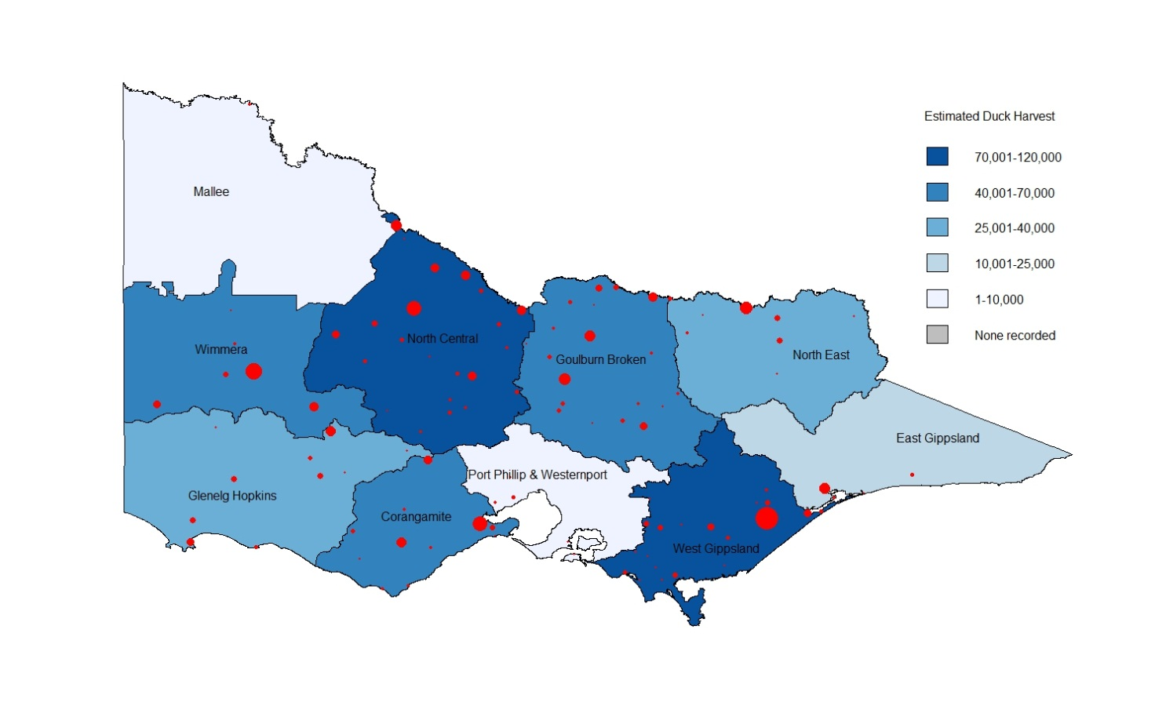

Figure 5. Estimated total duck harvest by CMA region. Red circles indicate the nearest town to harvest locations, with symbol size proportional to reported harvest.

* 1. Quail

The number of Game Licence holders endorsed to hunt quail increased throughout the season (Table 20). In order to achieve the required sample size of respondents, slightly more than 300 licence holders were contacted each survey, with an average of 99% of those contacted willing to take part.

Table 20. Summary of responses for quail surveys in 2013.

|  |  |  |  |  |  |  |
| --- | --- | --- | --- | --- | --- | --- |
| Quail Survey | Period | Licence holders | Respondents | Respondents who hunted | Days hunted[18] | Quail harvested[19] |
| 1 | April | 27,106 | 300 | 40 | 76 | 498 |
| 2 | May | 27,576 | 300 | 39 | 80 | 823 |
| 3 | June | 27,800 | 300 | 41 | 84 | 685 |

The proportion of Game Licence holders who hunted in each monthly survey period was very consistent, ranging from 13% to 14%. It is estimated that there were between 3,585 and 3,799 hunters in any one-month period (Table 21).

Table 21. Proportion and corresponding total number of quail licence holders who hunted in each survey period.

|  |  |  |  |  |  |  |  |  |
| --- | --- | --- | --- | --- | --- | --- | --- | --- |
| Period | Proportion | SE | 95% CI | | Total | SE | 95% CI | |
|  |  |  | Lower | Upper | hunters |  | Lower | Upper |
| April | 0.13 | 0.020 | 0.10 | 0.18 | 3,614 | 532 | 2,713 | 4,815 |
| May | 0.13 | 0.019 | 0.10 | 0.17 | 3,585 | 535 | 2,679 | 4,796 |
| June | 0.14 | 0.020 | 0.10 | 0.18 | 3,799 | 551 | 2,863 | 5,042 |

Within each survey period there was large variation in the reported harvest per hunter (i.e. per Game Licence holder who hunted), with some hunters harvesting over 40 quail and others zero quail within a survey period (Figure 6). The average number of quail harvested per hunter during a one-month period varied from 12.5 to 21.1 (Table 22).

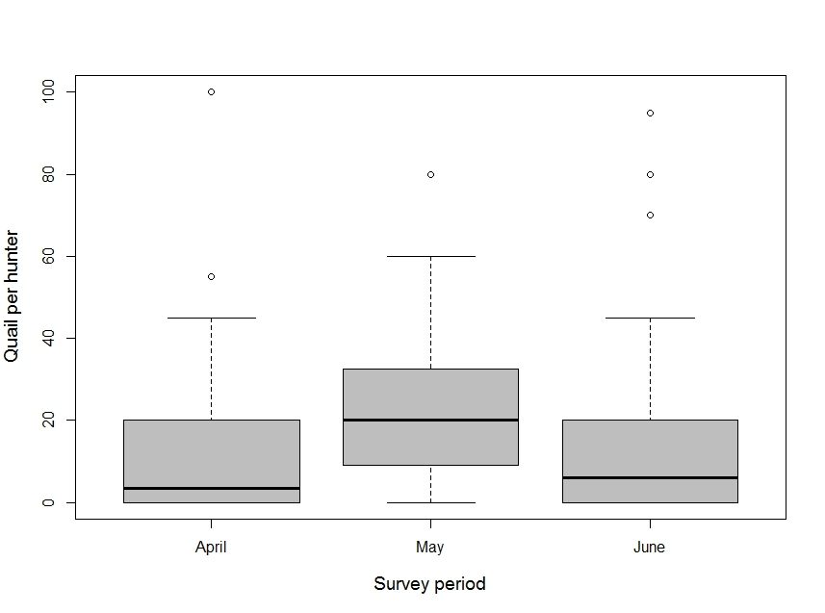

Figure 6. Boxplot of the number of quail reported harvested by individual hunters for each survey period. The bottom and top of each “box” indicates the 25th and 75th percentile, respectively, with the black horizontal line indicating the median reported value.

Table 22. Average harvest of quail per hunter (Game Licence holders who hunted) for each survey period.

|  |  |  |  |  |
| --- | --- | --- | --- | --- |
| Period | Average harvest per hunter[20] | SE | 95% CI | |
|  |  |  | Lower | Upper |
| April | 12.45 | 3.20 | 7.58 | 20.45 |
| May | 21.10 | 2.77 | 16.33 | 27.27 |
| June | 16.71 | 3.86 | 10.68 | 26.13 |

There were an estimated 184,123 quail harvested by all holders of a Game Licence for quail during the 2013 quail season (95% CI = 139,007–243,882). The May harvest was substantially higher than the June harvest, which in turn was substantially higher than the April harvest (Table 23).

Table 23. Estimates of the 2013 quail harvest in Victoria by licensed quail hunters.

|  |  |  |  |  |
| --- | --- | --- | --- | --- |
| Period | Total harvest[21] | SE | 95% CI | |
|  |  |  | Lower | Upper |
| April | 44,996 | 13,335 | 25,479 | 79,462 |
| May | 75,650 | 15,044 | 51,425 | 111,287 |
| June | 63,477 | 17,329 | 37,532 | 107,356 |
| **Season Total** | **184,123** | **26,541** | **139,007** | **243,882** |

The total average season harvest was 6.7 quail per Game Licence holder (95% CI = 5.05–8.86; Table 24). Note that for each survey period, the average quail harvest per Game Licence holder is lower than the average quail harvest per hunter, as the former averages across those respondents who did not hunt during the survey period, whereas the latter is conditional on those that hunted.

Table 24. Estimated average harvest of quail per Game Licence holder in each survey period.

|  |  |  |  |  |
| --- | --- | --- | --- | --- |
| Period | Average harvest[22] | SE | 95% CI | |
|  |  |  | Lower | Upper |
| April | 1.66 | 0.49 | 0.94 | 2.93 |
| May | 2.74 | 0.55 | 1.86 | 4.04 |
| June | 2.28 | 0.62 | 1.35 | 3.86 |
| **Season Total** | **6.69** | **0.96** | **5.05** | **8.86** |

The number of hunting days per licence holder was consistent throughout the season. On average, each quail licence holder hunted on 0.8 days during the 2013 season, corresponding to 21,958 hunter days (95% CI = 8,740–56,702; Table 25).

Table 25. Days quail hunted per Game Licence holder.

|  |  |  |  |  |
| --- | --- | --- | --- | --- |
| Period | Days hunted | SE | 95% CI | |
|  |  |  | Lower | Upper |
| April | 0.25 | 0.04 | 0.18 | 0.36 |
| May | 0.27 | 0.05 | 0.19 | 0.38 |
| June | 0.28 | 0.05 | 0.20 | 0.39 |
| **Total per licence holder** | **0.80** | **0.08** | **0.65** | **0.98** |
| **Total hunting days** | **21,958** | **2,924** | **16,934** | **28,474** |

Most quail hunting was conducted on private land (87.9% of the hunting days), resulting in 92.3% of the harvested quail (Table 26). A very small proportion of hunting was conducted in State Game Reserves (8.8%) or both private land and State Game Reserves during the same hunting trip (3.3%). Dogs were used to hunt quail on 75% of quail hunting days, accounting for 83% of the harvest. Most quail hunting, and quail harvest, took place on stubble (64.7% and 66.8% respectively), or combinations including native grasslands (a total of 29.4% and 25.7% respectively; Table 26). The total quail harvest was greatest in the North Central CMA, almost double the next largest harvest in the Corangamite CMA (Figure 7).

Table 26. Percentage of days hunted and associated quail harvest by land tenure.

|  |  |  |
| --- | --- | --- |
| Land Tenure | Days | Quail harvest |
| Private land only | 87.9% | 92.3% |
| State Game Reserves only | 8.8% | 1.7% |
| Private land and State Game Reserves | 3.3% | 6.0% |
| **Total** | **100.0%** | **100.0%** |

Table 27. Percentage of hunting days and associated quail harvest per grassland type.

|  |  |  |
| --- | --- | --- |
| Grassland | Days | Quail harvest |
| Introduced grass | 3.3% | 4.4% |
| Native grass | 19.2% | 16.2% |
| Introduced and native grass | 0.4% | 1.0% |
| Stubble | 64.7% | 66.8% |
| Stubble and native | 9.8% | 8.6% |
| Stubble and introduced | 2.5% | 3.0% |
| **Total** | **100.0%** | **100.0%** |

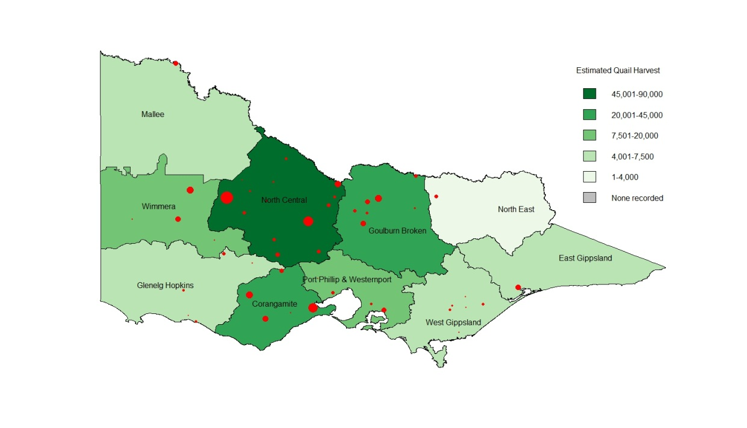

Figure 7. Estimated total quail harvest by CMA region. Red circles indicate the nearest town to harvest locations, with symbol size proportional to reported harvest.

1. Discussion
   1. Deer

A total of 50,112 deer were estimated to have been harvested in Victoria during the season from July 2012 to June 2013 (95% CI = 40,279–62,346). The most commonly harvested species was Sambar Deer (42,847), followed by Fallow Deer (6,138). No other species of deer were reported by surveyed Game Licence holders, making it impossible to make any inference from the survey about the estimated harvests of those species, except that they are likely to be small (<2000). Even though no survey respondent had successfully hunted Hog Deer, it should be noted that, in 2013, 124 Hog Deer (97 stags and 24 hinds) were recorded at checking stations, with an additional 61 Hog Deer (36 stags and 25 hinds) harvested on Sunday Island, a private cooperative.

The 2013 season harvest of 50,112 is substantially higher than previous years. The estimate is 20% larger than the next highest estimated deer harvest using these methods (Table 28). The 2013 season had the smallest number of hunting days and the second largest deer harvested per licence holder of the surveys to date. The efficiency of hunters (i.e. deer harvested per hunting day) in 2013 was the highest recorded since the surveys began in 2009. Most deer hunting continues to occur from mid-winter to mid-spring, which coincides with the hound hunting period and the reduced hunting over the hotter months.

Table 28. Comparison of deer harvest in 2009 to 2013 reports.

|  |  |  |  |  |  |
| --- | --- | --- | --- | --- | --- |
|  | 2009 | 2010 | 2011 | 2012[23] | 2013 |
| Harvest by species |  |  |  |  |  |
| Fallow Deer | 4,299 | 5,006 | 5,187 | 7,900 | 6,138 |
| Hog Deer | 81 | 454 | 105 | 102 | - |
| Red Deer | 670 | 767 | 1,437 | 773 | - |
| Sambar Deer | 34,368 | 28,762 | 34,000 | 32,826 | 42,847 |
| **Total harvest** | **39,418** | **35,278** | **40,728** | **41,601** | **50,112** |
| Hunting days | 125,428 | 149,930 | 140,471 | 152,051 | 150,910 |
| Deer per licence holder | 2.43 | 1.86 | 1.97 | 1.93 | 2.13 |
| Hunting days per licence holder | 7.75 | 7.91 | 6.83 | 7.04 | 6.43 |
| Hunting days per deer | 0.31 | 0.24 | 0.29 | 0.27 | 0.33 |

* 1. Duck

A total of 422,294 ducks were estimated to have been harvested in Victoria during the 2013 season (95% CI = 369,822–482,212), 17% less than the 2012 harvest (508,256), which was a 15% reduction on the 2011 harvest[24]. The number of Pink-eared Ducks harvested has run counter to this trend, increasing by 70% in 2012 and 40% in 2013. Both Chestnut and Grey Teal harvests increased in 2013, but are still less than their 2011 harvests. The harvest of Australian Wood Duck, Hardhead, and Pacific Black Duck were all substantially reduced from 2011 and 2012. The estimated hunting days and ducks per licence holder have decreased since the 2011 and 2012 seasons. However, hunter efficiency (ducks per hunting day) remained constant from 2012 to 2013 (Table 29).

Table 29. Comparison of duck harvests from 2009 to 2013.

|  |  |  |  |  |  |
| --- | --- | --- | --- | --- | --- |
|  | 2009 | 2010 | 2011 | 2012[25] | 2013 |
| Harvest by species |  |  |  |  |  |
| Pacific Black Duck | 55,150 | 96,487 | 156,484 | 160,704 | 92,714 |
| Australian Wood Duck | 131,084 | 112,390 | 132,908 | 150,150 | 106,553 |
| Australian Shelduck | 2,173 | 5,936 | 8,090 | 9,234 | 2,694 |
| Grey Teal | 20,919 | 26,011 | 211,034 | 110,574 | 135,947 |
| Chestnut Teal | 13,176 | 14,354 | 49,812 | 23,506 | 39,804 |
| Pink-eared Duck | NA | 0 | 12,597 | 21,587 | 30,129 |
| Australasian Shoveler | NA | 216 | 4,854 | 1,319 | 7,104 |
| Hardhead | NA | 324 | 25,657 | 30,222 | 7,349 |
| **Total harvest** | **222,302** | **270,574** | **600,739** | **508,256** | **422,294** |
| Hunting days | 76,659 | 85,801 | 103,450 | 109,718 | 91,748 |
| Ducks per licence holder | 11.10 | 12.54 | 26.02 | 21.19 | 17.24 |
| Hunting days per licence holder | 3.98 | 3.98 | 4.48 | 4.60 | 3.75 |
| Ducks per hunting day | 2.78 | 3.16 | 5.81 | 4.63 | 4.60 |

* 1. Quail

A total of 184,123 quail were estimated to have been harvested in Victoria during the 2013 season (95% CI = 139,007–243,882), a substantial increase on the 2012 harvest of 129,711, but still lower than the 2011 estimated harvest of 678,431 (Table 30). The pattern reflects the changes in hunter efficiency (quail per hunting day) of 14.5, 5.8 and 8.4 quail per hunting day in 2011, 2012 and 2013, respectively. The quail season in 2011 is unusual given the estimated total number of hunting days is almost double that of any other survey year. Anecdotal evidence suggests that the timing and extent of rainfall in 2011 resulted in thousands of hectares of cropping land that were only partially stripped, providing ideal feeding and breeding habitat for Stubble Quail, and therefore contributed to much higher quail densities in 2011. Anecdotal evidence suggests that the 2013 season provided only average conditions but conditions did improve over the three months of the season.

Table 30. Comparison of quail harvests from 2009 to 2013.

|  |  |  |  |  |  |
| --- | --- | --- | --- | --- | --- |
|  | 2009 | 2010 | 2011 | 2012[26] | 2013 |
| **Total harvest** | **189,155** | **86,302** | **678,431** | **129,711** | **184,123** |
| Hunting days | 24,648 | 24,739 | 46,719 | 22,262 | 21,958 |
| Quails per licence holder | 7.89 | 3.59 | 26.17 | 4.80 | 6.69 |
| Hunting days per licence holder | 1.03 | 1.03 | 1.80 | 0.82 | 0.98 |
| Quails per hunting day | 7.97 | 3.48 | 14.52 | 5.81 | 8.39 |

It should be noted that the number of hunting days is only an approximate estimate of total effort: someone who hunted for two hours and someone else who hunted for 12 hours are both recorded as having hunted for one day.

Due to the structure of Game Licences in Victoria, not every holder of a Game Licence endorsed to hunt quail will hunt quail. The price of a Game Licence for game birds including duck is the same as a Game Licence for game birds not including duck. Anyone that wants to hunt ducks automatically has quail included in their licence. For many hunters, duck hunting will be their primary activity. Hence, a high proportion of Game Licence holders will be permitted to hunt quail even though they may not intend to do so. This does not affect the estimates of quail harvest, because the calculations explicitly account for the proportion of quail Game Licence holders who did not actually hunt quail.

* 1. Assumptions

The estimates of harvest for each game type are derived under the assumption that the samples of respondents are representative of the entire population of Victorian Game Licence holders. This assumption may be violated due to a number of factors such as reasons for non-response (exceeded bag limit, or conversely did not harvest anything), memory recall (respondents cannot remember their harvest), and deliberate over- or under-reporting (reported numbers are knowingly reported incorrectly). Bias due to non-response is likely to be negligible as the response rate for all surveys was generally above 95% (i.e. very high). Memory bias can inflate estimates of total harvest, in some cases by as much as 40% (Wright 1978; Barker 1991). It is likely, however, that the sampling strategy of telephone interviews after each two-week period in the case of ducks and quail, and every two months for deer, will ensure that both memory bias and non-response bias will be kept low when compared with postal surveys and complete end-of-season surveys (Barker 1991; Barker et al. 1992). Nevertheless, some bias likely remains and the estimates of total harvest should be interpreted with care.

It is important to note that the methodology explicitly accounts for the possibility that not every Game Licence holder hunts in every survey period (see Gormley and Turnbull 2010). Therefore, the estimate of total season bag per Game Licence holder is the sum of the ‘harvest per Game Licence holder’, not the sum of the ‘harvest per hunter’.

The uncertainty in the estimates of total harvest (as indicated by the confidence intervals) is due to two factors. Firstly, there is variation in the reported numbers of animals harvested between respondents that had hunted (see Figure 1, Figure 4 and Figure 6). For example, within a given survey period for duck hunting, some respondents indicated that they hunted unsuccessfully, whereas others took multiple trips and indicated a total harvest of more than 50 ducks during that period. The second source of uncertainty is due to taking samples of hunters rather than a complete census. However, the degree of sampling uncertainty is reduced by having sample sizes of 200 respondents per survey for deer and ducks and 300 respondents per survey for quail.

The spatial distributions of the deer, duck and quail harvest should also be interpreted with care. Grouping the harvest by a relatively large region (CMA) provides a broad-scale view of the distribution of harvest. Grouping by smaller regions would provide a finer scale representation, but this would come at a cost of increased bias in many regions. Because the data are from a sample of Game Licence holders rather than a complete census, it is likely that some areas that were actually hunted would be shown as having a zero harvest if no respondents that hunted those areas were contacted. This would be increasingly likely at finer spatial scales. Furthermore, respondents were only asked to report the nearest town to where they hunted, not the actual location. It is therefore possible that the nearest town was in a different CMA than the hunting location.

# References

Barker, R.J. (1991) Nonresponse to New Zealand waterfowl harvest surveys. *Journal of Wildlife Management* **55**: 126–131.

Barker, R.J. (2006) Survey of waterfowl hunting in Victoria by Victorian licence holders 2006. Report for the Game Management Unit, Department of Sustainability and Environment, Victoria.

Barker, R.J., Geissler, P. H. and Hoover, B. A. (1992) Sources of nonresponse to the federal waterfowl hunter questionnaire. *Journal of Wildlife Management* **56**: 337–343.

Game Victoria (2013) Game hunting in Victoria, url: [*http://www.depi.vic.gov.au/fishing-and-hunting/game-hunting*](http://www.depi.vic.gov.au/fishing-and-hunting/game-hunting), accessed 20/08/2013.

Gormley, A.M. (2009) Survey of quail hunting in Victoria by Victorian licence holders 2008. Report for the Game Management Unit, DSE, Victoria. 10 pp.

Gormley, A.M. and Turnbull, J.D. (2009) Estimates of harvest for deer, duck and quail in Victoria: results from surveys of Victorian Game Licence holders in 2009. Arthur Rylah Institute for Environmental Research Technical Report Series No. 196. Department of Sustainability and Environment, Heidelberg, Victoria.

Gormley, A.M. and Turnbull, J.D. (2010) Estimates of harvest for deer, duck and quail in Victoria: results from surveys of Victorian Game Licence holders in 2010. Arthur Rylah Institute for Environmental Research Technical Report Series No. 210. Department of Sustainability and Environment, Heidelberg, Victoria.

Gormley, A.M. and Turnbull, J.D. (2011) Estimates of harvest for deer, duck and quail in Victoria: results from surveys of Victorian Game Licence holders in 2011. Arthur Rylah Institute for Environmental Research Technical Report Series No. 224. Department of Sustainability and Environment, Heidelberg, Victoria.

Moloney, P.D. and Turnbull, J.D. (2012) Estimates of harvest for deer, duck and quail in Victoria: results from surveys of Victorian Game Licence holders in 2012. Arthur Rylah Institute for Environmental Research Technical Report Series No. 239. Department of Sustainability and Environment, Heidelberg, Victoria.

Wright, V.L. (1978) Causes and effects of biases on waterfowl harvest estimates. *Journal of Wildlife Management* **42**: 251–262.

# Appendix 1

***Common definitions used***

SD = standard deviation of the data. Represents the variation in the numbers reported.

SE = standard error of the mean. Represents the variation in the estimated mean.

CV = Coefficient of variation. Calculated as: CV = SE ÷ Average. This provides an indication as to how much uncertainty is in the estimate relative to the mean.

***Calculations***

For each survey *j*, we surveyed *nj* respondents of which *hj* had hunted. The proportion of respondents that hunted in each period *j* is given as:

 e.g., for Duck Survey 3, we obtain: 

The total number of hunters for each survey period (*Hj*) was estimated by multiplying the total number of licence holders (*L*) by the proportion of respondents that reported having hunted during that survey period (*pj*), as found previously:

 e.g., for Duck Survey 3, we obtain: 

The estimated average harvest per hunter (*wj*) is the total reported harvest for survey *j* (*yj*) divided by the total number of respondents that hunted (*hj*):

 e.g., for Duck Survey 3, we obtain: 

The total harvest for each survey period (*Wj*) was estimated by multiplying the average harvest per hunter (*wj*) by the total number of hunters (*Hj*):

e.g., for Duck Survey 3, we obtain:

The estimate of total harvest is calculated as the sum of the estimated harvest for each survey period:



Standard errors (SE) for the proportion of respondents that hunted are given as:

$\text{SE}\left(p_{j}\right)=\sqrt{\frac{p_{j}\left(1-p_{j}\right)}{n_{j}}}$ e.g., for Duck Survey 3, we obtain: $\sqrt{\frac{0.17×0.83}{200}}=0.027$

Standard errors for the average harvest per hunter are given as:

$\text{SE}\left(w_{j}\right)=\frac{\text{SD}\left(w_{j}\right)}{\sqrt{h_{j}}}$ e.g., for Duck Survey 3, we obtain: 

The standard errors for the total estimated harvest per survey period (*Wj*) is found by determining the Coefficient of Variation (CV) of *pj* and *wj* and then adding their sum of squares to find the combined CV (assuming independence).

, and 





The standard error of the total harvest is calculated as:



Confidence intervals were computed on the natural logarithm scale and back-transformed to ensure that lower limits were ≥ 0. A consequence is that confidence intervals are asymmetric, and cannot be reported as the estimate plus or minus a fixed value. In general, for some estimate denoted as , 95% confidence interval limits were calculated using:

*upper limit*  
*lower limit*, where:



e.g., for the total duck harvest we have





Therefore, Upper and Lower Confidence Intervals are given by:





**ISSN 1835-3827 (print)**

**ISSN 1835-3835 (online)**

**ISBN 978-1-74287-950-5 (print)**

**ISBN 978-1-74287-951-2 (online)**

1. Since September 2012 Red Deer are permitted to be hunted all year. Prior to that they were only permitted to be hunted during June and July.
2. Australian Wood Duck is also referred to as Wood Duck, Maned Duck, and Maned Goose.
3. Australian Shelduck is often referred to as Mountain Duck.
4. Hardhead is also referred to as White-eyed Duck.
5. Australasian Shoveler is often referred to as Blue-winged Shoveler.
6. *Respondent* refers to game licence holders who were contacted and agreed to take part in the survey.
7. *Hunter* refers to a game licence holder who actually went out and hunted (successfully or unsuccessfully) at some point during the period with which the survey is concerned.
8. *Days hunted* indicates the combined number of days that hunting took place by respondents.
9. *Deer harvested* indicates total number of deer harvested by respondents.
10. *Average harvest per hunter* = *Deer harvested* divided by *Respondents who hunted* (Table 1).
11. *Total harvest* = *Harvest per hunter* (Table 3) × *Total hunters* (Table 2). Numbers may differ slightly due to rounding of average harvest per hunter.
12. *Average harvest per game licence holder* = *Deer harvested* divided by *Respondents* (Table 1).
13. *Days hunted* indicates the combined number of days that hunting took place by respondents.
14. *Ducks harvested* indicates total number of deer harvested by respondents.
15. *Average harvest per hunter* = *Duck harvested* divided by *Respondents who hunted* (Table 12).
16. *Total harvest* = *Harvest per hunter* (Table 14) × *Total hunters* (Table 13). Numbers may differ slightly due to rounding of average harvest per hunter.
17. *Average harvest per game licence holder* = *Ducks harvested* divided by *Respondents* (Table 12).
18. *Days hunted* indicates the combined number of days that hunting took place by respondents.
19. *Quail harvested* indicates total number of quail harvested by respondents.
20. *Average harvest per hunter* = *Quail harvested* divided by *Respondents who hunted* (Table 20).
21. *Total harvest* = *Harvest per hunter* (Table 22) × *Total hunters* (Table 21). Numbers may differ slightly due to rounding of average harvest per hunter.
22. *Average harvest per game licence holder* = *Quail harvested* divided by *Respondents* (Table 20).
23. The 2009, 2010, 2011 and 2012 estimates are from Gormley and Turnbull (2009), Gormley and Turnbull (2010), Gormley and Turnbull (2011) and Moloney and Turnbull (2012), respectively.
24. The length and daily bag limits of the 2009 and 2010 seasons were much lower than the 2011 to 2013 seasons, affecting direct comparisons of harvest rates.
25. The 2009, 2010, 2011 and 2012 estimates are from Gormley and Turnbull (2009), Gormley and Turnbull (2010), Gormley and Turnbull (2011) and Moloney and Turnbull (2012), respectively.
26. The 2009, 2010, 2011 and 2012 estimates are from Gormley and Turnbull (2009), Gormley and Turnbull (2010), Gormley and Turnbull (2011) and Moloney and Turnbull (2012), respectively.