Nail
Estimates of Harvest for Deer, Duck and Quail in Victoria: Results from Surveys of Victorian Game Licence Holders in 2010

A. M. Gormley and J. D. Turnbull
2010

Arthur Rylah Institute for Environmental Research
Technical Report Series No. 210

Arthur Rylah Institute for Environmental Research Technical Series No. 210
Estimates of harvest for deer, duck and quail
in Victoria: Results from surveys of Victorian
game licence holders in 2010
Andrew M. Gormley¹ and John D. Turnbull²
¹Arthur Rylah Institute for Environmental Research
123 Brown Street, Heidelberg, Victoria 3084
² Department of Sustainability and Environment
1 Mc Koy Street, Wodonga, Victoria 3690

December 2010

In partnership with the Game Management Unit, DSE
as part of the Enhancing Game Management Initiative.

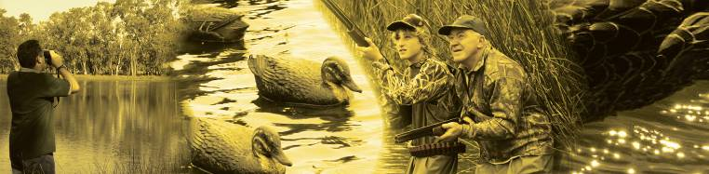

Arthur Rylah Institute for Environmental Research
Department of Sustainability and Environment
Heidelberg, Victoria

Report produced by: Arthur Rylah Institute for Environmental Research
Department of Sustainability and Environment
PO Box 137
Heidelberg, Victoria 3084
Phone (03) 9450 8600
Website: www.dse.vic.gov.au/ari
© State of Victoria, Department of Sustainability and Environment 2010
This publication is copyright. Apart from fair dealing for the purposes of private study, research, criticism or review as permitted under the Copyright Act 1968, no part may be reproduced, copied, transmitted in any form or by any means (electronic, mechanical or graphic) without the prior written permission of the State of Victoria, Department of Sustainability and Environment. All requests and enquiries should be directed to the Customer Service Centre, 136 186 or email customer.service@dse.vic.gov.au
Citation: Gormley, A. M. and Turnbull, J. D. (2010) Estimates of harvest for deer, duck and quail in Victoria: results from surveys of Victorian game licence holders in 2010. Arthur Rylah Institute for Environmental Research Technical Report Series No. 210. Department of Sustainability and Environment, Heidelberg, Victoria

ISSN 1835-3827 (print)
ISSN 1835-3835 (online)
ISBN 978-1-74242-917-5 (print)
ISBN 978-1-74242-918-2 (online)
Disclaimer: This publication may be of assistance to you but the State of Victoria and its employees do not guarantee that the publication is without flaw of any kind or is wholly appropriate for your particular purposes and therefore disclaims all liability for any error, loss or other consequence which may arise from you relying on any information in this publication.
Front cover photo: Enhancing Game Management Initiative, Game Management Unit, DSE.
Authorised by: Victorian Government, Melbourne
Printed by: NMIT Printroom, 77–91 St Georges Road, Preston 3072

Contents
List of tables and figures iv
Acknowledgements vi
Summary 1
1 Introduction 2
2 Methods 3
2.1 General methodology 3
2.2 Deer 4
2.3 Duck 4
2.4 Quail 4
3 Results 5
3.1 Deer 5
3.2 Duck 11
3.3 Quail 15
4 Discussion 18
4.1 Deer 18
4.2 Duck 18
4.3 Quail 19
4.4 Assumptions 19
References 21
Appendix 1 22

List of tables and figures

List of tables
Table 1: Summary of responses for deer surveys. 5
Table 2: Proportion and corresponding total number of deer licence holders that hunted, for each survey period. 5
Table 3: Average harvest of deer per hunter (game licence holders that hunted) for each survey period. 6
Table 4: Estimates of the total deer harvest in Victoria from July 2009 until June 2010, by holders of a deer game licence. 6
Table 5: Estimated average harvest of deer per game licence holder in each survey period. 6
Table 6: The number of each deer species reported harvested by hunters, and estimated total 2010 harvest. 7
Table 7: Reported numbers and percentages of each sex of deer species harvested. Standard errors for the percentages are shown in parentheses. 8
Table 8: Days hunted per game licence holder. 9
Table 9: Percentage of days hunted and associated deer harvest for various land types. 9
Table 10: Percentage of days hunted and associated deer harvest for hunting methods. 9
Table 11: Summary of responses for duck surveys in 2010. 11
Table 12: Proportion, and corresponding total number of game licence holders, that hunted for each survey period. 11
Table 13: Average harvest of ducks per hunter (i.e. game licence holders that hunted) for each survey period. 12
Table 14: Estimates of the duck harvest in Victoria in 2010 by holders of a duck game licence. 12
Table 15: Estimated harvest of ducks per game licence holder in each survey period. 12
Table 16: Reported numbers from hunters, proportion of the total harvest, and estimated total 2010 harvest for each species. 13
Table 17: Days hunted per game licence holder. 13
Table 18: Percentage of days hunted and associated duck harvest on private and public land. 13
Table 19: Summary of responses for quail surveys. 15
Table 20: Proportion of respondents that hunted, and estimated total number of licence holders that hunted, for each survey period. 15
Table 21: Average harvest of quail per hunter (i.e. game licence holders that hunted) for each survey period. 15
Table 22: Estimates of the 2010 quail harvest in Victoria by licensed quail hunters. 16
Table 23: Estimated harvest of quail per game licence holder. 16
Table 24: Days hunted per game licence holder. 16
Table 25: Percentage of days hunted and associated quail harvest by land tenure. 17
Table 26: Percentage of days hunted and associated quail harvest per grassland type. 17

List of figures
Figure 1: Estimated total deer harvest for each two-month survey period, by species. 8
Figure 2: Estimated total deer harvest by CMA region.. 10
Figure 3: Estimated total duck harvest by CMA region. 14
Figure 4: Estimated total quail harvest by CMA region. 17

Acknowledgements
We would like to thank all of the game licence holders who gave up their time to take part in the surveys. Dave Forsyth and Lindy Lumsden made valuable comments on previous drafts.

Summary
A telephone survey of Victorian hunters was conducted during the 2010 hunting seasons for deer, duck and quail to determine the total harvest for each game type. Game licence holders for each game type (deer, duck and quail) were randomly sampled and interviewed by telephone at intervals during the respective game seasons. For all surveys, respondents were asked whether they had hunted or not during the period for which the survey applied and if applicable the number and species of animals harvested. Additional information was obtained on hunting methods and locations.
Each holder of a game licence for deer hunted for approximately eight days on average during the 2010 deer-hunting season, with an average season harvest of 1.9 deer per game licence holder. Based on the total number of holders of a deer game licence, this corresponds to an estimated 35,278 deer harvested during the 2010 deer-hunting season in Victoria (95% confidence interval (CI) = 28,382 – 43,850). The most commonly harvested species was Sambar Deer (with an estimated total harvest of 28,762), followed by Fallow Deer (5,006). Harvest estimates for Red Deer (767) and Hog Deer (454) were based on a small number of responses.
Each holder of a game licence for ducks hunted for approximately four days during the 2010 duck-hunting season, with an average season harvest of 12.5 ducks per game licence holder. Based on the total number of game licence holders, this corresponds to an estimated 270,574 ducks harvested during the 2010 duck-hunting season in Victoria (95% CI = 234,857– 311,723). The most commonly harvested species was Australian Wood Duck (which comprised 45% of the total harvest), followed by Pacific Black Duck (36%), Grey Teal (10%), Chestnut Teal (5%), Australian Shelduck (2%), Australasian Shoveler (<1%) and Hardhead (<1%).
For quail, the average season harvest was 3.6 quail per game licence holder. Based on the total number of game licence holders, this corresponds to an estimated 86,302 quail harvested during the 2010 quail-hunting season in Victoria (95% CI = 60,465 – 123,179).
The approach used here explicitly accounts for the possibility that not every holder of a game licence will hunt during every survey period. The total number of game licence holders that hunted is estimated for each survey period and combined with the harvest per hunter to derive the total harvest for each survey period.
The methodology of performing telephone surveys throughout the season is likely to minimise memory bias and non-response bias compared to the end of year postal survey. However, sources of bias will remain due to over- and under-reporting, and the estimates of total harvest must be interpreted with care.

- Introduction
In order to effectively manage game species, it is important to quantify the numbers harvested. The Victorian Department of Sustainability and Environment (DSE) conducts a mail survey of 1,000 randomly selected game licence holders during June each year. There are, however, a number of problems associated with mail surveys, including recall bias, rounding of harvest estimates, and non-response bias (Wright 1978). Due to concerns about the reliability of the harvest estimates from the mail survey, DSE commissioned a series of regular telephone surveys to address the issue of recall bias. The three sets of telephone surveys were conducted during the various game harvest seasons for deer, duck and quail.
Deer hunting occurs all year round in Victoria. For this report, the 2010 deer-hunting season was defined as 1 July 2009 until 30 June 2010. There are four species of deer legally hunted in Victoria. Sambar Deer (Cervus unicolor) are able to be hunted all year by stalking. Hunting using scent trailing hounds is restricted to the second Saturday after Easter Sunday until 30 November. Hunting of Red Deer (Cervus elaphus) is restricted to the months of June and July only. Fallow Deer (Dama dama) are able to be hunted all year. Hog Deer (Axis porcinus) are only permitted to be hunted during April, and are subject to additional restrictions, such as one male and one female per hunter for the season. This survey follows similar telephone surveys performed during the 2009 deer-hunting season (Gormley and Turnbull 2009).
The 2010 duck-hunting season lasted ten weeks, from 20 March to 30 May. Eight species could legally be hunted in 2010: Pacific Black Duck (Anas superciliosa), Australian Wood Duck (Chenonetta jubata), Australian Shelduck (Tadorna tadornoides), Grey Teal (Anas gracilis), Chestnut Teal (Anas castanea), Pink-eared Duck (Malacorhynchus membranaceus), Hardhead (Aythya australis), Australasian Shoveler (Anas rhynchotis). The daily bag limit for the 2010 season was five game ducks per hunter (with a limit of one Australasian Shoveler). An additional three Australian Wood Duck could also be harvested, in effect increasing the daily bag limit to eight, depending on the species shot. These surveys follow from telephone surveys performed during the 2005, 2006 and 2009 duck-hunting seasons (Barker 2006; Gormley and Turnbull 2009).
The 2010 quail-hunting season lasted 12 weeks, from 3 April to 30 June. The daily bag limit for the 2010 season was 20 quail per hunter, with Stubble Quail (Coturnix pectoralis) the only native species that could legally be hunted. This survey follows similar telephone surveys performed during the 2008 and 2009 quail-hunting seasons (Gormley 2009; Gormley and Turnbull 2009).

- Methods
  - General methodology
A similar methodology was used to estimate deer, duck and quail harvests. All surveys were conducted by a telephone survey company called Marketing Skill on behalf of DSE. Estimates of total harvest by game licence holders were based on the reported hunting activities of the survey respondents.
For each game type, a series of surveys was performed throughout the corresponding season. Each survey involved telephoning a random sample of game licence holders and asking them to report their hunting activities only for the period covered by that survey. Therefore, although a respondent may have hunted during the period covered by Survey 2 and Survey 3, if they were contacted as part of Survey 3, then information was only collected that pertained to the period covered by Survey 3.
The information from the respondents was used as an estimate of the whole population of game licence holders for each game type. Estimates of harvest were determined for each of the survey periods and were summed to give an estimate of the total season harvest. For each survey period, the proportion of respondents that hunted was used as an estimate of the proportion of game licence holders that hunted. The proportion of game licence holders that hunted during each survey period was multiplied by the total number of game licence holders to give the total number of hunters for that survey period.
For each survey period, the average harvest per hunter was estimated from the total reported harvest divided by the number of respondents that hunted. The total harvest for each survey period was estimated by multiplying the average harvest per hunter by the total number of hunters for that survey period, as estimated previously. Finally, the total season harvest was estimated as the sum of the survey-specific total harvests.
We also estimated the season harvest per game licence holder. For each survey period, the average harvest per survey respondent was estimated by multiplying the average harvest per hunter by the proportion of respondents that hunted. The sum of these estimates across the season provided an estimate of the total season harvest per game licence holder.
Respondents that hunted were also asked to provide information on whether hunting was conducted on private land or public land (including State Game Reserves), the name of the town nearest to where they hunted, and the number of days they hunted. Regional harvest estimates were calculated by summing the reported harvest for each nearest town and then aggregating these by the corresponding Victorian Catchment Management Authority (CMA).
There were differences in the number and length of surveys between the duck, deer and quail surveys, as indicated in the following sections. Additional details of the methods, as well as examples of the calculations, are provided in Appendix 1.

  - Deer
Samples were drawn from hunters who held a game licence to harvest deer. Random samples of hunters were telephoned every two months over the 12-month period to give a total of six surveys. Respondents were asked to report the number and sex of each species harvested. During each survey, 200 respondents were interviewed regardless of whether they had hunted or not. Respondents were also asked what hunting methods they used (i.e. stalking, scent dogs or gun dogs).

  - Duck
Samples were drawn from hunters who held a game licence to harvest ducks during the 2010 season. A random sample of 200 licence holders was interviewed by telephone immediately after opening weekend (Duck Survey 1) followed by independent random samples of licence holders at two-week intervals for the remainder of the duck season (Duck Surveys 2 – 6). Respondents were also asked to report the number of each species harvested.

  - Quail
Samples were drawn from hunters who held a game licence to harvest quail during the 2010 season. A random sample of 300 licence holders was interviewed by telephone each month for April (Survey 1), May (Survey 2) and June (Survey 3). Respondents were asked to report the number of Stubble Quail harvested, the type of grassland where hunting occurred (native or stubble) and whether dogs were used.
- Results
  - Deer
The number of game licence holders with permits to hunt deer ranged from a high of 19,849 in November/December 2009, to a low of 16,088 in January/February 2010 (Table 1). In order to achieve the required sample size of 200 respondents per survey, a higher number of hunters were contacted, with an average of 95.6% of those contacted willing to take part in each survey.

Table 1: Summary of responses for deer surveys.
Deer Survey | Period | Licence holders | Respondents | Respondents who hunted | Days hunted | Deer harvested
1 | Jul–Aug 2009 | 19,250 | 200 | 81 | 449 | 108
2 | Sep–Oct 2009 | 19,369 | 200 | 65 | 309 | 64
3 | Nov–Dec 2009 | 19,849 | 200 | 46 | 149 | 42
4 | Jan–Feb 2010 | 16,088 | 200 | 23 | 67 | 18
5 | Mar–Apr 2010 | 18,148 | 200 | 80 | 355 | 64
6 | May–Jun 2010 | 19,364 | 200 | 57 | 255 | 75
Days hunted indicates the combined number of days that hunting took place and Deer harvested indicates total number of deer harvested respectively by respondents within each survey period.

The proportion of game licence holders that hunted in each survey period varied throughout the season (Table 2). An estimated 41% of deer game licence holders hunted at least once during July–August 2009, declining to a low of 12% during January–February 2010. These percentages correspond to 7,796 hunters in the July–August period and 1,738 hunters in the January–February period (Table 2).

Table 2: Proportion and corresponding total number of deer licence holders that hunted, for each survey period.
 |  |  | 95% CI |  | Total |  | 95% CI
Period | Proportion | SE | Lower | Upper | hunters | SE | Lower | Upper
Jul–Aug 2009 | 0.41 | 0.035 | 0.34 | 0.48 | 7,796 | 668 | 6,593 | 9,220
Sep–Oct 2009 | 0.33 | 0.033 | 0.27 | 0.40 | 6,198 | 641 | 5,158 | 7,683
Nov–Dec 2009 | 0.23 | 0.030 | 0.18 | 0.30 | 4,565 | 591 | 3,546 | 5,877
Jan–Feb 2010 | 0.12 | 0.023 | 0.08 | 0.17 | 1,850 | 363 | 1,264 | 2,708
Mar–Apr 2010 | 0.40 | 0.035 | 0.34 | 0.47 | 7,259 | 629 | 6,128 | 8,599
May–Jun 2010 | 0.29 | 0.032 | 0.23 | 0.35 | 5,519 | 618 | 4,434 | 6,869

The average number of deer harvested per hunter (i.e. per game licence holder that hunted) ranged from a high of 1.33 deer per hunter during July–August 2009 to a low of 0.78 in January–February 2010 (Table 3).
Table 3: Average harvest of deer per hunter (game licence holders that hunted) for each survey period.
 | Average harvest |  | 95% CI
Period | per hunter | SE | Lower | Upper
Jul–Aug 2009 | 1.33 | 0.24 | 0.94 | 1.90
Sep–Oct 2009 | 0.98 | 0.31 | 0.54 | 1.81
Nov–Dec 2009 | 0.91 | 0.22 | 0.58 | 1.44
Jan–Feb 2010 | 0.78 | 0.26 | 0.42 | 1.47
Mar–Apr 2010 | 0.80 | 0.15 | 0.56 | 1.15
May–Jun 2010 | 1.32 | 0.32 | 0.82 | 2.11
Average harvest per hunter = Deer harvested divided by Respondents who hunted (Table 1).

There were an estimated total of 35,278 deer harvested by all deer game licence holders from July 2009 through June 2010 inclusive (95% CI = 28,382 – 43,850; Table 4). Harvest was greatest in the winter months and lowest in the summer months.

Table 4: Estimates of the total deer harvest in Victoria from July 2009 until June 2010, by holders of a deer game licence.
 | Total |  | 95% CI
Survey | harvest | SE | Lower | Upper
Jul–Aug 2009 | 10,395 | 2,080 | 7,049 | 15,328
Sep–Oct 2009 | 6,198 | 2,074 | 3,273 | 11,737
Nov–Dec 2009 | 4,168 | 1,121 | 2,483 | 6,997
Jan–Feb 2010 | 1,448 | 556 | 700 | 2,996
Mar–Apr 2010 | 5,807 | 1,198 | 3,892 | 8,665
May–Jun 2010 | 7,262 | 1,947 | 4,333 | 12,170
Total Season | 35,278 | 3,927 | 28,382 | 43,850
Total harvest = Harvest per hunter (Table 3) × Total hunters (Table 2). Numbers may differ slightly due to rounding of Harvest per hunter.

The total average season harvest was 1.86 deer per game licence holder (95% CI = 1.49 – 2.30; Table 5). Note that for each survey period the average deer harvest per game licence holder (Table 5) is much lower than the average deer harvest per hunter (Table 3), as the former includes those respondents who did not hunt during the survey period.

Table 5: Estimated average harvest of deer per game licence holder in each survey period.
 | Average |  | 95% CI
Period | harvest | SE | Lower | Upper
Jul–Aug 2009 | 0.54 | 0.11 | 0.37 | 0.80
Sep–Oct 2009 | 0.32 | 0.11 | 0.17 | 0.61
Nov–Dec 2009 | 0.21 | 0.06 | 0.13 | 0.35
Jan–Feb 2010 | 0.09 | 0.03 | 0.04 | 0.19
Mar–Apr 2010 | 0.32 | 0.07 | 0.21 | 0.48
May–Jun 2010 | 0.38 | 0.10 | 0.22 | 0.63
Total Season | 1.86 | 0.20 | 1.49 | 2.30
Average harvest per game licence holder = Deer harvested divided by Respondents (Table 1).

Separate harvest estimates for each deer species are presented in Table 6. Estimates of Hog Deer and Red Deer were based on only a few reported harvest records, and therefore should be viewed with caution.

Table 6: The number of each deer species reported harvested by hunters, and estimated total 2010 harvest.
a. Sambar Deer
 |  |  | 95% CI
Period | Reported | Total harvest | Lower | Upper
Jul–Aug 2009 | 91 | 8,759 | 5,582 | 13,744
Sep–Oct 2009 | 62 | 6,004 | 3,115 | 11,573
Nov–Dec 2009 | 34 | 3,374 | 2,012 | 5,660
Jan–Feb 2010 | 7 | 563 | 217 | 1,464
Mar–Apr 2010 | 49 | 4,446 | 2,883 | 6,856
May–Jun 2010 | 58 | 5,616 | 2,987 | 10,558
Annual Total |  | 28,762 | 22,357 | 37,003

b. Fallow Deer
 |  |  | 95% CI
Period | Reported | Total harvest | Lower | Upper
Jul–Aug 2009 | 14 | 1,348 | 791 | 2,297
Sep–Oct 2009 | 2 | 194 | 57 | 661
Nov–Dec 2009 | 6 | 595 | 194 | 1,832
Jan–Feb 2010 | 11 | 885 | 327 | 2,394
Mar–Apr 2010 | 8 | 726 | 304 | 1,732
May–Jun 2010 | 13 | 1,259 | 581 | 2,728
Annual Total |  | 5,006 | 3,459 | 7,245

c. Hog Deer
 |  |  | 95% CI
Period | Reported | Total harvest | Lower | Upper
Jul–Aug 2009 | NA | NA | NA | NA
Sep–Oct 2009 | NA | NA | NA | NA
Nov–Dec 2009 | NA | NA | NA | NA
Jan–Feb 2010 | NA | NA | NA | NA
Mar–Apr 2010 | 5 | 454 | 172 | 1,195
May–Jun 2010 | NA | NA | NA | NA
Annual Total |  | 454 | 172 | 1,195
NB: Hog Deer are only permitted to be hunted during April.

d. Red Deer
 |  |  | 95% CI
Period | Reported | Total harvest | Lower | Upper
Jul–Aug 2009 | 3 | 289 | 57 | 1,465
Sep–Oct 2009 | NA | NA | NA | NA
Nov–Dec 2009 | NA | NA | NA | NA
Jan–Feb 2010 | NA | NA | NA | NA
Mar–Apr 2010 | *1 | 91 | 18 | 457
May–Jun 2010 | 4 | 387 | 153 | 983
Annual Total |  | 767 | 321 | 1,832
*NB: Red Deer are only permitted to be hunted in June and July.

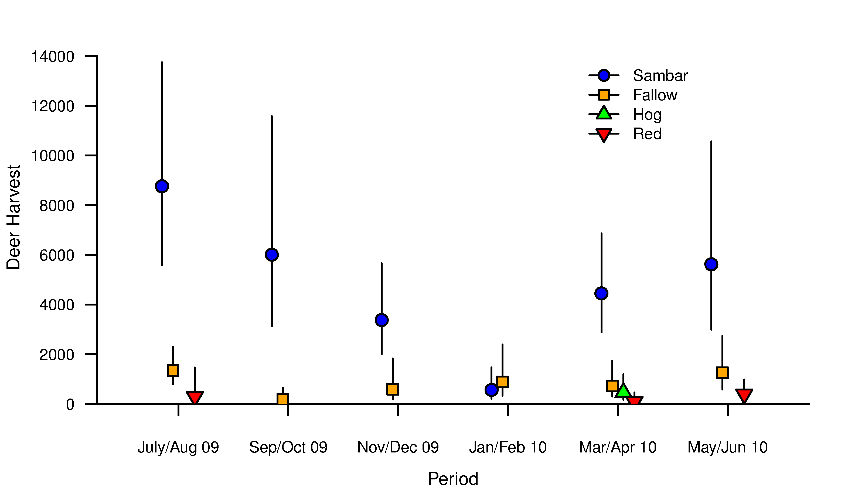
Figure 1: Estimated total deer harvest for each two-month survey period, by species. Vertical bars indicate 95% CIs.

For Sambar Deer, a higher proportion of stags (57%) were harvested compared to hinds (43%; Table 7). For Fallow Deer, the proportion of hinds and stags was the same (50% each). For Red Deer and Hog Deer, the reported numbers were too small to make any conclusions in terms of sex-specific harvest.

Table 7: Reported numbers and percentages of each sex of deer species harvested. Standard errors for the percentages are shown in parentheses.
 | Stags |  |  | Hinds
Species | n | % (SE) |  | n | % (SE)
Sambar Deer | 171 | 56.8% (2.9) |  | 130 | 43.2% (2.9)
Fallow Deer | 27 | 50.0% (6.7) |  | 27 | 50.0% (6.7)
Hog Deer | 4 | 80.0% (17.9) |  | 1 | 20.0% (17.9)
Red Deer | 6 | 75.0% (15.3) |  | 2 | 25.0% (15.3)

The number of days hunted in each survey period varied throughout the season. Each deer licence holder hunted an average of 7.91 days during the 2010 deer-hunting season, corresponding to a total of 149,930 hunter days (95% CI = 129,320 – 173,824; Table 8).
Table 8: Days hunted per game licence holder.
 | Days |  | 95% CI
Period | hunted | SE | Lower | Upper
Jul–Aug 2009 | 2.25 | 0.26 | – | –
Sep–Oct 2009 | 1.53 | 0.23 | – | –
Nov–Dec 2009 | 0.75 | 0.12 | – | –
Jan–Feb 2010 | 0.34 | 0.08 | – | –
Mar–Apr 2010 | 1.78 | 0.24 | – | –
May–Jun 2010 | 1.28 | 0.20 | – | –
Total days per licence holder | 7.91 | 0.49 | 7.01 | 8.92
Total hunting days | 149,930 | 11,328 | 129,320 | 173,824
NB: 95% CIs were only calculated for total days.
More deer hunting occurred on public land (70.6%) than on private land (20.2%), with similar proportions of deer harvested (Table 9).

Table 9: Percentage of days hunted and associated deer harvest for various land types.
Land Type | Days | Deer
Private Land | 20.2 % | 21.6 %
Public Land | 70.6 % | 73.3 %
Both | 8.7 % | 4.3 %
Not stated | 0.5 % | 0.8 %
Total | 100.0 % | 100.0 %

Stalking was the preferred hunting method, used in 79.9% of the hunting days compared, resulting in 65.2% of the reported harvest. However, hunting by scent hounds was the most productive method, used in only 15.8% of the hunting days, but accounting for 33.2% of the reported harvest (Table 10). The hunting method was not specified in 3.2% of the hunting days.

Table 10: Percentage of days hunted and associated deer harvest for hunting methods.
Hunting Method | Days | Deer
Stalking | 79.9 % | 65.2 %
Scent hounds | 15.8 % | 33.2 %
Gundogs | 1.1 % | 1.1 %
Not specified | 3.2 % | 0.5 %
Total | 100.0 % | 100.0 %

Total harvest was estimated to be greatest in the Goulburn Broken CMA, followed by the West Gippsland CMA (Figure 2). There was no reported harvest in the Mallee CMA or North Central CMA from the survey respondents.

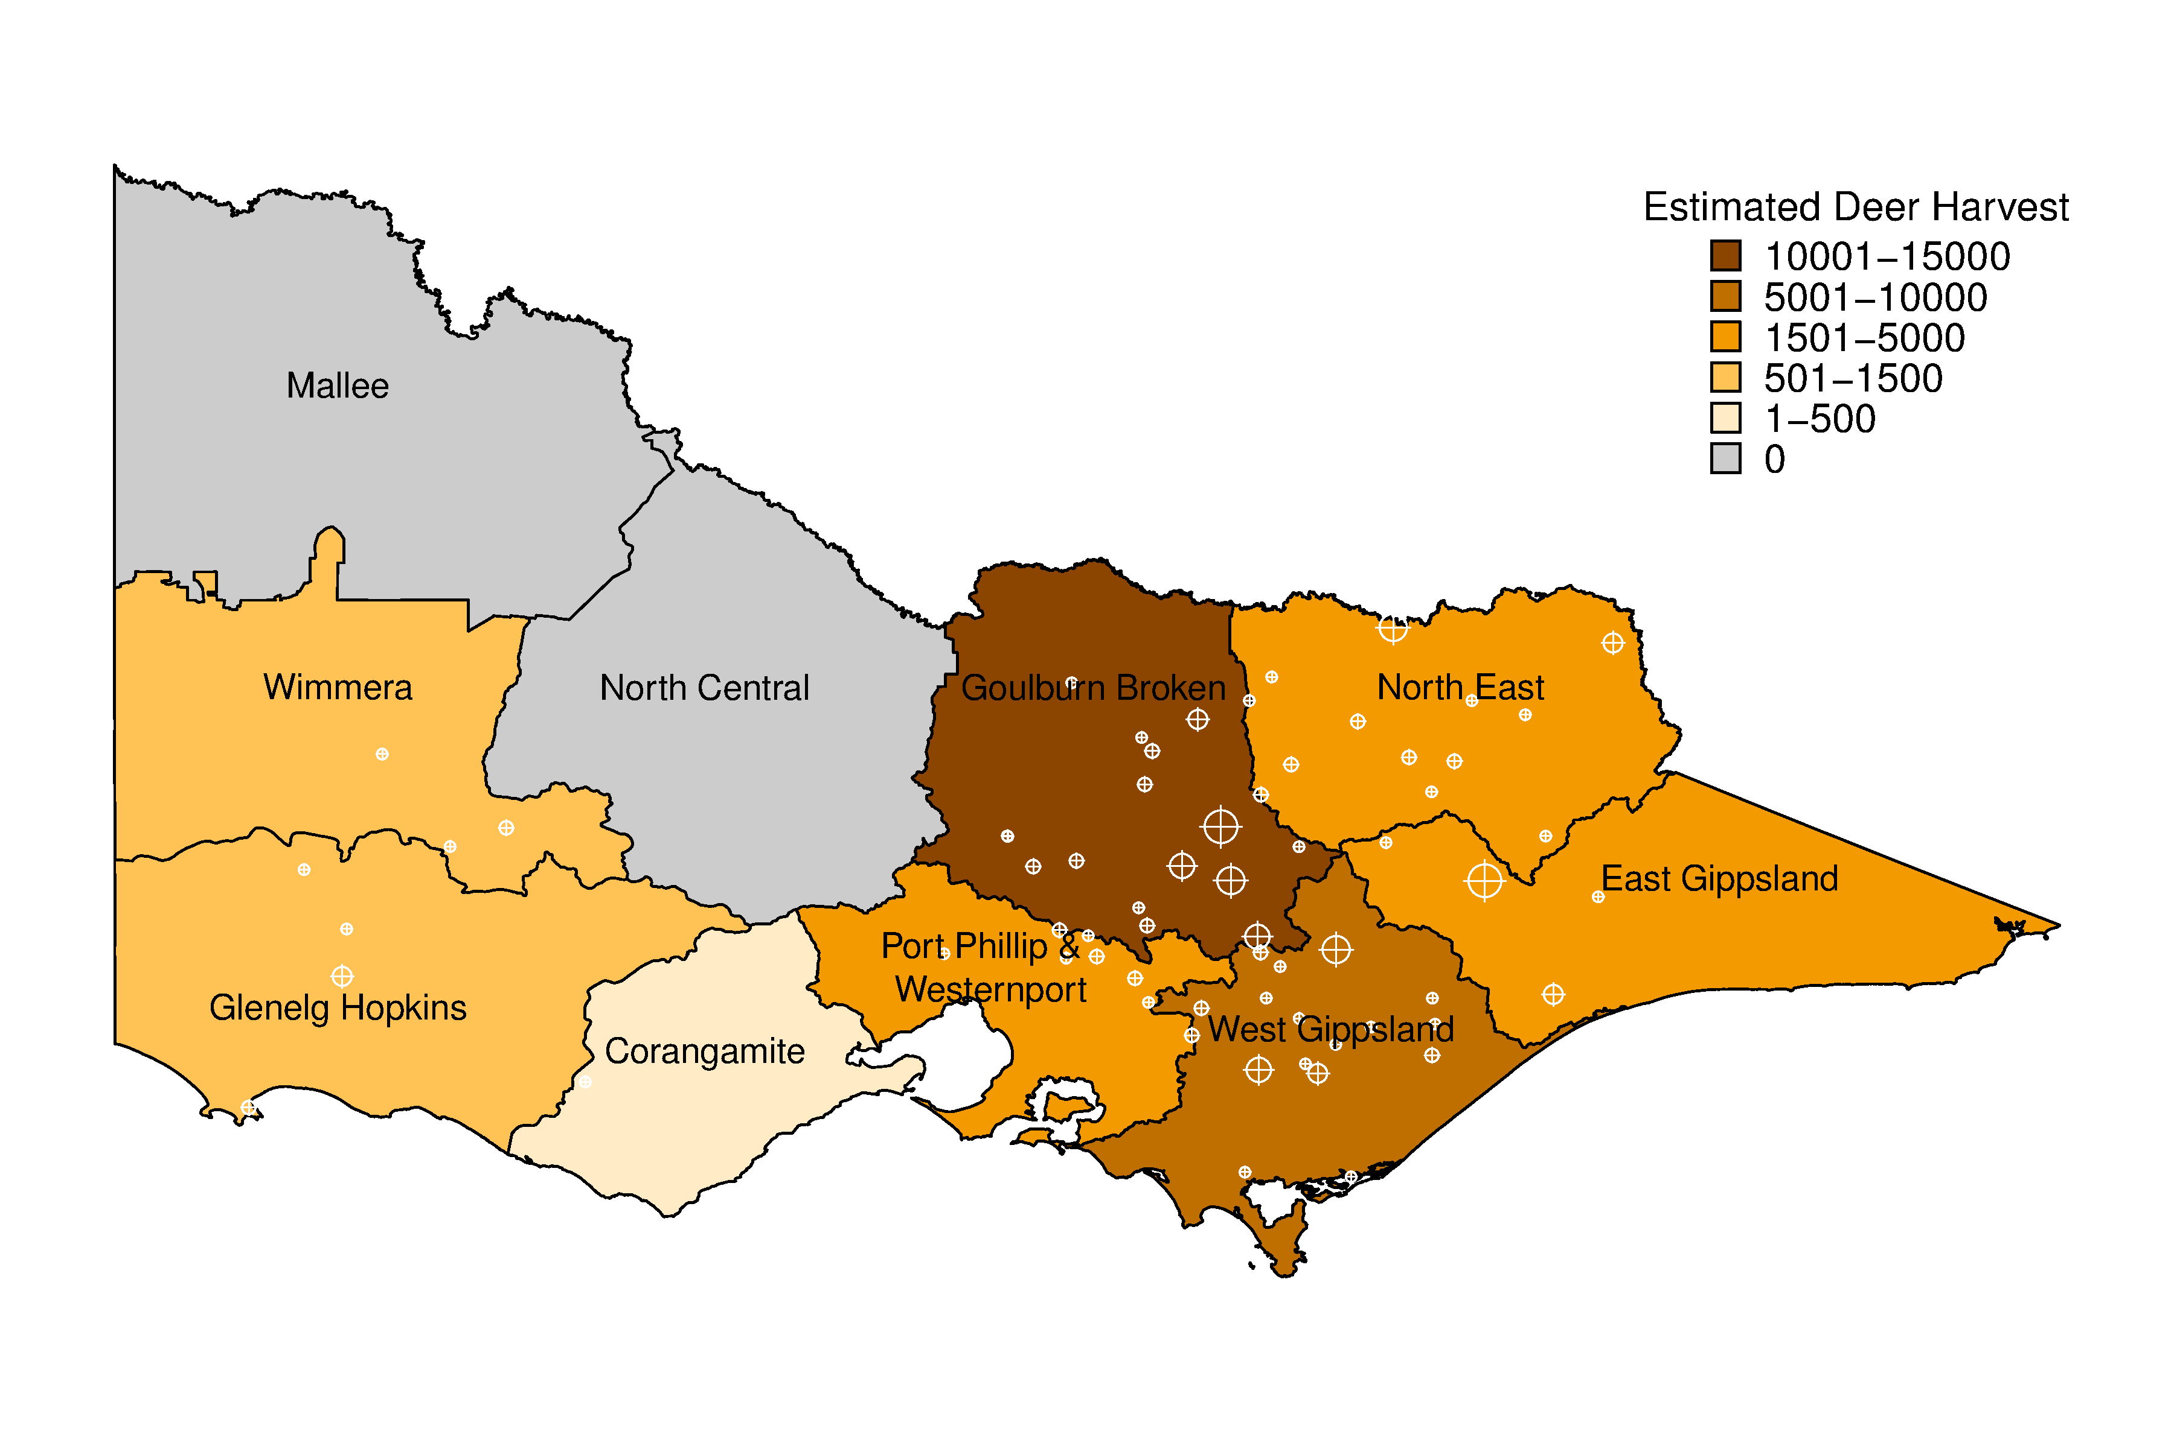
Figure 2: Estimated total deer harvest by CMA region. Cross-hairs indicate the nearest town to harvest locations from survey respondents, with larger symbols representing larger reported harvests.
  - Duck
The number of game licence holders with permits to hunt ducks remained relatively constant throughout the season, increasing slightly from 21,264 at opening weekend, to 21,861 at the end of May (Table 11). In order to achieve a sample size of 200 respondents per survey, a slightly higher number of hunters were contacted, with an average 94.5% of those contacted being willing to participate in each survey.

Table 11: Summary of responses for duck surveys in 2010.
Duck Survey | Period | Licence holders | Respondents | Respondents who hunted | Days hunted | Ducks harvested
1 | 20 Mar–21 Mar | 21,264 | 200 | 124 | 198 | 517
2 | 22 Mar–4 Apr | 21,264 | 200 | 63 | 151 | 480
3 | 5 Apr–18 Apr | 21,730 | 200 | 61 | 157 | 449
4 | 19 Apr–2 May | 21,730 | 200 | 42 | 93 | 280
5 | 3 May–15 May | 21,861 | 200 | 42 | 88 | 314
6 | 16 May–30 May | 21,861 | 200 | 52 | 109 | 467
Days hunted indicates the combined number of days that were hunted and Ducks harvested indicates total ducks harvested respectively by the respondents, within each survey period.

The proportion of game licence holders that hunted in each survey period varied throughout the season: 62% of licence holders hunted during opening weekend, corresponding to approximately 13,200 hunters (Table 12). The proportion that hunted during other survey periods varied from 21% to 32%, corresponding to between 4,500 and 6,700 duck hunters, respectively (Table 12).

Table 12: Proportion, and corresponding total number of game licence holders, that hunted for each survey period.
Duck |  |  |  | 95% CI |  | Total |  | 95% CI
Survey | Period | Proportion | SE | Lower | Upper | hunters | SE | Lower | Upper
1 | 20 Mar–21 Mar | 0.62 | 0.034 | 0.56 | 0.69 | 13,184 | 730 | 11,829 | 14,693
2 | 22 Mar–4 Apr | 0.32 | 0.033 | 0.26 | 0.39 | 6,698 | 698 | 5,463 | 8,212
3 | 5 Apr–18 Apr | 0.31 | 0.033 | 0.25 | 0.38 | 6,628 | 707 | 5,380 | 8,165
4 | 19 Apr–2 May | 0.21 | 0.029 | 0.16 | 0.27 | 4,563 | 626 | 3,492 | 5,963
5 | 3 May–15 May | 0.21 | 0.029 | 0.16 | 0.27 | 4,591 | 630 | 3,513 | 5,999
6 | 16 May–30 May | 0.26 | 0.031 | 0.21 | 0.33 | 5,684 | 678 | 4,503 | 7,175

The average number of ducks per hunter (i.e. per game licence holder that hunted) varied throughout the season (Table 13). The average harvest per hunter was 4.17 ducks on opening weekend, and ranged from 6.67 to 8.98 for the two-week survey periods.
Table 13: Average harvest of ducks per hunter (i.e. game licence holders that hunted) for each survey period.
Duck |  | Average harvest per hunter |  | 95% CI
Survey | Period | Average harvest per hunter | SE | Lower | Upper
1 | 20 Mar–21 Mar | 4.17 | 0.359 | 3.52 | 4.93
2 | 22 Mar–4 Apr | 7.62 | 0.741 | 6.30 | 9.21
3 | 5 Apr–18 Apr | 7.36 | 1.037 | 5.59 | 9.69
4 | 19 Apr–2 May | 6.67 | 0.910 | 5.11 | 8.70
5 | 3 May–15 May | 7.48 | 1.349 | 5.26 | 10.62
6 | 16 May–30 May | 8.98 | 1.685 | 6.24 | 12.93
Average harvest per hunter = Ducks harvested divided by Respondents who hunted (Table 11).
There were an estimated 54,967 ducks harvested during opening weekend (95% CI = 44,995 – 67,150). The total season harvest estimate was 270,574 (95% CI = 234,857 – 311,723; Table 14).

Table 14: Estimates of the duck harvest in Victoria in 2010 by holders of a duck game licence.
Duck | Period | Total harvest | SE | 95% CI
Survey | Period | Total harvest | SE | Lower | Upper
1 | 20 Mar–21 Mar | 54,967 | 5,629 | 44,995 | 67,150
2 | 22 Mar–4 Apr | 51,034 | 7,276 | 38,646 | 67,392
3 | 5 Apr–18 Apr | 48,784 | 8,623 | 34,591 | 68,799
4 | 19 Apr–2 May | 30,422 | 5,888 | 20,891 | 44,302
5 | 3 May–15 May | 34,322 | 7,777 | 22,136 | 53,217
6 | 16 May–30 May | 51,045 | 11,349 | 33,188 | 78,510
 | Total Season | 270,574 | 19,569 | 234,857 | 311,723
Total harvest = Harvest per hunter (Table 13) × Total hunters (Table 12).

The total average season harvest per licence holder was estimated to be 12.54 (95% CI = 10.89 – 14.43; Table 15). Note that for each survey period the average duck harvest per game licence holder is lower than the average duck harvest per hunter, as the former includes those respondents who did not hunt during the survey period, whereas the latter is conditional on those that hunted.

Table 15: Estimated harvest of ducks per game licence holder in each survey period.
Duck |  | Average harvest |  | 95% CI
Survey | Period | Average harvest | SE | Lower | Upper
1 | 20 Mar–21 Mar | 2.59 | 0.26 | 2.12 | 3.16
2 | 22 Mar–4 Apr | 2.40 | 0.34 | 1.82 | 3.17
3 | 5 Apr–18 Apr | 2.25 | 0.40 | 1.59 | 3.16
4 | 19 Apr–2 May | 1.40 | 0.27 | 0.96 | 2.04
5 | 3 May–15 May | 1.57 | 0.35 | 1.01 | 2.43
6 | 16 May–30 May | 2.34 | 0.52 | 1.52 | 3.59
 | Total Season | 12.54 | 0.90 | 10.89 | 14.43
Average harvest per game licence holder = Ducks harvested divided by Respondents (Table 11).

Australian Wood Duck comprised 45% of the total reported harvest, followed by Pacific Black Duck (36%), Grey Teal (10%), Chestnut Teal (5%), Australian Shelduck (2%), and Australasian Shoveler and Hardhead (<1% each), with no reported harvest of Pink-eared Duck. Total harvest estimates for each species were obtained by multiplying the total estimated duck harvest by the percentages of total harvest for that species (Table 16).

Table 16: Reported numbers from hunters, proportion of the total harvest, and estimated total 2010 harvest for each species.
 |  | Proportion |  | Estimated |  | 95% CI
Species | Reported | of harvest | SE | harvest | SE | Lower | Upper
Pacific Black Duck | 894 | 0.36 | 0.010 | 96,487 | 7,443 | 82,967 | 112,210
Australian Wood Duck | 1,134 | 0.45 | 0.010 | 122,390 | 9,251 | 105,559 | 141,904
Australian Shelduck | 55 | 0.02 | 0.003 | 5,936 | 901 | 4,417 | 7,978
Grey Teal | 241 | 0.10 | 0.006 | 26,011 | 2,465 | 21,610 | 31,307
Chestnut Teal | 133 | 0.05 | 0.004 | 14,354 | 1,595 | 11,552 | 17,836
Teal (species unspecified) | 22 | 0.01 | 0.002 | 2,374 | 532 | 1,538 | 3,665
Pink-eared Duck | 0 | 0 | NA | 0 | NA | NA | NA
Australasian Shoveler | 2 | <0.01 | 0.001 | 216 | 153 | 62 | 756
Hardhead | 3 | <0.01 | 0.001 | 324 | 188 | 112 | 933
Other (not specified) | 23 | 0.01 | 0.002 | 2,482 | 546 | 1,622 | 3,800

Each game licence holder hunted an average of four days during the 2010 duck-hunting season (Table 17). When multiplied by the total number of game licence holders in each survey period, this corresponds to a total of 85,801 hunter days (95% CI = 75,066 – 98,072).

Table 17: Days hunted per game licence holder.
Duck |  |  |  | 95% CI
Survey | Period | Average | SE | Lower | Upper
1 | 20 Mar–21 Mar | 0.99 | 0.06 | – | –
2 | 22 Mar–4 Apr | 0.76 | 0.10 | – | –
3 | 5 Apr–18 Apr | 0.79 | 0.11 | – | –
4 | 19 Apr–2 May | 0.47 | 0.08 | – | –
5 | 3 May–15 May | 0.44 | 0.07 | – | –
6 | 16 May–30 May | 0.55 | 0.09 | – | –
 | Total per licence holder | 3.98 | 0.21 | 3.58 | 4.42
 | Total hunting days | 85,801 | 5,858 | 75,066 | 98,072
NB: 95% CIs were only calculated for total days.
More duck hunting was conducted on private land (55.3%) than on public land (44.4%) (Table 18). A relatively higher proportion of the duck harvest was on private land (63.7%) compared to public land (35.8%). Total harvest was estimated to be greatest in the Goulburn Broken CMA, followed by the North Central CMA and Corangamite CMA (Figure 3).

Table 18: Percentage of days hunted and associated duck harvest on private and public land.
Land Type | Days | Duck harvest
Private land | 55.3 % | 63.7 %
Public land | 44.4 % | 35.8 %
Not specified | 0.3 % | 0.5 %
Total | 100.0 % | 100.0 %

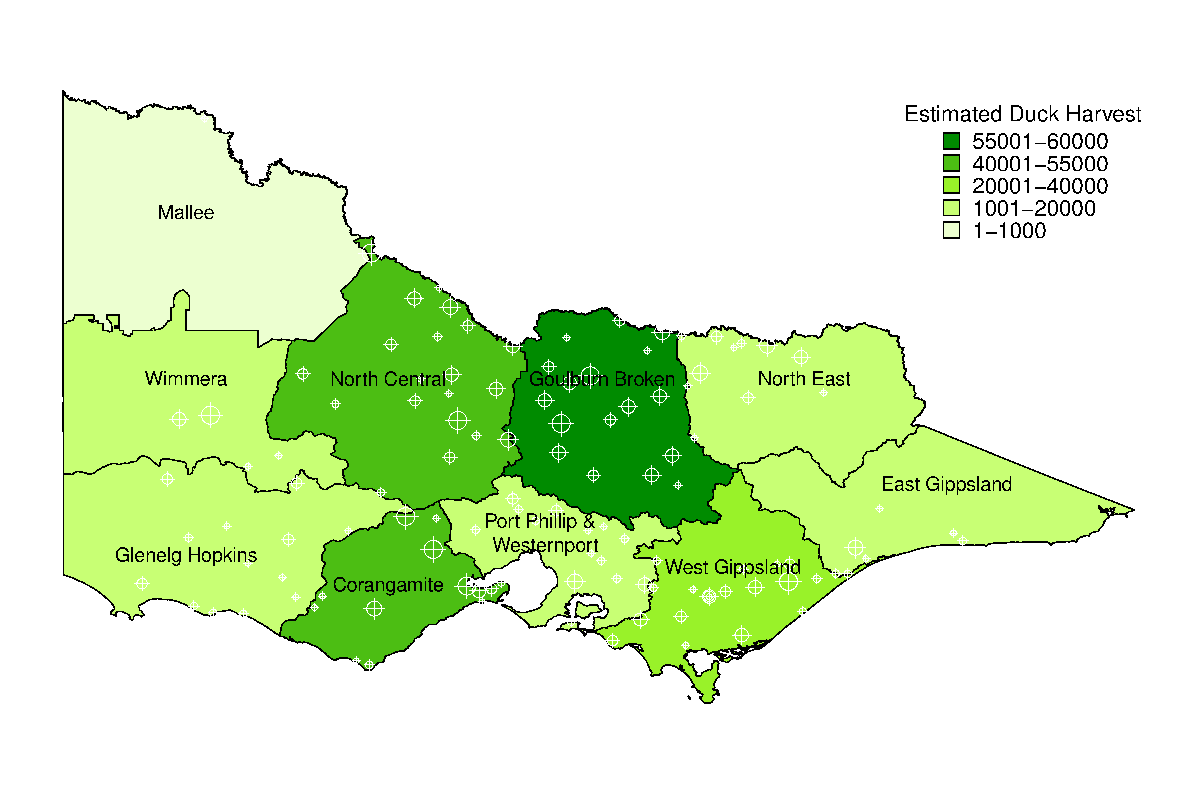
Figure 3: Estimated total duck harvest by CMA region. Cross-hairs indicate the nearest town to harvest locations from survey respondents, with larger symbols representing larger reported harvests.

  - Quail
The number of game licence holders with permits to hunt quail remained relatively constant throughout the season (Table 19). In order to achieve the required sample size of respondents, a slightly higher number of hunters were contacted, with an average of 95% of those contacted being willing to participate in each survey.

Table 19: Summary of responses for quail surveys.
Quail Survey | Period | Licence holders | Respondents | Respondents who hunted | Days hunted | Quail harvested
1 | April | 23,872 | 300 | 40 | 159 | 532
2 | May | 24,129 | 300 | 25 | 71 | 354
3 | June | 24,214 | 300 | 24 | 79 | 192
Days hunted indicates the combined number of days that were hunted and Quail harvested indicates the total quail harvested respectively by respondents within each survey period.

The proportion of game licence holders that hunted in each monthly survey period was generally low, ranging from 8% to 13%. These percentages correspond to between 1,937 and 3,183 hunters in any one-month period (Table 20).

Table 20: Proportion of respondents that hunted, and estimated total number of licence holders that hunted, for each survey period.
 |  |  | 95% CI |  | Total |  | 95% CI
Period | Proportion | SE | Lower | Upper | hunters | SE | Lower | Upper
April | 0.13 | 0.020 | 0.10 | 0.18 | 3,183 | 469 | 2,389 | 4,241
May | 0.08 | 0.016 | 0.06 | 0.12 | 2,011 | 385 | 1,386 | 2,917
June | 0.08 | 0.016 | 0.05 | 0.12 | 1,937 | 379 | 1,325 | 2,833

The average number of quail harvested per hunter (i.e. per game licence holder that hunted) varied throughout the season (Table 21). The average harvest per hunter ranged from 8 quail during June to 14 quail in May.

Table 21: Average harvest of quail per hunter (i.e. game licence holders that hunted) for each survey period.
 | Average harvest |  | 95% CI
Period | per hunter | SE | Lower | Upper
April | 13.30 | 2.99 | 8.60 | 20.56
May | 14.16 | 4.00 | 8.22 | 24.39
June | 8.00 | 2.08 | 4.84 | 13.21
Average harvest per hunter = Quail harvested divided by Respondents who hunted (Table 19).

There were an estimated 86,302 quail harvested by all holders of a game licence for quail during the 2010 quail season (95% CI = 60,465 – 123,179; Table 22).

Table 22: Estimates of the 2010 quail harvest in Victoria by licensed quail hunters.
 | Total |  | 95% CI
Period | harvest | SE | Lower | Upper
April | 42,333 | 11,379 | 25,226 | 71,042
May | 28,472 | 9,723 | 14,849 | 54,593
June | 15,497 | 5,047 | 8,317 | 28,875
Total Season | 86,302 | 15,796 | 60,465 | 123,179
Total harvest = Harvest per hunter (Table 21) × Total hunters (Table 20).

The total average season harvest was 3.59 quail per game licence holder (95% CI = 2.45 – 5.26; Table 23). Note that for each survey period, the average quail harvest per game licence holder is lower than the average quail harvest per hunter, as the former averages across those respondents who did not hunt during the survey period, whereas the latter is conditional on those that hunted.

Table 23: Estimated harvest of quail per game licence holder.
 | Average |  | 95% CI
Period | harvest | SE | Lower | Upper
April | 1.77 | 0.48 | 1.05 | 3.00
May | 1.18 | 0.46 | 0.57 | 2.46
June | 0.64 | 0.24 | 0.32 | 1.29
Total Season | 3.59 | 0.71 | 2.45 | 5.26
Average harvest = Quail harvested divided by Respondents (Table 19).

The number of days hunted each month varied throughout the season. On average, each quail licence holder hunted on approximately one day during the 2010 season, corresponding to 24,739 hunter days (95% CI = 17,711 – 34,557; Table 24).

Table 24: Days hunted per game licence holder.
 |  |  | 95% CI
Period | Av | SE | Lower | Upper
April | 0.53 | 0.12 | – | –
May | 0.24 | 0.05 | – | –
June | 0.26 | 0.06 | – | –
Total days per licence holder | 1.03 | 0.14 | 0.78 | 1.35
Total hunting days | 24,739 | 4,249 | 17,711 | 34,557
NB: 95% CIs were only calculated for total days.

Most quail hunting was conducted on private land (87.4% of the hunting days), resulting in 81.5% of the harvested quail (Table 25). A smaller proportion of hunting was conducted in State Game Reserves (7.4%), resulting in 9.3% of the harvested quail. A small proportion hunted on both private land and State Game Reserves during the same hunting trip. Dogs were used to assist in quail hunting approximately 83% of the time, resulting in 86% of the harvested quail. Most quail hunting, and quail harvest, took place on stubble grasslands, followed by native grasslands, or combinations of the two (Table 26). The total quail harvest was greatest in the Corangamite CMA, followed by the Port Phillip & Western Port CMA, and the North Central CMA (Figure 4). No quail harvest was reported from survey respondents in the North East CMA or the Mallee CMA.

Table 25: Percentage of days hunted and associated quail harvest by land tenure.
Land tenure | Days | Quail harvest
Private land only | 87.4 % | 81.5 %
State Game Reserves only | 7.4 % | 9.3 %
Private land and State Game Reserves | 5.2 % | 9.2 %
Total | 100.0 % | 100.0 %

Table 26: Percentage of days hunted and associated quail harvest per grassland type.
Grassland | Days | Quail harvest
Introduced grass | 8.7 % | 8.4 %
Native grass | 18.8 % | 21.3 %
Stubble | 34.0 % | 22.4 %
Stubble and native | 15.2 % | 30.1 %
Stubble and introduced | 6.8 % | 5.6 %
Stubble, native and introduced | 13.9 % | 6.2 %
Unspecified | 2.6 % | 6.0 %
Total | 100.0 % | 100.0 %

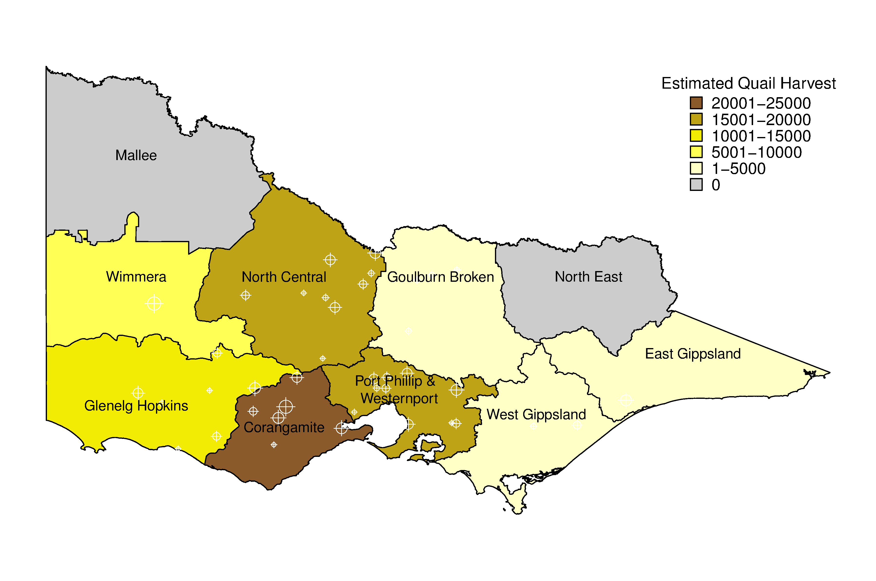
Figure 4: Estimated total quail harvest by CMA region. Cross-hairs indicate the nearest town to harvest locations from survey respondents, with larger symbols representing larger reported harvest.

- Discussion
  - Deer
A total of 35,278 deer were estimated to have been harvested in Victoria during the 2010 season (95% CI = 28,382 – 43,850). The most commonly harvested species was Sambar Deer (28,762), followed by Fallow Deer (5,006). It is difficult to make any inference about the harvest estimates of Red Deer and Hog Deer due to the very small numbers of reported harvest from surveyed game licence holders. The actual harvests of Red Deer and Hog Deer are likely to be very small (<1,000). The harvest of Hog Deer is strongly regulated and hence the actual number of animals legally harvested is recorded at checking stations. For 2010, 90 Hog Deer, comprised of 20 hinds and 70 stags, were recorded at checking stations. An additional 34 Hog Deer (9 hinds and 25 stags) were harvested on Sunday Island, a private cooperative. The total known harvest of 124 Hog Deer is less than the lower 95% confidence limit of 172 for the estimated harvest. This result illustrates the caution that must be exercised when dealing with small reported harvests.
The total 2010 season harvest is lower than the 2009 harvest of 39,418 deer (Gormley and Turnbull 2009), despite a greater number of game licence holders. The number of days hunted per game licence holder were similar between years (7.91 vs 7.75), although the total hunting days (i.e. aggregated across all game licence holders) was much greater in 2010. The lower total harvest is due to a lower annual harvest of 1.86 deer per game licence holder over the 2010 season compared to 2.43 over the 2009 season. A greater effort was apparently required in 2010, with 4.3 hunting days per deer, compared to 3.0 in 2009.
Similar numbers of Fallow Deer were harvested in 2010 (5,006) compared to 2009 (4,299), but the total harvest of Sambar Deer was substantially lower (28,762 in 2010 vs 34,368 in 2009).

  - Duck
A total of 270,574 ducks were estimated to have been harvested in Victoria during the 2010 season (95% CI = 234,857 – 311,273), a 20% increase on the 2009 harvest (222,302; Gormley and Turnbull 2009). The increased harvest in 2010 is unsurprising given the differences between the seasons. Firstly, the 2009 season was for seven weeks whereas the 2010 season lasted ten weeks. Interestingly, the number of days hunted per game licence holder over the entire season was the same in 2009 and 2010. In addition, the bag limit in 2009 was five ducks per hunter per day compared to eight ducks per hunter per day in 2010. The total season harvest per game licence holder was higher in 2010, with 12.54 ducks per game licence holder, compared to 11.10 in 2009. There was also an increase in the number of game licence holders in 2010, ranging from 21,264 to 21,861, compared to 20,030 in 2009. As a result of the increased bag limit, the average number of ducks per hunting day increased from 2.8 in 2009 to 3.2 in 2010.
The number of species able to be harvested was increased in 2010 to include Australasian Shoveler, Hardhead and Pink-eared Duck. However, the reported harvest of these species was very small, and likely comprise a very small proportion of the total harvest. As in 2009, the majority of the harvest was Australian Wood Duck and Pacific Black Duck, followed by Grey Teal, Chestnut Teal and Australian Shelduck. Total harvest of both Australian Wood Duck and Chestnut Teal in 2010 remained similar to the 2009 harvest estimates. Harvest of Pacific Black Duck increased from 55,150 in 2009 to 96,487 in 2010. Harvest of Grey Teal increased from 20,919 to 26,011, and Australian Shelduck increased from 2,173 in 2009 to 5,936 in 2010.

  - Quail
A total of 86,302 quail were estimated to have been harvested in Victoria during the 2010 season (95% CI = 60,465 – 123,179), a substantial decrease on the 2009 harvest of 189,155 (Gormley and Turnbull 2009). This decrease was despite a similar number of total hunter days (24,739 in 2010 and 24,648 in 2009). The number of quail per hunting day decreased from 7.8 in 2009 to only 3.5 in 2010. Whether this decrease reflects lower numbers, poorer hunting conditions or some other factor is unknown. It should be noted that the number of hunting days is only an approximate estimate of total effort: someone who hunted for two hours and someone else who hunted for 12 hours are both recorded as having hunted for one day.
Due to the structure of game licences in Victoria, not every holder of a game licence permitted to hunt quail will hunt quail. The price of a game licence for Game birds including duck is the same as a game licence for Game birds not including duck. Anyone that wants to hunt ducks automatically has quail included in their licence. For many hunters, duck hunting will be their primary activity. Hence, a high proportion of game licence holders will be permitted to hunt quail even though they may not intend to do so. This does not affect the estimates of quail harvest, because the calculations explicitly account for the proportion of quail game licence holders who did not actually hunt quail.

  - Assumptions
The estimates of harvest for each game type are derived under the assumption that the samples of respondents are representative of the entire population of Victorian game licence holders. This assumption may be violated for a number of reasons. One reason relates to the causes of non-response. For example, if some game licence holders do not want to take part in the survey due to having exceeded their bag limit, then the estimate of total harvest will be an underestimate of the true harvest. Conversely, if game licence holders do not want to take part because they had hunted unsuccessfully, then the estimate of harvest will be an overestimate of the true harvest. Other potential sources of bias are due to memory recall (respondents cannot remember their harvest), as well as deliberate over- or under-reporting (reported numbers are knowingly reported incorrectly). Memory bias and non-response bias tend to inflate estimates of total harvest by as much as 40% (Wright 1978, Barker 1991). It is likely, however, that the sampling strategy of telephone interviews after each two-week period in the case of ducks and quail, and every two months for deer, will ensure that both memory bias and non-response bias will be kept low when compared with postal surveys and complete end-of-season surveys (Barker 1991; Barker et al. 1992). It is worth noting that the response rate for all surveys was generally above 95% (i.e. very high). Nevertheless, it is likely that some bias remains and the estimates of total harvest should be interpreted with care.
It is important to note that the methodology used here explicitly accounts for the possibility that not every game licence holder hunts in every survey period, let alone hunts successfully (indeed some game licence holders may not hunt at all during the season). This was achieved by estimating the total number of game licence holders that hunted in each survey period. For example, there were only between 2,000–3,000 people hunting for quail in any one-month period (Table 20), out of a potential 24,000 quail hunters. Similarly, the estimate of total season bag per game licence holder is the sum of the harvest per game licence holder, not the sum of the harvest per hunter. For example, the average season bag for deer was estimated as 1.86 deer per game licence holder (Table 5). By comparison, summing the average harvest per hunter (from Table 3) gives a total of 6.1 deer: this would be the average season bag if every holder of a game licence for deer hunted in each period, which of course is not the case.
The reported uncertainty in the estimates of total harvest for deer, duck and quail is due to two factors. Firstly, there is always going to be variation in the reported numbers of animals shot between respondents that had hunted. For example, within a given survey period for duck hunting, some respondents indicated that they hunted unsuccessfully, whereas others took multiple trips and indicated a total harvest of up to 50 ducks during that period. The second source of uncertainty is due to taking samples of hunters rather than a complete census. However, the degree of sampling uncertainty is reduced by having a sample size of at least 200 respondents per survey. These sources of uncertainty are reflected by the confidence intervals for the estimates of total harvest.
The spatial distributions of the deer, duck and quail harvest should also be interpreted with care. Grouping the harvest by a relatively large region (CMA) provides a broad-scale view of the distribution of harvest. Grouping by smaller regions would provide a finer scale representation, but this would come at a cost of increased bias in many regions. Because the data are from a sample of game licence holders rather than a complete census, it is likely that some areas that were actually hunted would be shown as having a zero harvest if no respondents that hunted those areas were contacted. This would be increasingly likely at finer spatial scales. Furthermore, respondents were only asked to report the nearest town to where they hunted, not the actual location. It is therefore possible that the nearest town was in a different CMA than the hunting location.
The methodology used to produce these harvest estimates addresses some of the issues present in the hunter mail surveys. Repeating these surveys in subsequent years with the same methodology will provide better harvest estimates on which to base management decisions.

References
Barker, R. J. (1991) Nonresponse to New Zealand waterfowl harvest surveys. Journal of Wildlife Management 55: 126–131
Barker, R. J. (2006) Survey of waterfowl hunting in Victoria by Victorian licence holders 2006. Report for the Game Management Unit, DSE, Victoria
Barker, R. J., Geissler, P. H. and Hoover, B. A. (1992) Sources of nonresponse to the federal waterfowl hunter questionnaire. Journal of Wildlife Management 56: 337–343
Department of Sustainability and Environment (2010) Victorian Hunting Guide 2010. 46 pp.
Gormley, A. M. (2009) Survey of Quail Hunting in Victoria by Victorian licence holders 2008. Report for the Game Management Unit, DSE, Victoria. 10 pp.
Gormley, A. M. and Turnbull, J. D. (2009) Estimates of harvest for deer, duck and quail in Victoria: results from surveys of Victorian game licence holders in 2009. Arthur Rylah Institute for Environmental Research Technical Report Series No. 196. Department of Sustainability and Environment, Heidelberg, Victoria
Wright, V. L. (1978) Causes and effects of biases on waterfowl harvest estimates. Journal of Wildlife Management 42: 251–262

Appendix 1
Common definitions used
SD = standard deviation of the data. Represents the variation in the numbers reported.
SE = standard error of the mean. Represents the variation in the estimated mean.
CV = Coefficient of variation. Calculated as: CV = SE ÷ Average. This provides an indication as to how much uncertainty is in the estimate relative to the mean.

Calculations
For each survey j, we surveyed n_{j} respondents of which h_{j} had hunted. The proportion of respondents that hunted in each period j is given as:
$p_{j}=\frac{h_{j}}{n_{j}}$ e.g., for duck survey 3, we obtain: $\frac{\text{61}}{\text{200}}=0\text{.}\text{305}$

The total number of hunters for each survey period (H_{j}) was estimated by multiplying the total number of licence holders (L) by the proportion of respondents that reported having hunted during that survey period (p_{j}), as found previously:
$H_{j}=p_{j}L$ e.g., for duck survey 3, we obtain: $0\text{.}\text{305}×\text{21},\text{730}=6,\text{628}$

The estimated average harvest per hunter (w_{j}) is the total reported harvest for survey j (y_{j}) divided by the total number of respondents that hunted (h_{j}):
$w_{j}=\frac{y_{j}}{h_{j}}$ e.g., for duck survey 3, we obtain: $\frac{\text{449}}{\text{61}}=7\text{.}\text{36}$

The total harvest for each survey period (W_{j}) was estimated by multiplying the average harvest per hunter (w_{j}) by the total number of hunters (H_{j}):
$W_{j}=w_{j}H_{j}$ e.g., for duck survey 3, we obtain: $7\text{.}\text{36}×6,\text{628}=\text{48},\text{784}$

The estimate of total harvest is calculated as the sum of the estimated harvest for each survey period:
$$W_{\text{TOT}}=W_{1}+W_{2}+W_{3}+W_{4}$$

Standard errors (SE) for the proportion of respondents that hunted are given as:
$\text{SE}(p_{j})=\sqrt{\frac{p_{j}\left(1−p_{j}\right)}{n_{j}}}$ e.g., for duck survey 3, we obtain: $\sqrt{\frac{0\text{.}\text{31}\left(0\text{.}\text{69}\right)}{\text{200}}}=0\text{.}\text{033}$

Standard errors for the average harvest per hunter are given as:
$\text{SE}(w_{j})=\frac{\text{SD}\left(w_{j}\right)}{\sqrt{h_{j}}}$ e.g., for duck survey 3, we obtain: $\frac{8\text{.}1}{\sqrt{\text{61}}}=1\text{.}\text{037}$

The standard errors for the total estimated harvest per survey period (W_{j}) is found by determining the Coefficient of Variation (CV) of p_{j} and w_{j} and then adding their sum of squares to find the combined CV (assuming independence).

$\text{CV}(w_{j})=\frac{\text{SE}(w_{j})}{w_{j}}$, and $\text{CV}(p_{j})=\frac{\text{SE}(p_{j})}{p_{j}}$
$$\text{CV}(W_{j})=\sqrt{{\left(\text{CV}(w_{j})\right)}^{2}+{\left(\text{CV}(p_{j})\right)}^{2}}$$
$$\text{SE}(W_{j})=\text{CV}\left(W_{j}\right)×W_{j}$$

The standard error of the total harvest is calculated as:
$$\text{SE}(W_{\text{TOT}})=\sqrt{{\left(\text{SE}(W_{1})\right)}^{2}+{\left(\text{SE}(W_{2})\right)}^{2}+{\left(\text{SE}(W_{3})\right)}^{2}+{\left(\text{SE}(W_{4})\right)}^{2}}$$

Confidence intervals were computed on the natural logarithm scale and back-transformed to ensure that lower limits were ≥ 0. A consequence is that confidence intervals are asymmetric, and cannot be reported as the estimate plus or minus a fixed value. In general, for some estimate denoted as , 95% confidence interval limits were calculated using:
upper limit
lower limit, where:
e.g., for the total duck harvest we have
$$\text{CV}=\frac{\text{19},\text{569}}{\text{270},\text{574}}=0\text{.}\text{072}$$
$$r=\text{exp}\left(1\text{.}\text{96}\sqrt{\text{ln}\left(1+0\text{.}{\text{072}}^{2}\right)}\right)=1\text{.}\text{15}$$
Therefore, Upper and Lower Confidence Intervals are given by:
$$\begin{matrix}\text{UL}=\text{270},\text{574}×1\text{.}\text{15}=\text{311},\text{723} \\ \text{LL}=\text{270},\text{574}÷1\text{.}\text{15}=\text{234},\text{857}\end{matrix}$$

ISSN 1835-3827 (print)
ISSN 1835-3835 (online)
ISBN 978-1-74242-917-5 (print)
ISBN 978-1-74242-918-2 (online)

Australian Wood Duck is also referred to as Wood Duck, Maned Duck, and Maned Goose.
Australian Shelduck is often referred to as Mountain Duck.
Hardhead is also referred to as White-eyed Duck.
Australasian Shoveler is often referred to as Blue-winged Shoveler.
Respondent refers to game licence holders that were contacted and agreed to take part in the survey.
Hunter refers to a game licence holder who actually went out and hunted (successfully or unsuccessfully) at some point during the period with which the survey is concerned.

