
Estimates of Harvest for Deer, Duck and Quail in Victoria: Results from Surveys of Victorian Game Licence Holders in 2012

P.D. Moloney and J.D. Turnbull

November 2012
Arthur Rylah Institute for Environmental Research
Technical Report Series No. 239



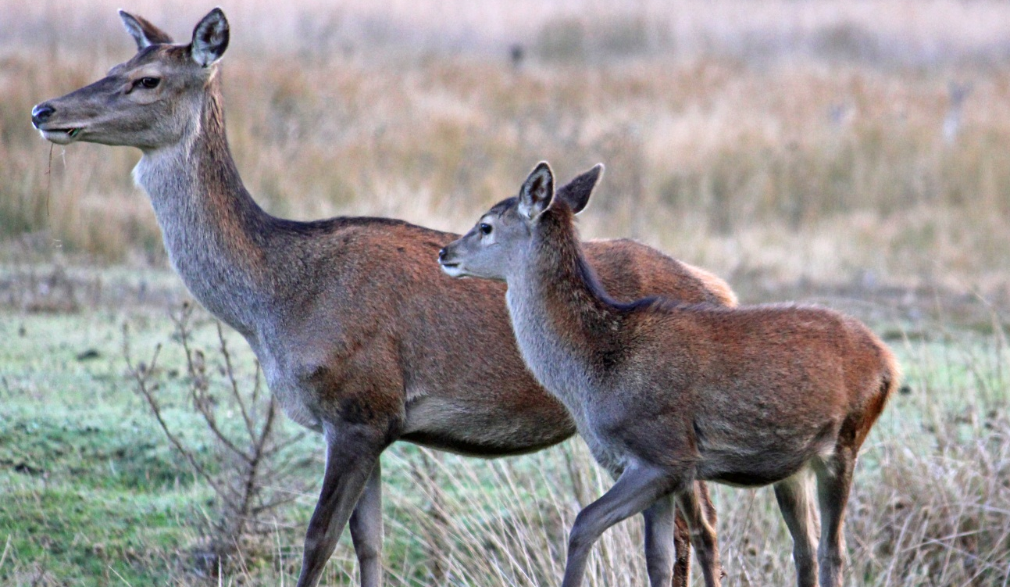



Estimates of harvest for deer, duck and quail
in Victoria: Results from surveys of Victorian
game licence holders in 2012
Paul D. Moloney¹ and John D. Turnbull²
¹Arthur Rylah Institute for Environmental Research
123 Brown Street, Heidelberg, Victoria, 3084
² Game Victoria, Department of Primary Industries
1 McKoy Street, Wodonga, Victoria 3690

November 2012

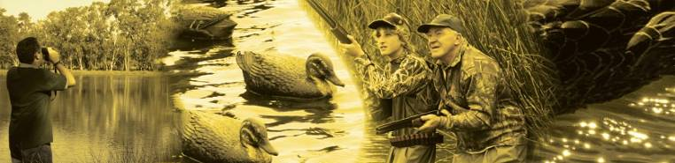

Arthur Rylah Institute for Environmental Research
Department of Sustainability and Environment
Heidelberg, Victoria

Report produced by: Arthur Rylah Institute for Environmental Research
Department of Sustainability and Environment
PO Box 137
Heidelberg, Victoria 3084
Phone (03) 9450 8600
Website: www.dse.vic.gov.au/ari
© State of Victoria, Department of Sustainability and Environment 2012
This publication is copyright. Apart from fair dealing for the purposes of private study, research, criticism or review as permitted under the Copyright Act 1968, no part may be reproduced, copied, transmitted in any form or by any means (electronic, mechanical or graphic) without the prior written permission of the State of Victoria, Department of Sustainability and Environment. All requests and enquiries should be directed to the Customer Service Centre, 136 186 or email customer.service@dse.vic.gov.au
Citation: Moloney, P. D. and Turnbull, J. D. (2012) Estimates of harvest for deer, duck and quail in Victoria: results from surveys of Victorian game licence holders in 2012. Arthur Rylah Institute for Environmental Research Technical Report Series No. 239. Department of Sustainability and Environment, Heidelberg, Victoria

ISSN 1835-3827 (print)
ISSN 1836-3835 (online)
ISBN 978-1-74287-704-4 (print)
ISBN 978-1-74287-705-1 (online)
Disclaimer: This publication may be of assistance to you but the State of Victoria and its employees do not guarantee that the publication is without flaw of any kind or is wholly appropriate for your particular purposes and therefore disclaims all liability for any error, loss or other consequence which may arise from you relying on any information in this publication.
Front cover photo: Heath Dunstan, Game Victoria, Department of Primary Industries.
Authorised by: Victorian Government, Melbourne
Printed by: NMIT Printroom, 77-91 St Georges Road, Preston 3072

Contents
Acknowledgements iv
Summary 1
1 Introduction 2
2 Methods 3
2.1 General methodology 3
2.2 Deer 4
2.3 Duck 4
2.4 Quail 4
3 Results 5
3.1 Deer 5
3.2 Duck 12
3.3 Quail 17
4 Discussion 22
4.1 Deer 22
4.2 Duck 22
4.3 Quail 23
4.4 Assumptions 24
References 26
Appendix 1 27

Acknowledgements
This project was funded by the Department of Primary Industries through Game Victoria. We thank all the game licence holders who gave their time to participate in the surveys, which were conducted by Marketing Skill Pty Ltd (Mt Eliza, Victoria). We would like to acknowledge Andrew Gormley for providing the spreadsheets used in the previous year’s analysis. We would also like to thank Dave Forsyth and David Ramsey for making valuable comments on drafts of this report.

Summary
A telephone survey of Victorian hunters was conducted during the 2012 hunting seasons for deer, duck and quail to determine the total harvest for each game type. Game licence holders for each game type (deer, duck and quail) were randomly sampled and interviewed by telephone at intervals during the respective game seasons. For all surveys, respondents were asked whether they had hunted or not during the period for which the survey applied and, if applicable, the number and species of animals harvested. Additional information was obtained on hunting methods and locations.
Each holder of a game licence for deer hunted for approximately seven days on average during the 2012 deer-hunting season, with an average season harvest of nearly two deer per game licence holder. Based on the total number of holders of a deer game licence, this corresponds to an estimated 41,601 deer harvested during the 2012 deer-hunting season in Victoria (95% confidence interval (CI) = 33,839–51,142). The most commonly harvested species was Sambar Deer (with an estimated total harvest of 32,826), followed by Fallow Deer (7,900). Harvest estimates for Red Deer (773) and Hog Deer (102) were based on a small number of responses and should be treated with caution.
Each holder of a game licence for ducks hunted on approximately 4.6 days during the 2012 duck-hunting season, with an average season harvest of 21.2 ducks per game licence holder. Based on the total number of game licence holders, this equates to an estimated 508,256 ducks harvested during the 2012 duck-hunting season in Victoria (95% CI = 396,053–652,246). The most commonly harvested species was Pacific Black Duck (which comprised 32% of the total harvest), followed by Australian Wood Duck (30%), Grey Teal (22%), Hardhead (6%), Chestnut Teal (5%), Pink-eared Duck (4%), Australian Shelduck (2%) and Australasian Shoveler (<1%).
For quail, the average season harvest was 4.8 quail per game licence holder. Based on the total number of game licence holders, this corresponds to an estimated 129,711 quail harvested during the 2012 quail-hunting season in Victoria (95% CI = 109,535–153,604).
The approach used here explicitly accounts for the possibility that not every holder of a game licence will hunt during every survey period. The total number of game licence holders who hunted is estimated for each survey period and combined with the harvest per hunter to derive the total harvest for each survey period.
The methodology of performing telephone surveys throughout the season is likely to minimise memory bias and non-response bias compared to the end of year postal survey. However, sources of bias will remain due to over- and under-reporting, and the estimates of total harvest must be interpreted with care.

- Introduction
In order to effectively manage game species, it is important to quantify the numbers harvested. Game Victoria (Department of Primary Industries) conducts a mail survey of 1,000 randomly selected game licence holders during June each year. There are, however, a number of problems associated with mail surveys, including recall bias, rounding of harvest estimates, and non-response bias (Wright 1978). Due to concerns about the reliability of the harvest estimates from the mail survey, Game Victoria commissioned a series of regular telephone surveys to address the issue of recall bias. The three sets of telephone surveys were conducted during the various game harvest seasons for deer, duck and quail.
Deer hunting occurs all year round in Victoria for some species. For this report, the 2012 deer-hunting reporting period was defined as 1 July 2011 until 30 June 2012. Sambar Deer (Cervus unicolor) could be hunted all year by stalking. Hunting using scent-trailing hounds was restricted to the second Saturday after Easter Sunday until 30 November. Hunting of Red Deer (Cervus elaphus) was restricted to the months of June and July only. Hog Deer (Axis porcinus) could be hunted only during April, and were subject to additional restrictions such as one male and one female per hunter. All other species, Fallow Deer (Dama dama), Chital Deer (Axis axis) and Rusa Deer (Cervus timorensis), could be hunted all year. This survey follows similar telephone surveys performed during the 2009, 2010 and 2011 deer-hunting seasons (Gormley and Turnbull 2009, 2010, 2011).
The 2012 duck-hunting season lasted 13 weeks, from 17 March to 11 June. Eight species could legally be hunted in 2012: Pacific Black Duck (Anas superciliosa), Australian Wood Duck (Chenonetta jubata), Australian Shelduck (Tadorna tadornoides), Grey Teal (Anas gracilis), Chestnut Teal (Anas castanea), Pink-eared Duck (Malacorhynchus membranaceus), Hardhead (Aythya australis), Australasian Shoveler (Anas rhynchotis). The daily bag limit for the 2012 season was ten game ducks per hunter (with a limit of two Australasian Shoveler). These surveys follow from telephone surveys performed during the 2005, 2006, 2009, 2010 and 2011 duck-hunting seasons (Barker 2006; Gormley and Turnbull 2009, 2010, 2011).
The 2012 quail-hunting season lasted 12 weeks, from 7 April to 30 June. The daily bag limit for the 2012 season was 20 quail per hunter, with Stubble Quail (Coturnix pectoralis) the only native species that could legally be hunted. This survey follows similar telephone surveys performed during the 2008, 2009, 2010 and 2011 quail-hunting seasons (Gormley 2009; Gormley and Turnbull 2009, 2010, 2011).
- Methods
  - General methodology
A similar methodology was used to estimate deer, duck and quail harvests. All surveys were conducted by the telephone survey company Marketing Skill on behalf of DSE. Estimates of total harvest by game licence holders were based on the reported hunting activities of the survey respondents.
For each game type, a series of surveys was performed throughout the corresponding season. Each survey involved telephoning a random sample of game licence holders and asking them to report their hunting activities only for the periods covered by that survey. Therefore, although a respondent may have hunted during the period covered by Survey 2 and Survey 3, if they were contacted as part of Survey 3, then information was only collected that pertained to the period covered by Survey 3.
The information from the respondents was used as an estimate of the whole population of game licence holders for each game type. Estimates of harvest were determined for each of the survey periods and were summed to give an estimate of the total season harvest. For each survey period, the proportion of respondents who hunted was used as an estimate of the proportion of game licence holders who hunted. The proportion of game licence holders who hunted during each survey period was multiplied by the total number of game licence holders to give the total number of hunters for that survey period.
For each survey period, the average harvest per hunter was estimated from the total reported harvest divided by the number of respondents that hunted. The total harvest for each survey period was estimated by multiplying the average harvest per hunter by the total number of hunters for that survey period, as estimated previously. Finally, the total season harvest was estimated as the sum of the survey-specific total harvests.
We also estimated the season harvest per game licence holder. For each survey period, the average harvest per survey respondent was estimated by multiplying the average harvest per hunter by the proportion of respondents who hunted. The sum of these estimates across the season provided an estimate of the total season harvest per game licence holder.
Respondents who hunted were also asked to provide information on whether hunting was conducted on private land or public land (including State Game Reserves), the name of the town nearest to where they hunted, and the number of days they hunted. Regional harvest estimates were calculated by summing the reported harvest for each nearest town and then aggregating these by the corresponding Victorian Catchment Management Authority (CMA) region.
There were differences in the number and length of surveys between the duck, deer and quail surveys, as indicated in the following sections. Additional details of the methods, as well as examples of the calculations, are provided in Appendix 1.

  - Deer
Samples were drawn from hunters who held a game licence to harvest deer. Random samples of hunters were telephoned every two months over the 12-month period to give a total of six surveys. Respondents were asked to report the number and sex of each species harvested. During each survey, 200 respondents were interviewed regardless of whether they had hunted or not. Respondents were also asked what hunting methods they used (i.e. stalking, scent-trailing hounds or gun dogs).
  - Duck
Samples were drawn from hunters who held a game licence to harvest ducks during the 2012 season. A random sample of 200 licence holders was interviewed by telephone immediately after opening weekend (Duck Survey 1) followed by independent random samples of licence holders at two-week intervals for the remainder of the duck season (Duck Surveys 2–7). Respondents were also asked to report the number of each species harvested and the costs they incurred.
  - Quail
Samples were drawn from hunters who held a game licence to harvest quail during the 2012 season. A random sample of 300 licence holders was interviewed by telephone each month for April (Survey 1), May (Survey 2) and June (Survey 3). Respondents were asked to report the number of Stubble Quail harvested, the type of grassland where hunting occurred (native, stubble or introduced), whether dogs were used and the costs they incurred.
- Results
  - Deer
The number of game licence holders with permits to hunt deer ranged from a high of 23,170 in November–December 2011, to a low of 18,915 in January–February 2012 (Table 1). In order to achieve the required sample size of respondents, slightly more than 200 licence holders were contacted each survey, with an average of 98.3% of those contacted willing to take part.
Table 1: Summary of responses for deer surveys.
Deer Survey | Period | Licence holders | Respondents | Respondents who hunted | Days hunted | Deer harvested
1 | Jul–Aug 2011 | 21,771 | 200 | 72 | 363 | 65
2 | Sep–Oct 2011 | 22,864 | 201 | 59 | 263 | 61
3 | Nov–Dec 2011 | 23,170 | 202 | 37 | 103 | 31
4 | Jan–Feb 2012 | 18,915 | 203 | 40 | 166 | 46
5 | Mar–Apr 2012 | 20,432 | 204 | 54 | 228 | 68
6 | May–Jun 2012 | 22,216 | 205 | 57 | 284 | 114
Days hunted indicates the combined number of days that hunting took place and Deer harvested indicates total number of deer harvested, respectively, by respondents within each survey period.

The proportion of deer game licence holders who hunted in each survey period varied throughout the season (Table 2). An estimated 36% of deer game licence holders hunted at least once during July–August 2011, declining to a low of 19% during November–December 2011. These percentages correspond to 7,838 hunters in the July–August period and 4,286 hunters in the November–December period. However, it was the January–February 2012 period that is estimated to have the fewest hunters as the number of licenced deer hunters was substantially lower (Table 2).
Table 2: Proportion and corresponding total number of deer licence holders that hunted, for each survey period.
 |  |  | 95% CI |  | Total |  | 95% CI
Period | Proportion | SE | Lower | Upper | hunters | SE | Lower | Upper
Jul–Aug 2011 | 0.36 | 0.034 | 0.30 | 0.43 | 7,838 | 739 | 6,518 | 9,424
Sep–Oct 2011 | 0.30 | 0.032 | 0.24 | 0.37 | 6,745 | 737 | 5,447 | 8,351
Nov–Dec 2011 | 0.19 | 0.027 | 0.14 | 0.25 | 4,286 | 636 | 3,210 | 5,725
Jan–Feb 2012 | 0.20 | 0.028 | 0.15 | 0.26 | 3,783 | 535 | 2,871 | 4,984
Mar–Apr 2012 | 0.27 | 0.031 | 0.22 | 0.34 | 5,517 | 641 | 4,396 | 6,923
May–Jun 2012 | 0.29 | 0.032 | 0.23 | 0.35 | 6,332 | 709 | 5,087 | 7,880

Within each survey period there was large variation in the reported harvest of deer per hunter (i.e. per game licence holder that hunted), with some hunters harvesting more than 10 deer in a survey period (Figure 1). The average number of deer harvested per hunter ranged from a high of 2 deer per hunter during May–June 2012 to a low of 0.84 in November–December 2011 (Table 3).
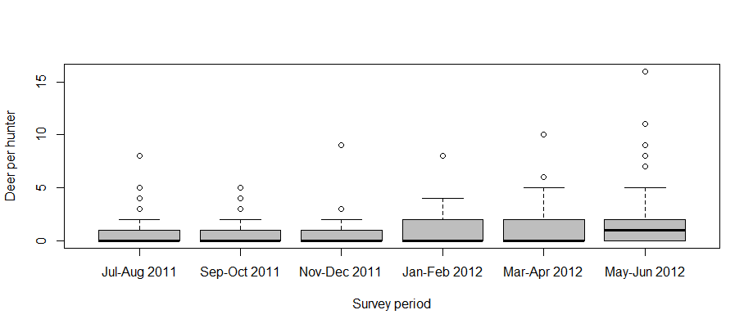
Figure 1: Boxplot of the number of deer reported harvested by individual hunters for each survey period. The bottom and top of each “box” indicates the 25th and 75th percentile, respectively, with the black horizontal line indicating the median reported value.

Table 3: Average harvest of deer per hunter (game licence holders who hunted) for each survey period.
 | Average harvest |  | 95% CI
Period | per hunter | SE | Lower | Upper
Jul–Aug 2011 | 0.90 | 0.178 | 0.62 | 1.32
Sep–Oct 2011 | 1.03 | 0.199 | 0.71 | 1.50
Nov–Dec 2011 | 0.84 | 0.270 | 0.45 | 1.55
Jan–Feb 2012 | 1.15 | 0.274 | 0.73 | 1.82
Mar–Apr 2012 | 1.26 | 0.287 | 0.81 | 1.96
May–Jun 2012 | 2.00 | 0.396 | 1.36 | 2.94
Average harvest per hunter = Deer harvested divided by Respondents who hunted (Table 1).

There was an estimated total of 41,601 deer harvested by all deer game licence holders from July 2011 through June 2012 inclusive (95% CI = 33,839–51,142; Table 4). Harvest was greatest in the winter months and lowest in the summer months.
Table 4: Estimates of the total deer harvest in Victoria from July 2011 until June 2012, by holders of a deer game licence.
 | Total |  | 95% CI
Survey | harvest | SE | Lower | Upper
Jul–Aug 2011 | 7,076 | 1,548 | 4,632 | 10,809
Sep–Oct 2011 | 6,973 | 1,545 | 4,540 | 10,711
Nov–Dec 2011 | 3,591 | 1,274 | 1,829 | 7,051
Jan–Feb 2012 | 4,350 | 1,205 | 2,553 | 7,413
Mar–Apr 2012 | 6,947 | 1,779 | 4,239 | 11,386
May–Jun 2012 | 12,663 | 2,879 | 8,155 | 19,664
Total Season | 41,601 | 4,395 | 33,839 | 51,142
Total harvest = Harvest per hunter (Table 3) × Total hunters (Table 2). Numbers may differ slightly due to rounding of average harvest per hunter.

The total average season harvest was 1.93 deer per game licence holder (95% CI = 1.57–2.36; Table 5). Note that for each survey period the average deer harvest per game licence holder (Table 5) is much lower than the average deer harvest per hunter (Table 3), as the former includes those respondents who did not hunt during the survey period.
Table 5: Estimated average harvest of deer per game licence holder in each survey period.
 | Average |  | 95% CI
Period | harvest | SE | Lower | Upper
Jul–Aug 2011 | 0.33 | 0.07 | 0.21 | 0.50
Sep–Oct 2011 | 0.31 | 0.07 | 0.20 | 0.47
Nov–Dec 2011 | 0.16 | 0.05 | 0.08 | 0.30
Jan–Feb 2012 | 0.23 | 0.06 | 0.13 | 0.39
Mar–Apr 2012 | 0.34 | 0.09 | 0.21 | 0.56
May–Jun 2012 | 0.57 | 0.13 | 0.37 | 0.89
Total Season | 1.93 | 0.20 | 1.57 | 2.36
Average harvest per game licence holder = Deer harvested divided by Respondents (Table 1).

Separate harvest estimates for each deer species are presented in Figure 2 and Table 6. No Chital Deer or Rusa Deer were reported harvested. Estimates of Hog Deer and Red Deer were based on only a few reported harvest records, and therefore should be viewed with caution. In general, harvest was highest in the winter months and lowest in the summer months.
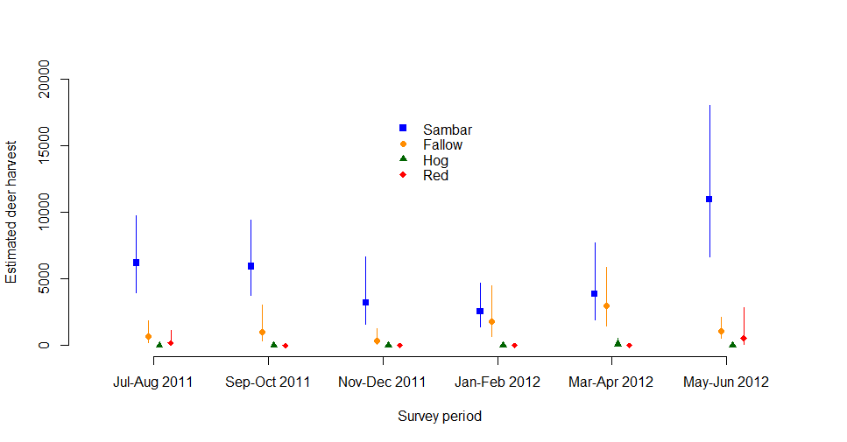
Figure 2: Estimated total deer harvest for each two-month survey period, by species. Vertical bars indicate 95% CIs.

Table 6: The number of each deer species reported harvested by hunters, and estimated total 2012 harvest.
a. Sambar Deer
 |  |  | 95% CI
Period | Reported | Total harvest | Lower | Upper
Jul–Aug 2011 | 57 | 6,205 | 3,942 | 9,767
Sep–Oct 2011 | 52 | 5,945 | 3,745 | 9,436
Nov–Dec 2011 | 28 | 3,244 | 1,582 | 6,652
Jan–Feb 2012 | 27 | 2,553 | 1,395 | 4,675
Mar–Apr 2012 | 38 | 3,882 | 1,956 | 7,705
May–Jun 2012 | 99 | 10,997 | 6,704 | 18,038
Annual Total | 301 | 32,826 | 25,832 | 41,713

b. Fallow Deer
 |  |  | 95% CI
Period | Reported | Total harvest | Lower | Upper
Jul–Aug 2011 | 6 | 653 | 228 | 1,867
Sep–Oct 2011 | 9 | 1,029 | 348 | 3,046
Nov–Dec 2011 | 3 | 348 | 94 | 1,291
Jan–Feb 2012 | 19 | 1,797 | 715 | 4,514
Mar–Apr 2012 | 29 | 2,963 | 1,496 | 5,866
May–Jun 2012 | 10 | 1,111 | 579 | 2,131
Annual Total | 76 | 7,900 | 5,291 | 11,795
c. Hog Deer
 |  |  | 95% CI
Period | Reported | Total harvest | Lower | Upper
Jul–Aug 2011 | 0 | 0 | NA | NA
Sep–Oct 2011 | 0 | 0 | NA | NA
Nov–Dec 2011 | 0 | 0 | NA | NA
Jan–Feb 2012 | 0 | 0 | NA | NA
Mar–Apr 2012 | 1 | 102 | 20 | 527
May–Jun 2012 | 0 | 0 | NA | NA
Annual Total | 1 | 102 | 20 | 527
NB: Hog Deer are only permitted to be hunted during April.
d. Red Deer
 |  |  | 95% CI
Period | Reported | Total harvest | Lower | Upper
Jul–Aug 2011 | 2 | 218 | 42 | 1,119
Sep–Oct 2011 | 0 | 0 | NA | NA
Nov–Dec 2011 | 0 | 0 | NA | NA
Jan–Feb 2012 | 0 | 0 | NA | NA
Mar–Apr 2012 | 0 | 0 | NA | NA
May–Jun 2012 | 5 | 555 | 108 | 2,861
Annual Total | 7 | 773 | 201 | 2,970
*NB: Red Deer are only permitted to be hunted in June and July.
For Sambar Deer, similar proportions of stags and hinds were harvested (Table 7). For Fallow Deer, a greater proportion of females were harvested (59%). For Red Deer and Hog Deer, the reported numbers were too small to make any conclusions in terms of sex-specific harvest.
Table 7: Reported numbers and percentages of each sex of deer species harvested. Standard errors for the percentages are shown in parentheses.
 | Stags |  |  | Hinds
Species | n | % (SE) |  | n | % (SE)
Sambar Deer | 143 | 48.0% (2.9) |  | 155 | 52.0% (2.9)
Fallow Deer | 31 | 41.3% (5.7) |  | 44 | 58.7% (5.7)
Hog Deer | 1 | 100.0% (NA) |  | 0 | 0.0% (NA)
Red Deer | 5 | 71.4% (17.1) |  | 2 | 28.6% (17.1)
The number of days hunted in each survey period varied throughout the season, with most hunting occurring in winter. Each deer licence holder hunted an average of 7 days during the 2012 deer-hunting season, corresponding to a total of 152,051 hunter days (95% CI = 129,545–178,467; Table 8).
Table 8: Days hunted per game licence holder.
 | Days |  | 95% CI
Period | hunted | SE | Lower | Upper
Jul–Aug 2011 | 1.82 | 0.27 | 1.36 | 2.43
Sep–Oct 2011 | 1.32 | 0.20 | 0.97 | 1.77
Nov–Dec 2011 | 0.52 | 0.10 | 0.36 | 0.75
Jan–Feb 2012 | 0.83 | 0.15 | 0.58 | 1.18
Mar–Apr 2012 | 1.14 | 0.17 | 0.85 | 1.52
May–Jun 2012 | 1.42 | 0.21 | 1.07 | 1.88
Total days per licence holder | 7.04 | 0.47 | 6.18 | 8.01
Total hunting days | 152,051 | 12,448 | 129,545 | 178,467
More deer hunting occurred exclusively on public land (64.8%) than on private land (24.1%), with correspondingly similar proportions of deer harvested (Table 9).
Table 9: Percentage of days hunted and associated deer harvest by land tenure.
Land tenure | Days | Deer
Private Land only | 22.4% | 27.5%
Public Land only | 64.8% | 65.5%
Both | 11.7% | 5.7%
Total | 98.9% | 98.7%
Stalking was the preferred hunting method, being used in 63.5% of the hunting days and accounting for 63.9% of the reported harvest. Hunting with scent-trailing hounds was the most productive hunting method, being used in 14.6% of the hunting days but accounting for 32.2% of the reported harvest (Table 10). It should be noted that the hunting method was not specified in 18.3% of the hunting days and associated with a very low percentage of the harvest, only 0.3%.
Table 10: Percentage of days hunted and associated deer harvest for hunting methods.
Hunting Method | Days | Deer
Stalking | 63.5% | 63.9%
Stalking with gundog | 3.6% | 3.6%
Scent-trailing hounds | 14.6% | 32.2%
Unspecified | 18.3% | 0.3%
Total | 100.0% | 100.0%
While stalking is the preferred hunting method, it would seem to be more productive on private land, accounting for 18% of the surveyed hunting days but 27% of the surveyed harvest (Table 11). The vast majority (87%) of all hunting days using scent-trailing hounds were on only public lands. While this accounted for 13% of the total hunting days, it contributed over 30% of the surveyed harvest.
Table 11: Percentage of days hunted and associated deer harvest by hunting method and land tenure.
Land Tenure | Private only |  | Public only |  | Both |  | Unspecified |  | Total
Hunting Method | Days | Deer | Days | Deer | Days | Deer | Days | Deer | Days | Deer
Stalking | 17.7% | 26.8% | 35.9% | 31.9% | 9.6% | 3.9% | 0.4% | 1.3% | 63.5% | 63.9%
Stalking with gundog | 0.3% | 0.8% | 3.0% | 2.9% | 0.3% | 0.0% | 0.0% | 0.0% | 3.6% | 3.6%
Scent-trailing hounds | 0.1% | 0.0% | 12.9% | 30.4% | 1.7% | 1.8% | 0.0% | 0.0% | 14.6% | 32.2%
Unspecified | 4.3% | 0.0% | 13.1% | 0.3% | 0.1% | 0.0% | 0.7% | 0.0% | 18.3% | 0.3%
Total | 22.4% | 27.5% | 64.8% | 65.5% | 11.7% | 5.7% | 1.1% | 1.3% | 100% | 100%

Total harvest was estimated to be greatest in the East Gippsland CMA, followed by the Goulburn Broken CMA, the North East CMA and the West Gippsland CMA (Figure 3). There was no reported harvest in the Mallee CMA or North Central CMA.
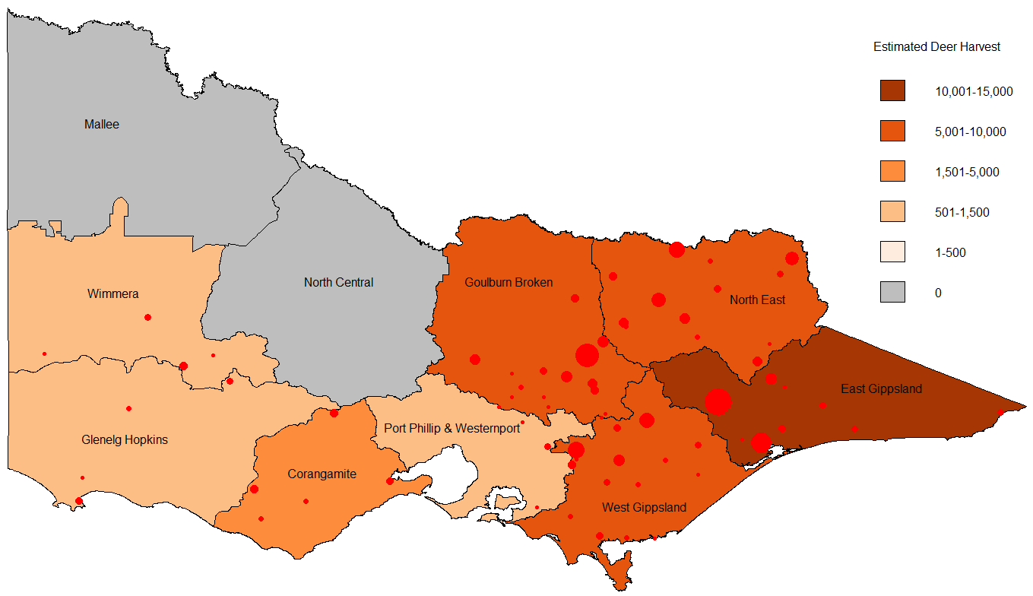
Figure 3: Estimated total deer harvest by CMA region. Red circles indicate the nearest town to harvest locations, with symbol size proportional to reported harvest.
  - Duck
The number of game licence holders with permits to hunt ducks remained relatively constant throughout the season, increasing from 22,942 at opening weekend to 24,533 at the end of May (Table 12). In order to achieve the required sample size of respondents, slightly more than 200 licence holders were contacted each survey, with an average of 98.7% of those contacted willing to take part.
Table 12: Summary of responses for duck surveys in 2012.
Duck Survey | Period | Licence holders | Respondents | Respondents who hunted | Days hunted | Ducks harvested
1 | 18 Mar–20 Mar | 22,942 | 200 | 116 | 195 | 610
2 | 21 Mar–1 Apr | 22,942 | 200 | 60 | 133 | 472
3 | 2 Apr–15 Apr | 24,183 | 200 | 60 | 142 | 994
4 | 16 Apr–1 May | 24,183 | 200 | 39 | 83 | 421
5 | 2 May–13 May | 24,427 | 200 | 38 | 64 | 257
6 | 14 May–28 May | 24,427 | 200 | 64 | 182 | 714
7 | 29 May–11 Jun | 24,533 | 200 | 45 | 121 | 770
Days hunted indicates the combined number of days that were hunted and Ducks harvested indicates total ducks harvested respectively by the respondents, within each survey period.

The proportion of duck game licence holders who hunted in each survey period varied throughout the season: 58% of licence holders hunted during opening weekend, corresponding to approximately 13,306 hunters (Table 13). The proportion that hunted during other survey periods varied from 19% to 32%, corresponding to between 3,491 and 6,390 duck hunters, respectively (Table 13).
Table 13: Proportion, and corresponding total number, of duck game licence holders who hunted in each survey period.
Duck |  |  |  | 95% CI |  | Total |  | 95% CI
Survey | Period | Proportion | SE | Lower | Upper | hunters | SE | Lower | Upper
1 | 18 Mar–20 Mar | 0.58 | 0.035 | 0.52 | 0.65 | 13,306 | 801 | 11,827 | 14,970
2 | 21 Mar–1 Apr | 0.30 | 0.032 | 0.24 | 0.37 | 6,883 | 743 | 5,573 | 8,500
3 | 2 Apr–15 Apr | 0.30 | 0.032 | 0.24 | 0.37 | 7,255 | 784 | 5,874 | 8,960
4 | 16 Apr–1 May | 0.20 | 0.028 | 0.15 | 0.26 | 4,716 | 678 | 3,563 | 6,240
5 | 2 May–13 May | 0.19 | 0.028 | 0.14 | 0.25 | 4,641 | 678 | 3,491 | 6,169
6 | 14 May–28 May | 0.32 | 0.033 | 0.26 | 0.39 | 7,817 | 806 | 6,390 | 9,562
7 | 29 May–11 Jun | 0.23 | 0.030 | 0.17 | 0.29 | 5,520 | 724 | 4,273 | 7,131

Within each survey period, there was large variation in the reported harvest of ducks per hunter (i.e. per game licence holder who hunted), with some hunters harvesting more than 70 ducks in a survey period (Figure 4). The average number of ducks per hunter varied throughout the season (Table 14). The average harvest per hunter was 5.26 ducks on opening weekend, the lowest of the season. The largest harvest per hunter for the two-week survey periods was 17.11 ducks.
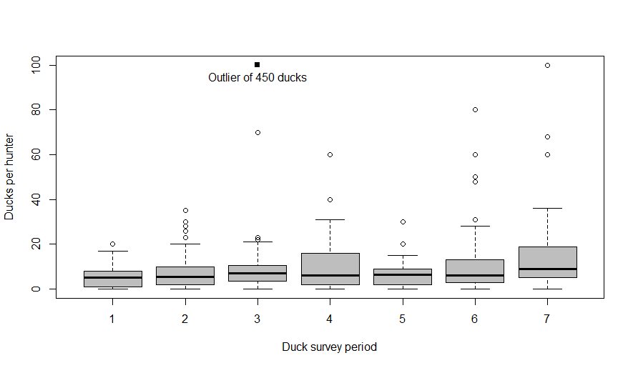
Figure 4: Boxplot of the number of ducks reported harvested by individual hunters in each survey period. The bottom and top of each “box” indicates the 25th and 75th percentile, respectively, with the black horizontal line indicating the median reported value.

Table 14: Average harvest of ducks per hunter (i.e. game licence holders who hunted) for each survey period.
Duck |  | Average harvest per hunter |  | 95% CI
Survey | Period | Average harvest per hunter | SE | Lower | Upper
1 | 18 Mar–20 Mar | 5.26 | 0.43 | 4.49 | 6.16
2 | 21 Mar–1 Apr | 7.87 | 1.03 | 6.09 | 10.16
3 | 2 Apr–15 Apr | 16.57 | 7.46 | 7.14 | 38.46
4 | 16 Apr–1 May | 10.79 | 2.08 | 7.43 | 15.69
5 | 2 May–13 May | 6.76 | 0.99 | 5.09 | 8.99
6 | 14 May–28 May | 11.16 | 1.84 | 8.09 | 15.38
7 | 29 May–11 Jun | 17.11 | 3.40 | 11.64 | 25.16
Average harvest per hunter = Ducks harvested divided by Respondents who hunted (Table 12).
There were an estimated 69,973 ducks harvested during opening weekend (95% CI = 57,458–85,215). The harvest throughout the season varied considerably between surveys with the lowest estimate for at 31,389 while the largest was 120,190. The total season harvest estimate was 508,256 (95% CI = 396,053–652,246; Table 15).

Table 15: Estimates of the duck harvest in Victoria in 2012 by holders of a duck game licence.
Duck | Period | Total harvest | SE | 95% CI
Survey | Period | Total harvest | SE | Lower | Upper
1 | 18 Mar–20 Mar | 69,973 | 7,053 | 57,458 | 85,215
2 | 21 Mar–1 Apr | 54,143 | 9,204 | 38,893 | 75,373
3 | 2 Apr–15 Apr | 120,190 | 55,667 | 50,653 | 285,185
4 | 16 Apr–1 May | 50,905 | 12,226 | 32,003 | 80,972
5 | 2 May–13 May | 31,389 | 6,481 | 21,030 | 46,849
6 | 14 May–28 May | 87,204 | 16,951 | 59,787 | 127,196
7 | 29 May–11 Jun | 94,452 | 22,489 | 59,611 | 149,657
 | Total Season | 508,256 | 64,945 | 396,053 | 652,246
Total harvest = Harvest per hunter (Table 14) × Total hunters (Table 13).

The total average season harvest per licence holder was estimated to be 21.2 (95% CI = 16.55–27.13; Table 16). Note that for each survey period the average duck harvest per game licence holder is lower than the average duck harvest per hunter, as the former includes those respondents who did not hunt during the survey period, whereas the latter is conditional on those that hunted.

Table 16: Estimated harvest of ducks per game licence holder in each survey period.
Duck |  | Average harvest |  | 95% CI
Survey | Period | Average harvest | SE | Lower | Upper
1 | 18 Mar–20 Mar | 3.05 | 0.31 | 2.50 | 3.71
2 | 21 Mar–1 Apr | 2.36 | 0.40 | 1.70 | 3.29
3 | 2 Apr–15 Apr | 4.97 | 2.30 | 2.09 | 11.79
4 | 16 Apr–1 May | 2.11 | 0.51 | 1.32 | 3.35
5 | 2 May–13 May | 1.29 | 0.27 | 0.86 | 1.92
6 | 14 May–28 May | 3.57 | 0.69 | 2.45 | 5.21
7 | 29 May–11 Jun | 3.85 | 0.92 | 2.43 | 6.10
 | Total Season | 21.19 | 2.68 | 16.55 | 27.13
Average harvest per game licence holder = Ducks harvested divided by Respondents (Table 12).

Total harvest estimates for each species were obtained by multiplying the total estimated duck harvest by the percentages of total harvest for that species (Table 17). The most frequently harvested species was the Pacific Black Duck, comprising 32% of the total reported harvest, followed by Australian Wood Duck (30%) and Grey Teal (22%). Other species comprised 16% of the total harvest.

Table 17: Reported numbers of ducks harvested by hunters, proportion of the total harvest, and estimated total 2011 harvest for each duck species.
 | Reported | Proportion |  | Estimated |  | 95% CI
Species | harvest | of harvest | SE | harvest | SE | Lower | Upper
Pacific Black Duck | 1,340 | 0.316 | 0.007 | 160,704 | 20,853 | 81,040 | 318,678
Australian Wood Duck | 1,252 | 0.295 | 0.007 | 150,150 | 19,514 | 75,680 | 297,899
Australian Shelduck | 77 | 0.018 | 0.002 | 9,234 | 1,575 | 4,243 | 20,099
Grey Teal | 922 | 0.218 | 0.006 | 110,574 | 14,492 | 55,582 | 219,975
Chestnut Teal | 196 | 0.046 | 0.003 | 23,506 | 3,422 | 11,412 | 48,416
Pink-eared Duck | 180 | 0.042 | 0.003 | 21,587 | 3,176 | 10,443 | 44,623
Australasian Shoveler | 11 | 0.003 | 0.001 | 1,319 | 432 | 465 | 3,742
Hardhead | 252 | 0.059 | 0.004 | 30,222 | 4,280 | 14,809 | 61,677

Each game licence holder hunted an average of 4.6 days during the 2012 duck hunting season (Table 18). When multiplied by the total number of game licence holders in each survey period, this equals a total of 109,718 hunter days (95% CI = 96,213–125,120).
Table 18: Days hunted per game licence holder.
Duck |  |  |  | 95% CI
Survey | Period | Average | SE | Lower | Upper
1 | 18 Mar–20 Mar | 0.98 | 0.07 | 0.85 | 1.12
2 | 21 Mar–1 Apr | 0.67 | 0.10 | 0.50 | 0.88
3 | 2 Apr–15 Apr | 0.71 | 0.09 | 0.55 | 0.92
4 | 16 Apr–1 May | 0.42 | 0.08 | 0.29 | 0.60
5 | 2 May–13 May | 0.32 | 0.06 | 0.23 | 0.45
6 | 14 May–28 May | 0.91 | 0.12 | 0.70 | 1.18
7 | 29 May–11 Jun | 0.61 | 0.11 | 0.43 | 0.85
 | Total per licence holder | 4.60 | 0.24 | 4.15 | 5.10
 | Total hunting days | 109,718 | 7,361 | 96,213 | 125,120

Similar amounts of duck hunting were conducted on public land (45.8%) and private land (47.4%), with a greater proportion of ducks harvested solely on private lands (52.8% to 39.9%) (Table 19). Total harvest was estimated to be greatest in the North Central CMA and the Goulburn Broken CMA (Figure 5).

Table 19: Percentage of days hunted and associated duck harvest on private and public land.
Land tenure | Days | Duck harvest
Private land | 47.4% | 52.8%
Public land | 45.8% | 39.9%
Both | 5.6% | 6.4%
Total | 98.7% | 99.1%

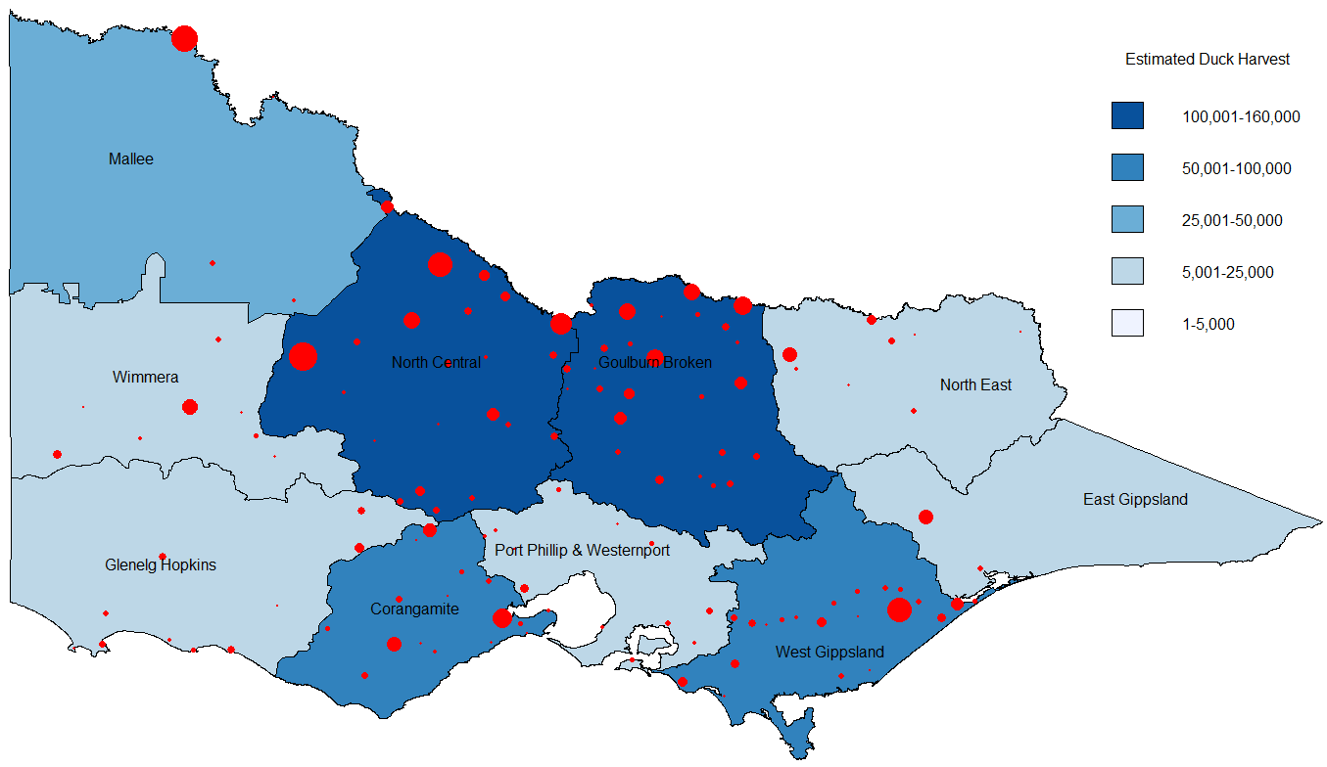
Figure 5: Estimated total duck harvest by CMA region. Red circles indicate the nearest town to harvest locations, with symbol size proportional to reported harvest.

  - Quail
The number of game licence holders with permits to hunt quail increased throughout the season (Table 20). In order to achieve the required sample size of respondents, slightly more than 300 licence holders were contacted each survey, with an average of 98% of those contacted willing to take part.
Table 20: Summary of responses for quail surveys.
Quail Survey | Period | Licence holders | Respondents | Respondents who hunted | Days hunted | Quail harvested
1 | April | 26,671 | 300 | 47 | 81 | 477
2 | May | 27,115 | 300 | 33 | 65 | 535
3 | June | 27,284 | 300 | 43 | 101 | 429
Days hunted indicates the combined number of days that were hunted and Quail harvested indicates the total quail harvested, respectively, by respondents within each survey period.
The proportion of game licence holders who hunted in each monthly survey period ranged from 11% to 16%. It is estimated that there were between 2,166 and 5,427 hunters in any one-month period (Table 21).
Table 21: Proportion of respondents who hunted, and estimated total number of licence holders that hunted, for each survey period.
 |  |  | 95% CI |  | Total |  | 95% CI
Period | Proportion | SE | Lower | Upper | hunters | SE | Lower | Upper
April | 0.16 | 0.021 | 0.12 | 0.20 | 4,178 | 560 | 3,217 | 5,427
May | 0.11 | 0.018 | 0.08 | 0.15 | 2,983 | 490 | 2,166 | 4,106
June | 0.14 | 0.020 | 0.11 | 0.19 | 3,911 | 552 | 2,970 | 5,150

Within each survey period there was large variation in the reported harvest per hunter (i.e. per game licence holder who hunted), with some hunters harvesting over 100 quail and others zero quail within a survey period (Figure 6). The average number of quail harvested per hunter during a one-month period varied from 10 to 16 (Table 22).
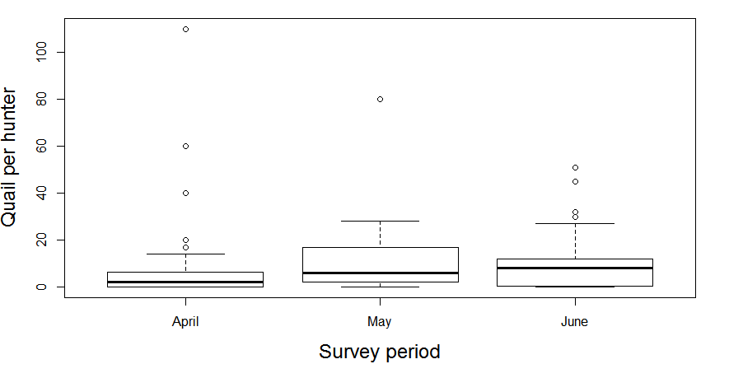
Figure 6: Boxplot of the number of quail reported harvested by individual hunters in each survey period. The bottom and top of each “box” indicates the 25th and 75th percentile, respectively, with the black horizontal line indicating the median reported value.

Table 22: Average harvest of quail per hunter (i.e. game licence holders who hunted) for each survey period.
 | Average harvest |  | 95% CI
Period | per hunter | SE | Lower | Upper
April | 10.15 | 3.12 | 5.63 | 18.31
May | 16.21 | 4.37 | 9.64 | 27.26
June | 9.98 | 1.83 | 6.99 | 14.24
Average harvest per hunter = Quail harvested divided by Respondents who hunted (Table 20).
A
There were an estimated 129,711 quail harvested by all holders of a game licence for quail during the 2012 quail season (95% CI = 109,535–153,604), with the May harvest being substantially higher than the other two months (Table 23).

Table 23: Estimates of the 2012 quail harvest in Victoria by licensed quail hunters.
 | Total |  | 95% CI
Period | harvest | SE | Lower | Upper
April | 42,407 | 5,681 | 32,653 | 55,075
May | 48,355 | 7,941 | 35,122 | 66,574
June | 39,016 | 5,507 | 29,627 | 51,381
Total Season | 129,711 | 11,210 | 109,535 | 153,604
Total harvest = Harvest per hunter (Table 22) × Total hunters (Table 21).

The total average season harvest was 4.8 quail per game licence holder (95% CI = 2.19–10.54; Table 24). Note that for each survey period, the average quail harvest per game licence holder is lower than the average quail harvest per hunter, as the former averages across those respondents who did not hunt during the survey period, whereas the latter is conditional on those that hunted.

Table 24: Estimated harvest of quail per game licence holder.
 | Average |  | 95% CI
Period | harvest | SE | Lower | Upper
April | 1.59 | 0.530 | 0.56 | 4.55
May | 1.78 | 0.558 | 0.64 | 4.96
June | 1.43 | 0.329 | 0.59 | 3.49
Total Season | 4.80 | 0.837 | 2.19 | 10.54
Average harvest = Quail harvested divided by Respondents (Table 20).

The number of days hunted each month varied throughout the season. On average, each quail licence holder hunted on 1.8 days during the 2012 season, corresponding to 22,262 hunter days (95% CI = 8,740–56,702; Table 25).

Table 25: Days hunted per game licence holder.
 |  |  | 95% CI
Period | Average | SE | Lower | Upper
April | 0.27 | 0.100 | 0.09 | 0.81
May | 0.22 | 0.113 | 0.06 | 0.77
June | 0.34 | 0.129 | 0.11 | 1.03
Total days per licence holder | 0.82 | 0.198 | 0.33 | 2.05
Total hunting days | 22,262 | 5,688 | 8,740 | 56,702
Most quail hunting was conducted on private land (93.9% of the hunting days), resulting in 98.3% of the harvested quail (Table 26). A very small proportion of hunting was conducted in State Game Reserves (2.4%) or both private land and State Game Reserves during the same hunting trip (3.6%). Dogs were used to hunt quail on 78% of days hunted and in 89% of the harvest. Most quail hunting, and quail harvest, took place on stubble (55.1% and 48.9% respectively), or combinations of stubble and introduced and/or native grasslands (a total of 27.2% and 30.2% respectively, see Table 27). The total quail harvest was greatest in the North Central CMA and the Goulburn Broken CMA followed by the North East CMA (Figure 7).
Table 26: Percentage of days hunted and associated quail harvest by land tenure.
 | Days | Quail harvest
Private land only | 93.9% | 98.3%
State Game Reserves only | 2.4% | 0.8%
Private land and State Game Reserves | 3.6% | 0.8%

Table 27: Percentage of days hunted and associated quail harvest per grassland type.
Grassland | Days | Quail harvest
Introduced grass | 2.0% | 1.2%
Native grass | 13.8% | 17.7%
Introduced and native grass | 1.6% | 1.9%
Stubble | 55.1% | 48.9%
Stubble and native | 4.9% | 7.8%
Stubble and introduced | 8.1% | 9.5%
Stubble, native and introduced | 14.2% | 12.9%
Unspecified | 0.4% | 0.0%
Total | 100.0% | 100.0%

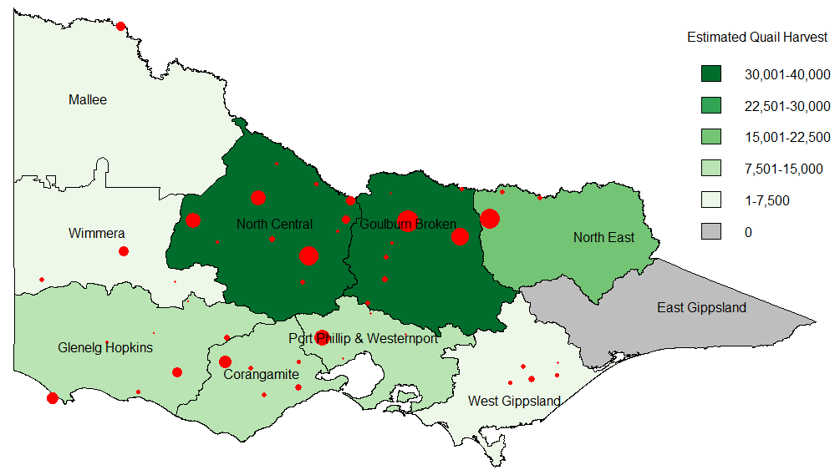
Figure 7: Estimated total quail harvest by CMA region. Red circles indicate the nearest town to harvest locations, with symbol size proportional to reported harvest.
- Discussion
  - Deer
A total of 41,601 deer were estimated to have been harvested in Victoria during the 2012 season (95% CI = 33,839–51,142). The most commonly harvested species was Sambar Deer (32,832), followed by Fallow Deer (7,900). Due to the very small harvests of Red Deer and Hog Deer reported by surveyed game licence holders, it is difficult to make any inference about the estimated harvests of those species except that they are likely to be small (<2000). The harvest of Hog Deer is strongly regulated, with the actual number of animals legally harvested recorded at checking stations. In 2012, 91 Hog Deer were recorded at checking stations, with an additional 43 Hog Deer harvested on Sunday Island, a private cooperative. We note that although the estimated harvest of Hog Deer is based on one reported deer, the 95% CI contains the total known harvest of 134 Hog Deer.
The 2012 season harvest of 41,601 deer is similar to the 2011 harvest (40,728) but is the largest estimated harvest using these methods (Table 28). There has been a steady increase in deer licence holders since 2009. The 2012 season also had the largest number of hunters and hunter days recorded using this technique. The efficiency of hunters (i.e. average number of deer per licence holder and days hunted per deer) in 2011 and 2011 was similar.
Table 28: Comparison of deer harvest with previous years.
 | 2009* | 2010* | 2011* | 2012

Harvest by species
Fallow Deer | 4,299 | 5,006 | 5,187 | 7,900
Hog Deer | 81 | 454 | 105 | 102
Red Deer | 670 | 767 | 1,437 | 773
Sambar Deer | 34,368 | 28,762 | 34,000 | 32,826
Total harvest | 39,418 | 35,278 | 40,728 | 41,601
Hunter days | 125,428 | 149,930 | 140,471 | 152,051
Deer per licence holder | 2.43 | 1.86 | 1.97 | 1.93
Days hunted per licence holder | 7.75 | 7.91 | 6.83 | 7.04
Days hunted per deer | 3.2 | 4.3 | 3.5 | 3.7
*The 2009, 2010 and 2011 estimates are from Gormley and Turnbull (2009), Gormley and Turnbull (2010) and Gormley and Turnbull (2011), respectively.
  - Duck
A total of 508,256 ducks were estimated to have been harvested in Victoria during the 2012 season (95% CI = 396,053–652,246), 15% less than the 2011 harvest (600,739). However, the 2012 duck harvest is roughly double the 2009 and 2010 harvests (222,302 and 270,574; Table 29): the length and daily bag limits of the 2009 and 2010 seasons were much lower than the 2012 season. The harvest of Grey Teal in 2012 was almost half that of 2011, but more than quadruple the 2009 and 2010 harvests. The Chestnut Teal harvest in 2012 was less than half the 2011 harvest (Table 29). The number of hunting days has remained similar from 2011 to 2012. The average number of ducks per licence holder and ducks per hunting days was lower in 2012 (21.2 and 4.6, respectively) compared to the 2011 duck season (26 and 5.8, respectively). It would seem that the 2011 duck season was a particularly efficient season, with the 2012 season being 20% lower in average duck harvest per hunting day.
The summer water bird count shows an increase in game duck species in 2012 (Purdey and Loyn 2012). The estimated percentage of wetlands with water coverage above 75% declined from 80% in 2011 to 54% in 2012 (Purdey and Loyn 2012). Coupled with high rainfall in inland Australia the number of Grey Teal and Chestnut Teal available to hunters is likely to have been lower in 2012 than 2011 (Purdey and Loyn 2012).
Table 29: Comparison of duck harvest with previous years.
 | 2009* | 2010* | 2011* | 2012

Harvest by species
Pacific Black Duck | 55,150 | 96,487 | 156,484 | 160,704
Australian Wood Duck | 131,084 | 112,390 | 132,908 | 150,150
Australian Shelduck | 2,173 | 5,936 | 8,090 | 9,234
Grey Teal | 20,919 | 26,011 | 211,034 | 110,574
Chestnut Teal | 13,176 | 14,354 | 49,812 | 23,506
Pink-eared Duck | NA | 0 | 12,597 | 21,587
Australasian Shoveler | NA | 216 | 4,854 | 1,319
Hardhead | NA | 324 | 25,657 | 30,222
Total harvest | 222,302 | 270,574 | 600,739 | 508,256
Hunter days | 76,659 | 85,801 | 103,450 | 109,718
Ducks per licence holder | 11.10 | 12.54 | 26.02 | 21.19
Days hunted per licence holder | 3.98 | 3.98 | 4.48 | 4.60
Ducks per hunting day | 2.78 | 3.16 | 5.81 | 4.63
*The 2009, 2010 and 2011 estimates are from Gormley and Turnbull (2009), Gormley and Turnbull (2010) and Gormley and Turnbull (2011), respectively.
  - Quail
A total of 129,711 quail were estimated to have been harvested in Victoria during the 2012 season (95% CI = 109,535–153,604), a substantial decrease on the 2011 harvest of 678,431 (Table 30). The reduced harvest is partially explained by the number of total hunting days reducing by over 50% (22,262 in 2012 compared with 46,719 in 2011). Most of the reduced harvest is due to a substantial decrease in the number of quail harvested per hunting day, down from 14.5 in 2011 to 5.81 in 2012. Anecdotal evidence suggests that the timing and extent of rainfall in 2011 resulted in thousands of hectares of cropping land that were only partially stripped, providing ideal feeding and breeding habitat for stubble quail, and therefore contributed to much higher quail densities in 2011. The quail harvest in 2012 is between that the 2010 and 2009 harvests in quails per licence holder and quails per hunt days (Table 30).

Table 30: Comparison of quail harvest with previous years
 | 2009* | 2010* | 2011* | 2012
Total harvest | 189,155 | 86,302 | 678,431 | 129,711
Hunter days | 24,648 | 24,739 | 46,719 | 22,262
Quail per licence holder | 7.89 | 3.59 | 26.17 | 4.80
Days per licence holder | 1.03 | 1.03 | 1.80 | 0.82
Quail per hunting day | 7.97 | 3.48 | 14.52 | 5.81
*The 2009, 2010 and 2011 estimates are from Gormley and Turnbull (2009), Gormley and Turnbull (2010) and Gormley and Turnbull (2011), respectively.
It should be noted that the number of hunting days is only an approximate estimate of total effort: someone who hunted for two hours and someone else who hunted for 12 hours are both recorded as having hunted for one day.
Due to the structure of game licences in Victoria, not every holder of a game licence permitted to hunt quail will hunt quail. The price of a game licence for Game birds including duck is the same as a game licence for Game birds not including duck. Anyone that wants to hunt ducks automatically has quail included in their licence. For many hunters, duck hunting will be their primary activity. Hence, a high proportion of game licence holders will be permitted to hunt quail even though they may not intend to do so. This does not affect the estimates of quail harvest, because the calculations explicitly account for the proportion of quail game licence holders who did not actually hunt quail.
  - Assumptions
The estimates of harvest for each game type are derived under the assumption that the samples of respondents are representative of the entire population of Victorian game licence holders. This assumption may be violated due to a number of factors such as reasons for non-response (exceeded bag limit, or conversely did not harvest anything), memory recall (respondents cannot remember their harvest), and deliberate over- or under-reporting (reported numbers are knowingly reported incorrectly). Bias due to non-response is likely to be negligible as the response rate for all surveys was generally above 95% (i.e. very high). Memory bias can inflate estimates of total harvest, in some cases by as much as 40% (Wright 1978; Barker 1991). It is likely, however, that the sampling strategy of telephone interviews after each two-week period in the case of ducks and quail, and every two months for deer, will ensure that both memory bias and non-response bias will be kept low when compared with postal surveys and complete end-of-season surveys (Barker 1991; Barker et al. 1992). Nevertheless, some bias likely remains and the estimates of total harvest should be interpreted with care.
It is important to note that the methodology explicitly accounts for the possibility that not every game licence holder hunts in every survey period (see Gormley and Turnbull 2010). Therefore, the estimate of total season bag per game licence holder is the sum of the ‘harvest per game licence holder’, not the sum of the ‘harvest per hunter’.
The uncertainty in the estimates of total harvest (as indicated by the confidence intervals) is due to two factors. Firstly, there is variation in the reported numbers of animals shot between respondents that had hunted (see Figure 1, Figure 4 and Figure 6). For example, within a given survey period for duck hunting, some respondents indicated that they hunted unsuccessfully, whereas others took multiple trips and indicated a total harvest of more than 50 ducks during that period. The second source of uncertainty is due to taking samples of hunters rather than a complete census. However, the degree of sampling uncertainty is reduced by having sample sizes of 200 respondents per survey for deer and ducks and 300 for quail.
The spatial distributions of the deer, duck and quail harvest should also be interpreted with care. Grouping the harvest by a relatively large region (CMA) provides a broad-scale view of the distribution of harvest. Grouping by smaller regions would provide a finer scale representation, but this would come at a cost of increased bias in many regions. Because the data are from a sample of game licence holders rather than a complete census, it is likely that some areas that were actually hunted would be shown as having a zero harvest if no respondents that hunted those areas were contacted. This would be increasingly likely at finer spatial scales. Furthermore, respondents were only asked to report the nearest town to where they hunted, not the actual location. It is therefore possible that the nearest town was in a different CMA than the hunting location.

References
Barker, R.J. (1991) Nonresponse to New Zealand waterfowl harvest surveys. Journal of Wildlife Management 55: 126–131.
Barker, R.J. (2006) Survey of waterfowl hunting in Victoria by Victorian licence holders 2006. Report for the Game Management Unit, Department of Sustainability and Environment, Victoria.
Barker, R.J., Geissler, P. H. and Hoover, B. A. (1992) Sources of nonresponse to the federal waterfowl hunter questionnaire. Journal of Wildlife Management 56: 337–343.
Game Victoria (2012) Victorian Hunting Guide 2012.
Gormley, A.M. (2009) Survey of quail hunting in Victoria by Victorian licence holders 2008. Report for the Game Management Unit, DSE, Victoria. 10 pp.
Gormley, A.M. and Turnbull, J.D. (2009) Estimates of harvest for deer, duck and quail in Victoria: results from surveys of Victorian game licence holders in 2009. Arthur Rylah Institute for Environmental Research Technical Report Series No. 196. Department of Sustainability and Environment, Heidelberg, Victoria.
Gormley, A.M. and Turnbull, J.D. (2010) Estimates of harvest for deer, duck and quail in Victoria: results from surveys of Victorian game licence holders in 2010. Arthur Rylah Institute for Environmental Research Technical Report Series No. 210. Department of Sustainability and Environment, Heidelberg, Victoria.
Gormley, A.M. and Turnbull, J.D. (2011) Estimates of harvest for deer, duck and quail in Victoria: results from surveys of Victorian game licence holders in 2011. Arthur Rylah Institute for Environmental Research Technical Report Series No. 224. Department of Sustainability and Environment, Heidelberg, Victoria.
Purdey, D. and Loyn, R. (2010) The 2010 Summer Waterbird Count in Victoria. Unpublished Client Report, Arthur Rylah Institute for Environmental Research, Department of Sustainability and Environment, Heidelberg, Victoria.
Purdey, D. and Loyn, R. (2011) The 2011 Summer Waterbird Count in Victoria. Unpublished Client Report, Arthur Rylah Institute for Environmental Research, Department of Sustainability and Environment, Heidelberg, Victoria.
Purdey, D. and Loyn, R. (2012) The 2012 Summer Waterbird Count in Victoria. Unpublished Client Report, Arthur Rylah Institute for Environmental Research, Department of Sustainability and Environment, Heidelberg, Victoria.
Wright, V.L. (1978) Causes and effects of biases on waterfowl harvest estimates. Journal of Wildlife Management 42: 251–262.

Appendix 1
Common definitions used
SD = standard deviation of the data. Represents the variation in the numbers reported.
SE = standard error of the mean. Represents the variation in the estimated mean.
CV = Coefficient of variation. Calculated as: CV = SE ÷ Average. This provides an indication as to how much uncertainty is in the estimate relative to the mean.

Calculations
For each survey j, we surveyed n_{j} respondents of which h_{j} had hunted. The proportion of respondents that hunted in each period j is given as:
$p_{j}=\frac{h_{j}}{n_{j}}$ e.g., for duck survey 3, we obtain: $\frac{\text{60}}{\text{200}}=0\text{.}3$

The total number of hunters for each survey period (H_{j}) was estimated by multiplying the total number of licence holders (L) by the proportion of respondents that reported having hunted during that survey period (p_{j}), as found previously:
$H_{j}=p_{j}L$ e.g., for duck survey 3, we obtain: $0\text{.}3×\text{24},\text{183}=7,\text{255}$

The estimated average harvest per hunter (w_{j}) is the total reported harvest for survey j (y_{j}) divided by the total number of respondents that hunted (h_{j}):
$w_{j}=\frac{y_{j}}{h_{j}}$ e.g., for duck survey 3, we obtain: $\frac{\text{994}}{\text{60}}=\text{16}\text{.}\text{57}$

The total harvest for each survey period (W_{j}) was estimated by multiplying the average harvest per hunter (w_{j}) by the total number of hunters (H_{j}):
$W_{j}=w_{j}H_{j}$ e.g., for duck survey 3, we obtain:$\text{16}\text{.}\text{57}×7,\text{255}=\text{120},\text{190}$

The estimate of total harvest is calculated as the sum of the estimated harvest for each survey period:
$$W_{\text{TOT}}=W_{1}+W_{2}+W_{3}+W_{4}+W_{5}+W_{6}+W_{7}$$

Standard errors (SE) for the proportion of respondents that hunted are given as:
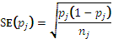 e.g., for duck survey 3, we obtain: 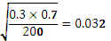

Standard errors for the average harvest per hunter are given as:
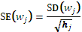 e.g., for duck survey 3, we obtain: $\frac{\text{57}\text{.}\text{78}}{\sqrt{\text{60}}}=7\text{.}\text{46}$

The standard errors for the total estimated harvest per survey period (W_{j}) is found by determining the Coefficient of Variation (CV) of p_{j} and w_{j} and then adding their sum of squares to find the combined CV (assuming independence).

$\text{CV}(w_{j})=\frac{\text{SE}(w_{j})}{w_{j}}$, and $\text{CV}(p_{j})=\frac{\text{SE}(p_{j})}{p_{j}}$
$$\text{CV}(W_{j})=\sqrt{{\left(\text{CV}(w_{j})\right)}^{2}+{\left(\text{CV}(p_{j})\right)}^{2}}$$
$$\text{SE}(W_{j})=\text{CV}\left(W_{j}\right)×W_{j}$$

The standard error of the total harvest is calculated as:
$$\text{SE}(W_{\text{TOT}})=\sqrt{{\left(\text{SE}(W_{1})\right)}^{2}+{\left(\text{SE}(W_{2})\right)}^{2}+…+{\left(\text{SE}(W_{7})\right)}^{2}}$$

Confidence intervals were computed on the natural logarithm scale and back-transformed to ensure that lower limits were ≥ 0. A consequence is that confidence intervals are asymmetric, and cannot be reported as the estimate plus or minus a fixed value. In general, for some estimate denoted as , 95% confidence interval limits were calculated using:
upper limit
lower limit, where:
e.g., for the total duck harvest we have
$$\text{CV}=\frac{\text{64},\text{945}}{\text{508},\text{256}}=0\text{.}\text{128}$$
$$r=\text{exp}\left(1\text{.}\text{96}\sqrt{\text{ln}\left(1+0\text{.}{\text{128}}^{2}\right)}\right)=1\text{.}\text{28}$$
Therefore, Upper and Lower Confidence Intervals are given by:
$$\begin{matrix}\text{UL}=\text{508},\text{256}×1\text{.}\text{28}=\text{652},\text{246} \\ \text{LL}=\text{508},\text{256}÷1\text{.}\text{28}=\text{396},\text{053}\end{matrix}$$

ISSN 1835-3827 (print)
ISSN 1835-3835 (online)
ISBN 978-1-74287-704-4 (print)
ISBN 978-1-74287-705-1 (online)

Australian Wood Duck is also referred to as Wood Duck, Maned Duck, and Maned Goose.
Australian Shelduck is often referred to as Mountain Duck.
Hardhead is also referred to as White-eyed Duck.
Australasian Shoveler is often referred to as Blue-winged Shoveler.
Respondent refers to game licence holders who were contacted and agreed to take part in the survey.
Hunter refers to a game licence holder who actually went out and hunted (successfully or unsuccessfully) at some point during the period with which the survey is concerned.

